Platte River
Recovery Implementation Program

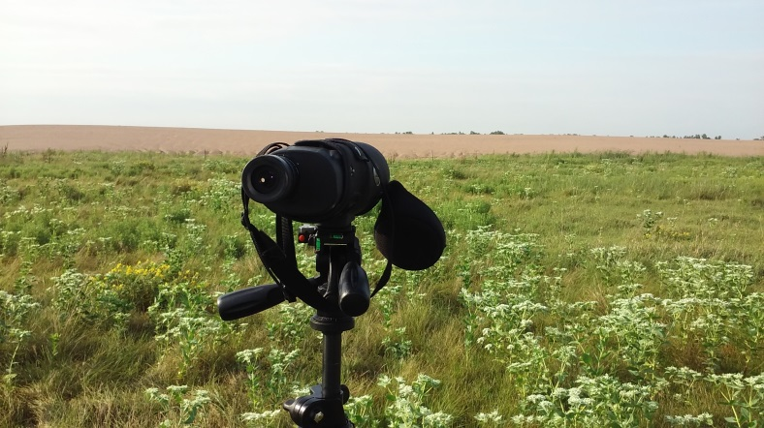
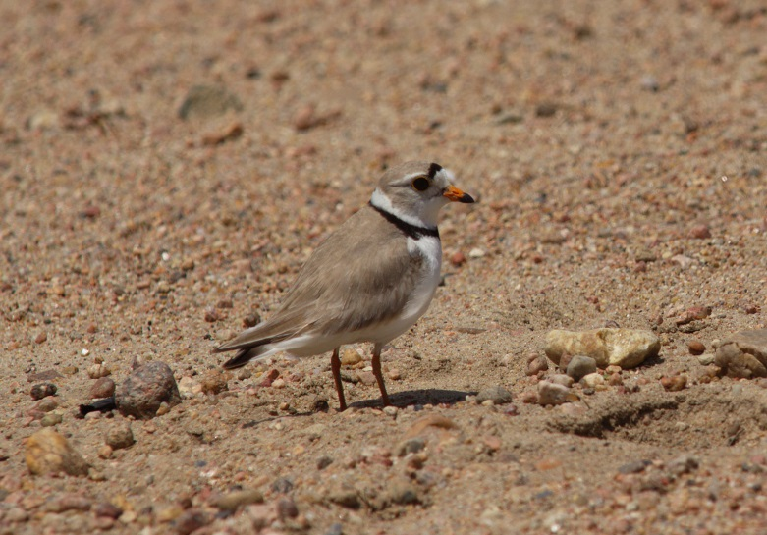
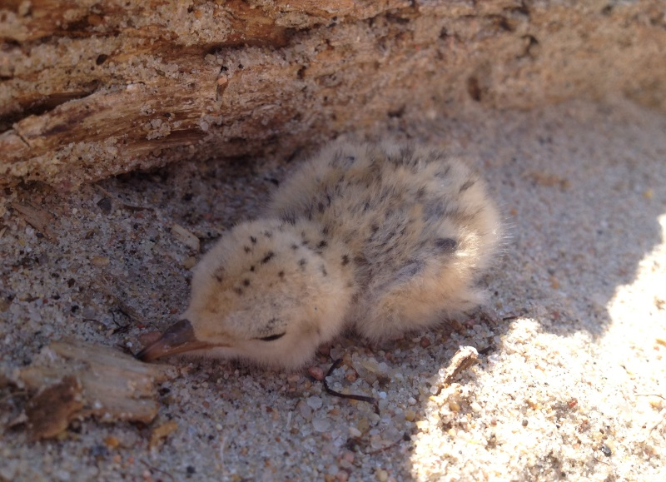
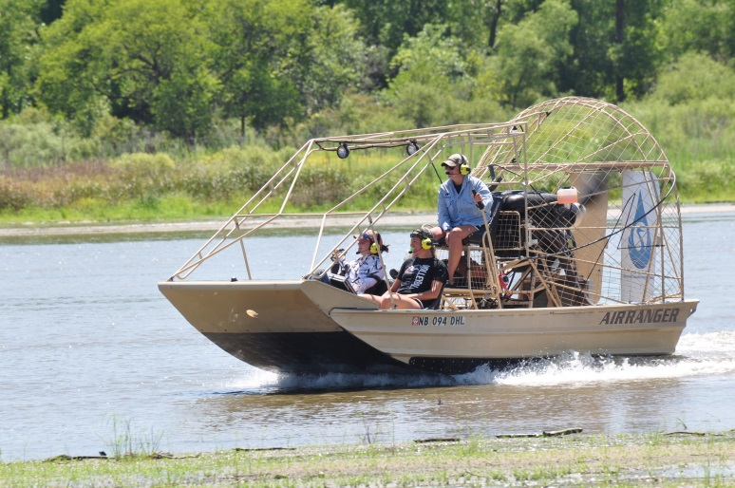
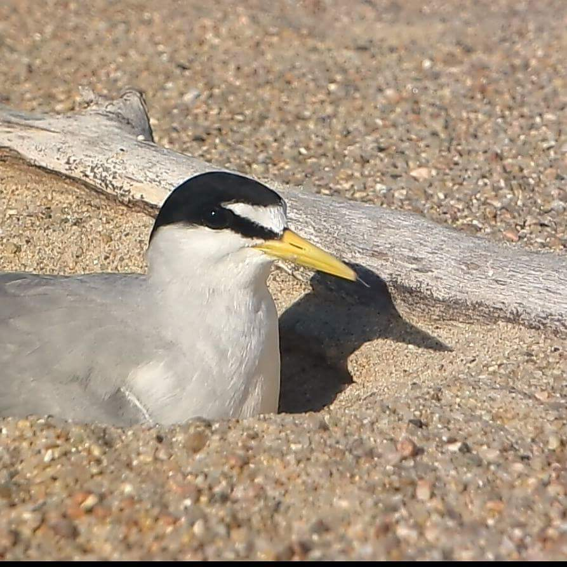
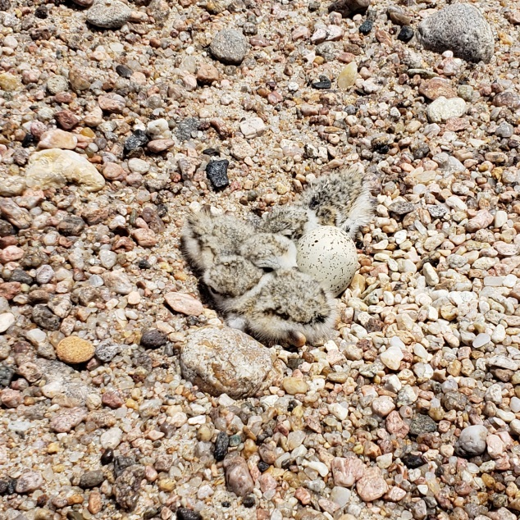
2018 Interior Least Tern and Piping Plover Monitoring and Research Report,
Central Platte River, Nebraska

Prepared for: Governance Committee
Prepared by: Executive Director’s Office

02/06/2019

Platte River Recovery Implementation Program

2018 Interior Least Tern and Piping Plover
Monitoring and Research Report,
Central Platte River, Nebraska

Prepared By

Kari Mohlman
Headwaters Corporation, Inc.
Platte River Recovery Implementation Program
Executive Director’s Office
4111 4th Avenue, Suite 6
Kearney, NE 68845
mohlmank@headwaterscorp.com

David Baasch, PhD, CWB
Headwaters Corporation, Inc.
Platte River Recovery Implementation Program
Executive Director’s Office
4111 4th Avenue, Suite 6
Kearney, NE 68847
baaschd@headwaterscorp.com

Suggested Citation:
Mohlman, K.L., and D.M. Baasch. 2019. Platte River Recovery Implementation Program: 2018 interior least tern and piping plover monitoring and research report, central Platte River, Nebraska.
PREFACE
This is a report of the Platte River Recovery Implementation Program’s (Program or PRRIP) monitoring and research efforts for interior least terns (least tern) and piping plovers during 2018. The report was prepared to inform Program partners, licensing agencies, and the general public of our activities and to provide a summary of results to fulfill the requirements of the Program’s state (Nebraska Master Permit #1014) and federal (TE183430-0) monitoring permits. Data analyses are not final and should be treated as such when citing information, data, or analyses found in this document.
TABLE OF CONTENTS
Introduction 4
This section provides details of the study area and summarizes conditions observed during the 2018 nesting season.
Management 6
This section describes on- and off-river land management practices used to facilitate nesting and actions taken to protect least tern and piping plover colonies and nests from predation and disturbance. This section also provides a summary of habitat availability and species response, 2007−2018.
Monitoring 10
This section presents data collected annually and includes the number of least tern and piping plover adults, breeding pairs, nests, chicks, and fledglings observed along the central Platte River during 2018. These data are collected and summarized in a form to allow comparisons across the entire range of each species and includes annual survey results.
Research 30
This section contains a summary of least tern and piping plover research conducted since 2007. Once research projects are finalized, detailed methodologies and results for such projects can be found on the Program’s website (www.platteriverprogram.org).
Appendices 38
This section contains results of survival analyses developed using package RMARK in Program R nest survival methods.
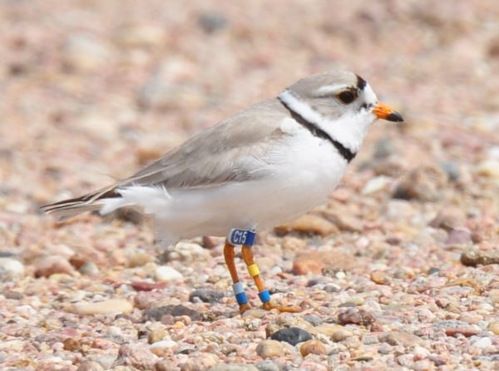
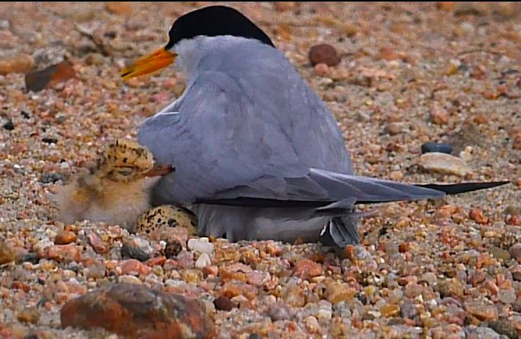
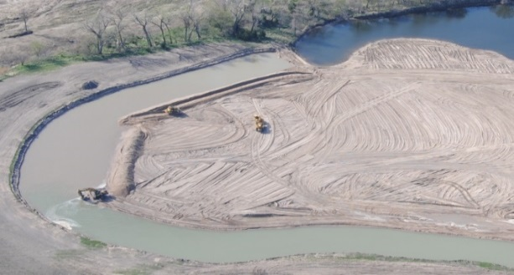
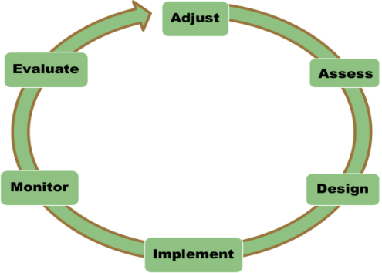

INTRODUCTION
The Platte River Recovery Implementation Program (Program or PRRIP) was initiated on 1 January, 2007 as a result of a cooperative agreement negotiating process that started in 1997 between the states of Colorado, Wyoming, and Nebraska; the U.S. Department of the Interior (DOI); water users; and conservation groups. The Program is intended to address issues related to the Endangered Species Act and loss of habitat in the central Platte River between Lexington and Chapman, Nebraska by managing certain land and water resources following principles of adaptive management to provide benefits for four “target species” including the endangered interior least tern (Sternula antillarum) and the threatened piping plover (Charadrius melodus). The northern Great Plains population of piping plovers was listed as threatened on January 10, 1986. The least tern was listed as endangered on June 27, 1985; however, a recently completed five-year review recommends delisting least terns due to recovery. The U.S. Fish and Wildlife Service (USFWS) is now in the process of putting in place the necessary monitoring plans, conservation agreements, and population models in hopes of moving forward with a proposed delisting in the near future. The Program is led by a Governance Committee (GC) that is assisted by several standing advisory committees as well as an Executive Director (ED) and staff.
The Program has three main elements:
- Increasing stream flows in the central Platte River during relevant time periods through re-timing and water conservation or supply projects. The first increment objective is to re-time and improve flows in the central Platte River to reduce shortages to target flows by an average of 130,000 – 150,000 acre-feet per year at Grand Island.
- Enhancing, restoring, and protecting habitat lands for the target species. The first increment objective is to protect, restore, and maintain 10,000 acres of habitat.
- Accommodating certain new water-related activities.
The data summarized in this report were collected in accordance with the Program’s 2017 interior least tern and piping plover monitoring protocol. The primary objectives of protocol implementation include: 1) monitoring interior least tern (least tern) and piping plover (plover) use and productivity on midstream-river sandbars and sand and gravel mines; and 2) document habitat characteristics that are believed to influence nest site selection and nest and brood success along the central Platte River between Lexington and Chapman, Nebraska. The Program has also banded least tern and piping plover adults and chicks on the central Platte with three objectives: 1) quantify dispersal of adults between units of nesting habitat on the Central Platte River among years; 2) quantify colonization rate of newly constructed or managed nesting habitat by local versus immigrant adults; and 3) quantify frequency and location of renesting attempts by adults with failed nests. As such, banding least tern and piping plover adults and chicks was conducted for seven consecutive years on the central Platte River (2009‒2016). The 2018 season marked the second year banding didn’t occur; we plan to continue band resighting over the coming years. We anticipate a final report documenting results of those efforts will be available on the Program’s online Public Library in 2019. Monitoring and research during 2018 was a collaborative effort between personnel of Headwaters Corporation (EDO or Program staff), Central Platte Natural Resources District (CPNRD), and Nebraska Public Power District (NPPD). Past data and analyses are reported in annual reports produced by West Incorporated (2001−2007) and Program staff (2008−2017) and are available in the Program’s online Public Library. Least tern and piping plover activity and reproductive success during 2018 are summarized in this report.
STUDY AREA
Our study area encompassed the “PRRIP Associated Habitats” region of the central Platte River between Lexington and Chapman, Nebraska (~90 river miles, Figure 1) as well as off-channel and sandpit sites within three miles of the river in this reach. In the central Platte River system, least tern and piping plover habitat was located at both on- and off-channel sites. River or on-channel habitat included midstream sandbars used for nesting and open river channel used for foraging. Off-channel habitat included spoil piles of sparsely- or non-vegetated sand and associated sandpit lakes at sand and gravel mines. Least terns nested on managed sandpit spoil piles or river islands and foraged in sandpit lakes and open river channel. Piping plovers nested on managed sandpit spoil piles or river islands and foraged on low elevation river islands or along the waterline of sandpit ponds.

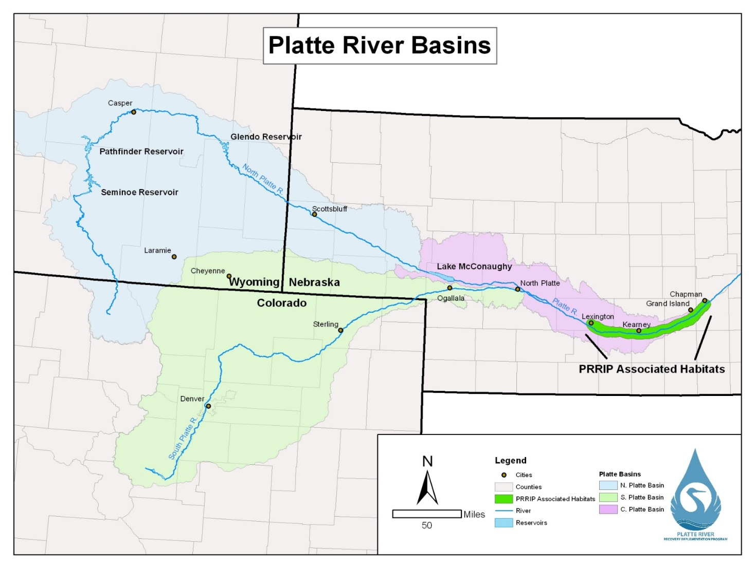
Figure 1. Platte River Basins extending from Colorado and Wyoming through Nebraska. The study area for our least tern and piping plover monitoring and research efforts was the PRRIP Associated Habitats region of the Platte River located between Lexington and Chapman, Nebraska.

2018 RIVER CONDITIONS
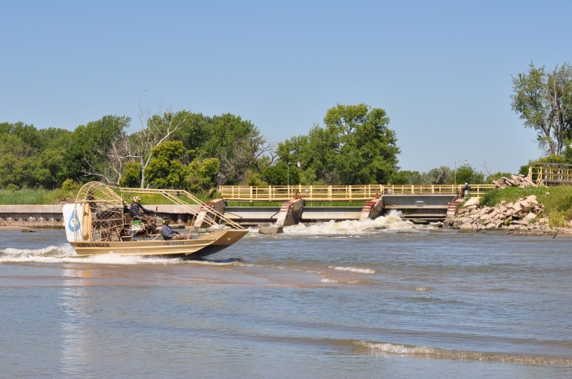
The number of low-elevation sandbars present within the PRRIP associated habitats region of the central Platte River is variable and dependent on seasonal and daily fluctuations in river flow. The size and distribution of non-vegetated, high-elevation sandbars characteristic of least tern and piping plover nesting sites within the region has been dependent upon construction and vegetation management efforts.
In 2018 daily flows were fairly normal during May, dropped below average levels during June, and returned to normal during July and August. The peak flow of the 2018 season at the Kearney gages was 2,520 cubic feet per second (cfs).
Surveying from the airboat searching for birds with bands

Figure 2. Mean daily discharge (ft³/second; cfs) at Kearney, Nebraska (USGS gage 06770200). Average across 2001‒2018 from Kearney (USGS gage 06770200). See Figure 3 for the location of gage stations within our study area. Data available at: waterdata.usgs.gov/ne/nwis/current/?type=flowandgroup_key=NONEandsearch_site_no_station_nm=platte%20river.

MANAGEMENT
Management actions designed to increase nesting habitat (bare sand) and productivity of least terns and piping plovers within Program associated habitats were taken at on- and off-channel sites during fall 2017 and spring 2018. Management activities were site specific and included: mechanical actions to create nesting habitat (dozers, scrapers, and backhoes), mechanical actions to improve nesting conditions and remove vegetative cover (disking, tree removal, mowing, and nest furniture distribution); chemical application to kill or prevent emergence of vegetation (spring or fall herbicide application); and predator control (fencing and trapping).

SUMMARY OF HABITAT AVAILABILITY AND SPECIES RESPONSE, 2007−2018

On-Channel Mechanical Habitat Creation and Maintenance
Constructed on-channel habitat availability has been variable and somewhat limited during the First Increment of the Program (Table 1). Approximately 24 acres of constructed habitat were present in the Associated Habitat Reach (AHR) in 2007 as the result of efforts by other conservation organizations. That habitat was subsequently lost over the course of several years due to erosion during natural high flow events. The Program began large-scale on-channel habitat construction efforts at the Elm Creek complex in the fall of 2012 and was also able to create on-channel habitat at the Cottonwood Ranch and Plum Creek complexes as part of sediment augmentation activities. Much of that habitat was lost during a natural high flow event in the fall of 2013. On-channel island construction began at the Shoemaker Island complex following the fall 2013 event. A high flow event in June of 2014 eroded a portion of the habitat constructed in the fall of 2013, but the Program was able to construct a total of 28 acres of on-channel habitat during the fall of 2014 at the Elm Creek and Shoemaker Island complexes. However, all of it was lost due to erosion during the 2015 and 2016 high flow events. On-channel habitat construction by other conservation organizations has been very limited since 2007.
Table 1. On- and off-channel nesting habitat in the Associated Habitat Reach by year, 2007−2018.
 | On-Channel Habitat (ac) |  |  | Off-Channel Habitat (ac)
Year | PRRIP | Others | Total | PRRIP | Others | Total
2007 | 0 | 24 | 24 | 0 | 48 | 48
2008 | 0 | 21 | 21 | 0 | 48 | 48
2009 | 0 | 15 | 15 | 0 | 48 | 48
2010 | 0 | 5 | 5 | 32 | 48 | 80
2011 | 0 | 5 | 5 | 60 | 48 | 108
2012 | 0 | 0 | 0 | 72 | 48 | 120
2013 | 55 | 0 | 55 | 72 | 48 | 120
2014 | 19 | 0 | 19 | 80 | 48 | 128
2015 | 47 | 0 | 47 | 90 | 48 | 138
2016 | 4 | 0 | 4 | 87 | 51 | 138
2017 | 0 | 0 | 0 | 99 | 61 | 160
2018 | 0 | 0 | 0 | 109 | 83 | 192
Average | 11.4 | 6.4 | 17.7 | 53.8 | 48.0 | 101.8

On- and Off-Channel Mechanical Habitat Creation and Maintenance
Approximately 48 acres of managed off-channel nesting habitat were present in the AHR at the beginning of the First Increment (Table 1). The Program began acquiring and restoring off-channel sites in 2009. Total managed off-channel habitat in the AHR increased to 192 acres during the period of 2009−2018 as the Program constructed and/or restored 109 acres of habitat. The Program plans to acquire or construct an additional 60 acres of off-channel habitat prior to the end of the First Increment in 2019. Mining at Follmer Alda and Newark East sites are still under way and more habitat should become available during the 2019 nesting season.
SANDPIT SITES:
Eleven of the fifteen off-channel sites monitored during 2018 were actively managed to increase least tern and piping plover reproduction. Program owned and/or managed sites are denoted with a superscript “P” (^{P}) and managed sites are identified by a superscript “M” (^{M}).
^{M} Lexington Pit – A pre-emergent herbicide was applied during spring 2017, the woven-wire predator fence with offset electric wires along the west side of the nesting areas was maintained, and predator trapping occurred during 2018. No sand and gravel mining occurred during 2018.
^{PM} Dyer Pit – A contact herbicide was applied to kill existing vegetation primarily along the waterline during fall 2017. A pre-emergent herbicide was applied during spring 2018, a permanent 4-foot tall woven wire predator fences with offset electric wires across the south ends of each peninsula were electrified, and sand around the fence was moved to combat accumulation. Predator trapping also occurred during 2018. No sand and gravel mining occurred during 2018.
^{PM} Cottonwood Ranch OCSW – A contact herbicide was applied to kill existing vegetation primarily along the waterline during fall 2017, a pre-emergent herbicide was applied, and predator trapping occurred during 2018. A permanent 4-foot tall woven wire predator fence with offset electric wires was maintained in 2018. No sand and gravel mining occurred.
^{M} Blue Hole – A pre-emergent herbicide was applied during spring 2018, the existing permanent predator fence was maintained, a temporary 4-foot tall electrified predator fence was installed along the southwest edge of the peninsula and electrified, and predator trapping occurred during 2018.
^{M} Johnson Pit – A pre-emergent herbicide was applied during spring 2018, the woven-wire predator fence with offset electric wires along the west side of the nesting area was maintained and electrified, and predator trapping occurred during 2018. No sand and gravel mining occurred during 2018.
Ed Broadfoot and Sons – Non-program unmanaged site. Sand and gravel mining occurred during 2018.
^{PM}Broadfoot South – A contact herbicide was applied to kill existing vegetation primarily along the waterline during fall 2017 and a pre-emergent herbicide was applied to the nesting area during spring 2018. A temporary 4-foot tall electrified predator fence was installed across the east end of the main peninsula, and predator trapping occurred during 2018. Sand and gravel mining occurred northwest of the main peninsula during 2018.
Broadfoot South Non-access Islands
^{PM}Broadfoot South—Non-Access Islands – A 4-foot tall hog-panel fence with chicken wire was placed across the land-bridge extending to one of the non-access islands located northwest of the main peninsula. Sand and gravel mining occurred directly east of the islands during 2018. Nine acres were available for least tern or piping plover nesting in 2018.
^{PM} Newark West – A contact herbicide was applied to kill existing vegetation primarily along the waterline during fall 2017. A pre-emergent herbicide was applied during spring 2018, permanent 4-foot tall woven wire predator fences with offset electric wires across the ends of each peninsula were electrified, and predator trapping occurred during 2018. No sand and gravel mining occurred during 2018.
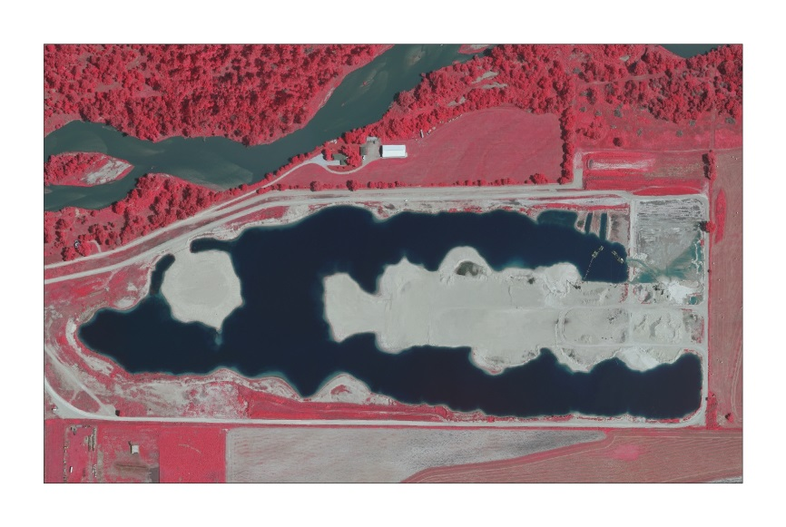
^{PM} Newark East – A contact herbicide was applied to kill existing vegetation primarily along the waterline during fall 2017. A pre-emergent herbicide was applied during spring 2018. The west peninsula contains a permanent 4-foot tall woven wire predator fence with offset electric wires across the ends of the peninsula, which were electrified. A temporary 4-foot tall electrified predator fence was installed across the east peninsula. Sand and gravel mining and predator trapping occurred during 2018. Fourteen acres were available for least tern or piping plover nesting in 2018.
Newark East Nesting Site

^{PM} Leaman East OCSW – A contact herbicide was applied to kill existing vegetation along the waterline during fall 2017. A pre-emergent herbicide was applied to the nesting area during spring and predator trapping occurred during 2018. A permanent, 4-foot tall woven wire predator fence with offset electric wires was maintained in 2018. No sand and gravel mining occurred.
Trust Wild Rose East – Not managed during 2018 and no sand and gravel mining occurred.
^{PM} Follmer-Alda Pit – A contact herbicide was applied to kill existing vegetation along the waterline during fall 2017. A pre-emergent herbicide was applied to the nesting area during spring 2018 and a temporary 4-foot tall electrified predator fence was installed across the west end of the main peninsula. Sand and gravel mining occurred east of the main peninsula during 2018.
DeWeese-Alda – Not managed. Sand and gravel mining occurred during 2018.
Hooker Brothers - GI South East – Not managed. Sand and gravel mining occurred during 2018.

RIVERINE SITES:
Penrose Island – Disked prior to the 2018 nesting season, but pre-emergent herbicide was not applied so no suitable nesting habitat was available during the 2018 monitoring season.

MONITORING
In 1997, the DOI and the States of Nebraska, Colorado, and Wyoming adopted the “Cooperative Agreement for Platte River Research and Other Efforts Relating to Endangered Species Habitats” (Cooperative Agreement). In 2001, the Cooperative Agreement coordinated a standardized protocol for monitoring reproductive success and reproductive habitat parameters of least terns and piping plovers in the central Platte River from Lexington to Chapman, Nebraska. The standardized protocol was implemented by CNPPID, CPNRD, NPPD, and USFWS-GI during 2001−2006. In 2007, the Program assumed responsibilities of the protocol; Program staff, contracted personnel, and cooperators have since implemented it. The protocol was revised prior to the 2010 nesting season and again prior to the 2017 nesting season (PRRIP 2017).

SEMI-MONTHLY RIVER AND SANDPIT SURVEYS:
METHODS
We conducted 7 semi-monthly surveys (1 and 15 May, June, and July and 1 August) of the central Platte River between Chapman and Lexington, Nebraska (river surveys). In addition, we surveyed all sandpits within Program Associated Habitats that met the Program’s minimum habitat criteria (sandpit surveys) to document adults, breeding pairs, nests, chicks, and fledglings during 2018. We derived least tern and piping plover breeding pair estimates (BPE; Baasch et al. 2015) by adding the number of active, or recently failed nests to the number of active, or recently failed or fledged broods observed on a given date. We obtained least tern breeding pair estimates by assuming: 1) least tern nests did not hatch within 21 days of being initiated; 2) least terns did not re-nest within 5 days of losing a nest or brood; 3) least tern chicks fledged at 21 days of age (fledging age 2010−2018); 4) least tern chicks that survived to 15 days of age (fledging age 2007−2009) also fledged; and 5) least terns did not re-nest after fledging chicks. We determined piping plover breeding pair counts by assuming: 1) piping plover nests did not hatch within 28 days of being initiated; 2) piping plovers did not re-nest within 5 days of losing a nest or brood; 3) piping plover chicks fledged at 28 days of age (fledging age 2010−2018); and 4) piping plover chicks that survived to 15 days of age (fledging age 2007−2009) also fledged. We included summaries of the total number of adults, breeding pairs, nests, chicks, and fledglings observed during river surveys, sandpit surveys, and a combination of river and sandpit surveys (semi-monthly survey totals) to provide 7 snap-shots of the numbers observed during the 2018 nesting seasons. All counts of adults, breeding pairs, nests, chicks, and fledglings reported during semi-monthly surveys represent minimums present.
Semi-monthly River Surveys – Program staff and technicians conducted semi-monthly river surveys between the J2 Return and the Chapman Bridge on 1-2 May; 15-16 May; 30-31 May; 12-13; 2-3 July; 17-19 July; and 31 July - 1 August during 2018. We used an airboat to survey all channels wider than 75 yards between Lexington and Chapman, NE that could be safely navigated and documented all observations of least tern and piping plover adults, breeding pairs, nests, chicks, and fledglings located within this reach of river.
Semi-monthly Sandpit Surveys – We conducted semi-monthly surveys from outside the nesting colony at 16 sandpit sites to count individual birds and document least tern and piping plover adults, breeding pairs, nests, chicks, and fledglings. Semi-monthly sandpit surveys were conducted outside the nesting area on 30 April - 2 May; 14-17 May; 31 May – 4 June; 13-15 June; 29 June – 6 July, 16 July, and 31 July – 03 August during 2018. Program staff, technicians and personnel from CPNRD and NPPD conducted semi-monthly sandpit surveys during 2018.
Semi-monthly Survey Totals – To obtain an estimate of numbers of least tern and piping plover adults, breeding pairs, nests, chicks, and fledglings within the Program Associated Habitat Area throughout the 2018 nesting season, we summed numbers detected during semi-monthly river and sandpit surveys nearest 1 and 15 May, June, and July and 1 August. We derived least tern and piping plover breeding pair estimates (BPE) by adding the number of active, or recently failed nests to the number of active, or recently failed or fledged broods observed on a given date (Baasch et al. 2015).
RESULTS
Semi-monthly River Surveys – Each of the 7 semi-monthly river surveys between Lexington and Chapman, Nebraska during 2018 required 2–3 days to conduct. We observed the most least tern adults (41) on the river during the 15-July and 1-August river surveys. The most piping plover adults (12) were observed on the river during the 1-July river survey in 2018 (Table 2). We observed no least tern or piping plover breeding pairs during 2018 river surveys. All least tern and piping plover adults and fledglings observed during semi-monthly river surveys in 2018 were either known (banded) or were presumed (near areas with sandpits that fledged chicks) to be associated with nearby sandpit nesting sites.
Table 2. Number of Least Tern and Piping Plover adults, breeding pairs (pair), nests, chicks, and fledglings observed during semi-monthly airboat surveys of the Platte River between Lexington and Chapman, Nebraska, in 2018.
 | Interior Least Tern |  |  |  |  | Piping Plover
Survey | Adults | Pair* | Nests | Chicks | Fledglings | Adults | Pair* | Nests | Chicks | Fledglings
1-May | 0 | 0 | 0 | 0 | 0 | 0 | 0 | 0 | 0 | 0
15-May | 6 | 0 | 0 | 0 | 0 | 4 | 0 | 0 | 0 | 0
1-Jun | 16 | 0 | 0 | 0 | 0 | 9 | 0 | 0 | 0 | 0
15-Jun | 28 | 0 | 0 | 0 | 0 | 7 | 0 | 0 | 0 | 0
1-Jul | 16 | 0 | 0 | 0 | 0 | 12 | 0 | 0 | 0 | 0
15-Jul | 41 | 0 | 0 | 0 | 9 | 2 | 0 | 0 | 0 | 4
1-Aug | 41 | 0 | 0 | 0 | 49 | 0 | 0 | 0 | 0 | 2
* Pair represents the number of breeding pairs, as defined above, present on river islands on 1 and 15 May, June, and July, and 1 August. Breeding pair counts were obtained using the Program’s Breeding Pair Estimator (BPE). Quantities of Nests may be different from Breeding Pair because semi-monthly surveys occurred over several days and Breeding Pair counts were determined on the 1st or 15th of the month.
Semi-monthly Sandpit Surveys – Each of the 7 semi-monthly sandpit surveys from outside the nesting area required 2–4 days to conduct in 2018. Similar to past years, most least tern and piping plover breeding pairs, nests, and chicks were observed on sandpit sites where management activities occurred prior to the nesting seasons. We did, however, observe 2 piping plover breeding pairs and 2 nests at the Trust sandpit; neither nest hatched. We also observed 1 piping plover breeding pair and 1 nest on the Broadfoot South non-access islands; this nest failed as well. There was also a 1 piping plover breeding pair observed on Ed Broadfoot and Sons sandpit and 1 nest; the nest was successful and hatched at least 1 chick, however the chicks were not observed after the hatch date as we did not have access to view the rest of the pit. We observed the most adult least terns (122) and the most active nests (72) during the 15-June sandpit survey (Table 3). The most least tern breeding pair (86) were observed during the 1-July survey. We observed the most piping plover adults (53) as well as the most piping plover breeding pair (36) during the 15-June sandpit survey, when there were 19 active nests and 27 chicks present across all sandpit sites. The most piping plover active nests (26) occurred during the 1-June sandpit survey. A total of 15 sites were monitored during each of the semi-monthly survey periods.
Table 3. Number of least tern and piping plover adults, breeding pairs (pair), nests, chicks, and fledglings documented from outside the nesting area during semi-monthly sandpit surveys in 2018.
 | Interior Least Tern |  |  |  |  | Piping Plover
Survey | Adults | Pair* | Nests | Chicks | Fledglings | Adults | Pair* | Nests | Chicks | Fledglings
1-May | 0 | 0 | 0 | 0 | 0 | 18 | 0 | 0 | 0 | 0
15-May | 8 | 0 | 0 | 0 | 0 | 22 | 12 | 9 | 0 | 0
1-Jun | 86 | 40 | 34 | 0 | 0 | 49 | 30 | 26 | 6 | 0
15-Jun | 122 | 80 | 72 | 0 | 0 | 53 | 36 | 19 | 27 | 0
1-Jul | 101 | 86 | 21 | 112 | 0 | 34 | 30 | 7 | 20 | 0
15-Jul | 80 | 78 | 1 | 27 | 43 | 12 | 17 | 6 | 8 | 3
1-Aug | 33 | 66 | 4 | 4 | 16 | 2 | 6 | 0 | 4 | 0
* Pair represents the number of breeding pairs, as defined above, present on sandpits on 1 and 15 May, June, and July, and 1 August. Breeding pair counts were obtained using the Program’s Breeding Pair Estimator (BPE). Quantities of Nests may be different from Breeding Pairs because semi-monthly surveys occurred over several days and Breeding Pair counts were determined on the 1st or 15th of the month.
Semi-monthly Survey Totals – Semi-monthly survey totals include both sandpit and river survey counts of adults, breeding pairs, nests, chicks, and fledglings observed during the 7 semi-monthly sandpit and river surveys and represent an estimate of the overall numbers present within Program Associated Habitats during 7 time periods in the 2018 nesting season. In 2018, we observed 72 active least tern nests during the 15-June survey when 150 adults and 80 breeding pairs were observed (Table 4). We observed 65 least tern fledglings during the 1-August survey. In 2018, we observed 26 active piping plover nests during the 1-June survey when 58 adults and 30 breeding pairs were observed. For the 15-July survey 7 piping plover fledglings were observed. A total of 16 sandpit sites and the river were surveyed each semi-monthly survey period (Table 4).
Table 4. Number of least tern and piping plover adults, breeding pairs (pair), nests, chicks, and fledglings observed within Program Associated Habitats during semi-monthly surveys of sandpits and the river in 2018.
Interior Least Terns |  |  |  |  |  | Piping Plovers
Survey | Adults | Pair* | Nests | Chicks | Fledglings | Adults | Pair* | Nests | Chicks | Fledglings
1-May | 0 | 0 | 0 | 0 | 0 | 18 | 0 | 0 | 0 | 0
15-May | 14 | 0 | 0 | 0 | 0 | 26 | 12 | 9 | 0 | 0
1-Jun | 102 | 40 | 34 | 0 | 0 | 58 | 30 | 26 | 6 | 0
15-Jun | 150 | 80 | 72 | 0 | 0 | 60 | 36 | 19 | 27 | 0
1-Jul | 117 | 86 | 21 | 112 | 0 | 46 | 30 | 7 | 20 | 0
15-Jul | 121 | 78 | 1 | 27 | 52 | 14 | 17 | 6 | 8 | 7
1-Aug | 74 | 66 | 4 | 4 | 65 | 2 | 6 | 0 | 4 | 2
* Pair represents the number of breeding pairs, as defined above, present on river islands on 1 and 15 May, June, and July, and 1 August. Breeding pair counts were obtained using the Program’s Breeding Pair Estimator (BPE). Quantities of Nests may be different from Breeding Pairs because semi-monthly surveys occurred over several days and Breeding Pair counts were determined on the 1st or 15th of the month.

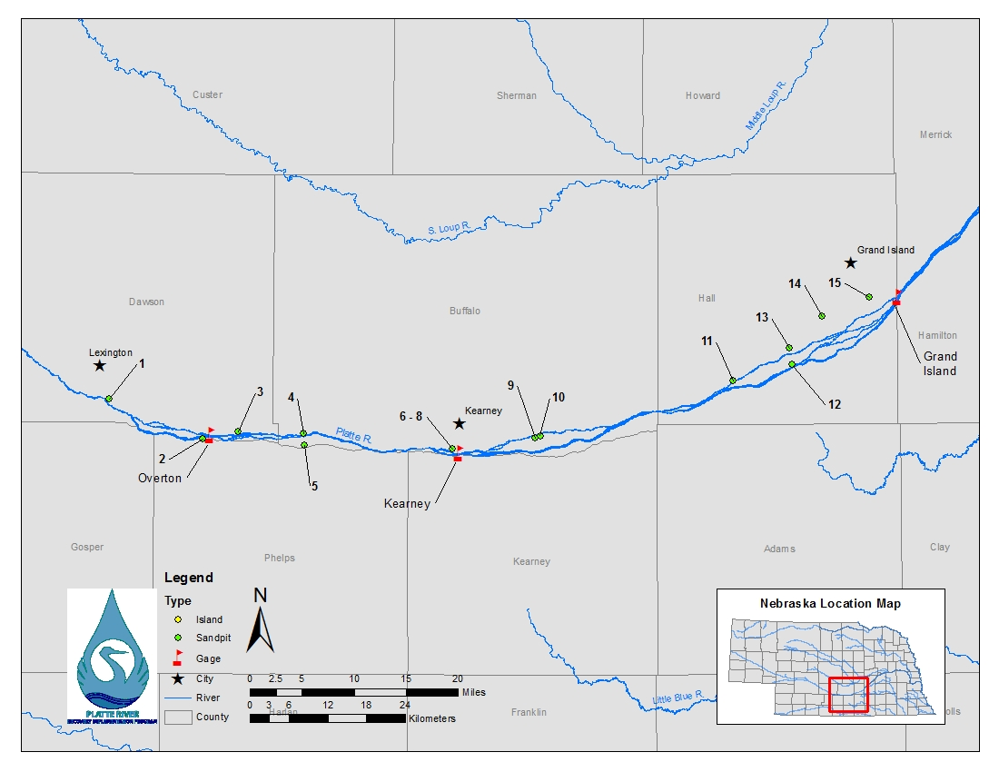
Figure 3. Study area including sandpits and river channels monitored for least tern and piping plover nesting and foraging activities during 2018. Names of sites are located in Table 7.

MID-MONTH AND SEMI-MONTHLY SURVEYS
River Surveys, 2001–2018: We observed slight use of the river by least terns and piping plovers throughout the nesting season. Counts of least tern and piping plover adults observed during river surveys in 2018 were generally similar to numbers observed prior to Program implementation (2001–2006; Figure 4). The trend in numbers of adult least terns observed during the 2018 river surveys of the central Platte River were generally higher than those of 2017 and were similar to previous years. The numbers of piping plovers in the rivers were lower overall than 2017.

Figure 4. Numbers of least tern (top) and piping plover (bottom) adults observed during mid-month and semi-monthly surveys of the Platte River between Lexington and Chapman, Nebraska, 2001-2018. * indicates minimum numbers present as several river surveys were not completed due to a lack of flow in the channel.
Sandpit Surveys, 2001–2018: We observed slightly less piping plover adults, on sandpits within the Program Associated Habitat Area, in 2018 than we did the previous three years (Figure 5). Least tern counts on sandpit sites during 2018 were slightly higher than counts observed in 2017, but still lower than 2015 and 2016. We observed the most adult least terns (122) during semi-monthly sandpit surveys that occurred during the 15-June. We observed the most adult piping plovers (53) during the 15-June semi-monthly sandpit survey.
Figure 5. Numbers of least tern (top) and piping plover (bottom) adults observed during mid-month and semi-monthly surveys of sandpits along the Platte River between Lexington and Chapman, Nebraska, 2001–2018.

Sandpit-River Surveys, 2001–2018: We observed similar numbers of least tern adults, within the Program Associated Habitat Area, in 2018 as we did the past 2 years (Figure 6). We observed similar numbers of piping plover adults during 2018 bi-monthly surveys as we did the previous seven years. The most adult least terns (150) and piping plovers (60) were observed during the mid-June semi-monthly sandpit and river surveys. The river was used exclusively for foraging by both species as all least tern and piping plover nests were located on off-channel sandpits.

Figure 6. Numbers of adult least tern (top) and piping plover (bottom) adults observed during mid-month and semi-monthly surveys of sandpits and central Platte River channels between Chapman and Lexington, Nebraska, 2001–2018. Counts represent minimum numbers present as several river surveys were not completed due to a lack of flow in the channel (see Figure 4).
*

Numbers of adult least terns and piping plovers observed during mid-month surveys of the Program Associated Habitat Area declined sharply after 2007, but have since rebounded to where counts observed during 2018 were similar or higher than numbers observed prior to Program implementation (Figure 7). Program analyses indicate least tern and piping plover adult and breeding pair counts are positively correlated with habitat availability, however, analyses of future data will be used to confirm the relationship between breeding pair counts and available habitat.
Fledgling Least Tern
; Rho = 0.64; p=0.0052
; Rho = 0.84; p<0.0001
Figure 7. Trends (lines) in peak counts of least tern (red bars) and piping plover (blue bars) adults observed during mid-month and semi-monthly surveys of sandpits (light blue and light red bars) and the Platte River (dark blue and dark red bars) between Lexington and Chapman, Nebraska, 2001-2018.
NEST AND CHICK MONITORING
METHODS:
In addition to semi-monthly surveys, we monitored all sites with active nests or broods on a semi-weekly basis throughout the nesting season. We attempted to observe nests and chicks twice per week until the nest or brood failed or the chicks fledged. We conducted surveys of adults, nests, chicks, and fledglings from outside the nesting area. Program staff and technicians and Program partners monitored nesting sites during 2018.
We recorded date, observation start and stop times, and the number of least tern and piping plover adults, nests, broods, chicks, and fledglings present during each semi-weekly site visit. We used a GIS to determined distances to predator perch, nearest waterline and elevation of each nest above the waterline. When chicks or fledglings were observed, we estimated the date of hatching or fledging based on current and previous chick observations. We determined the amount of nesting habitat available at each site using a GIS. Summaries of the habitat metrics for Off-channel least tern and piping plover nests from 2007–2018 can be found in Tables 12-13 under the Research portion of this report.
Outside Monitoring – Outside surveys were performed using binoculars and/or spotting scopes, at a distance great enough to not cause disturbance to nesting birds (usually >165 ft., but closer or farther as terrain dictated), and for at least 1/2 hour. Observations were conducted from multiple locations to provide as complete of coverage of the site as possible. Nests and chicks were often located by observing adult birds.
Survival – We calculated daily and incubation-period nest survival rates using package RMARK in Program RStudio (R Core Team 2017). We included nests located at sandpit and riverine sites that were monitored during 2018 by Program staff and technicians and personnel from CPNRD and NPPD to determine survival rates. Nest success was defined as any nest that hatched ≥1 chick. We considered the incubation period for least terns and piping plovers to be 21 and 28 days, respectively, from when nests were determined to have been initiated. When the fate of a nest was unknown, we assigned a “failed” status to the nest if the date of determination (date first observed inactive) was <21 days (least tern) or <28 days (piping plover) after the date the nest was initiated and we failed to observe chicks of appropriate age near the nest bowl. For example, if a piping plover nest, observed to be active and intact 12 days after it was initiated was found to be empty (no eggs) 16 days after it was initiated with no sign of chicks of appropriate age in the area, we censored the nest at 14 days (midpoint of the 2 observation periods) and assigned a “failed” status to the nest as it likely did not hatch within 16 days of initiation. If, however, a piping plover nest with an unknown fate was last observed to be active 25 days after it was initiated, but 29 days after it was initiated we observed an empty nest bowl and no sign of chicks of appropriate age in the area, we assigned the fate of the nest to be 27 days (midpoint of the 2 observation periods) and assigned a “successful” status to the nest. Our assumption was that, on average, we discarded survived and failed intervals in the same proportion they existed in the data.
We also used package RMARK in Program RStudio to determine daily and brooding-period survival rates for broods of chicks. As the exact date of hatching was occasionally unknown, we considered the brooding period for least tern and piping plover chicks to be 21 and 28 days from the date we first observed nestlings, respectively. A successful brood was defined as any brood with ≥1 chick that was observed fledged or that survived 21 days (least terns) or 28 days (piping plovers). Similar to nest survival methods, when the fate of a brood was unknown, we assigned the fate of the broods to be the midpoint of when a brood was last observed active and first documented as an “unknown” status and assigned a failed status to a brood if the date of fate determination was <21 or <28 days after we first observed least tern or piping plover chicks, respectively, and a successful status to the brood otherwise.
RESULTS:
Mortality: We observed no research-related mortality during 2018. Weather was attributed as the cause of 1 piping plover nest (8%) and 3 least tern nests (9%) failures during 2018. Predation was documented as the cause of loss for 4 piping plover nests (33%) and 6 least tern nests (18%) and was suspected in the loss of other additional least tern and piping plover nests and chicks during 2018. Of the 10 nests documented as being lost to predation, 8 of them occurred at Blue Hole sandpit during 2018. One least tern nest (3%) was determined abandoned. Twenty-three least tern (68%) and 6 piping plover (50%) nest failures were attributed to unknown causes. One least tern nest (3%) and 1 piping plover nest (8%) were declared to have unknown outcomes. Because inside monitoring was not preformed this year, determining nest fates was not as precise as previous years. Unknown outcomes could have been attributed to weather and/or predation related events.
Least Terns: Least tern nests were observed and monitored at 7 of the 15 sandpits monitored during 2018 (Table 7, Figure 8). All counts of adults, nests, chicks, and fledglings reported in Table 5 represent maximum numbers observed from outside the nesting colony during all surveys. The first observation of a least tern nest occurred on 24 May, 2018 and the last nest was first observed on 23 July, 2018. The first observation of a least tern chick occurred on 18 June, 2018 and the last nest known to hatch did so on 3 August, 2018. At least 1 egg from 67% (79/113) of least tern nests hatched which resulted in which resulted in 167 chicks and an overall nest-success rate of 1.48 chicks/nest or 1.90 chicks/breeding pair (167 chicks/88 breeding pairs) during 2018 (Table 5). Average daily survival rate of least tern nests during 2018 was 0.9799 (range =0.9672-1.0000; Appendix 1) with at least one significant difference observed between sites [χ²_{(5, N=112)} = 11.255; p = 0.047]; average survival rate over the 21-day incubation period was 0.653 (range = 0.4963–1.0000). We observed the first least tern fledgling on 5 July, 2018 and the last known least tern chick to fledge did so on 23 August, 2018. Apparent fledge success at all sites monitored was 1.04 fledglings/nest (117 fledglings/113 nests) or 1.33 fledglings/breeding pair (117 fledglings/88 breeding pairs) with all nests occurring on sandpit sites during 2018. Average daily survival rates for least tern broods across all sites during 2018 was 0.9827 (range = 0.5000–1.0000; Appendix 2) with at least one significant difference observed between sites [χ²_{(4, N=79)} = 35.882; p < 0.001]; average brooding-period survival rate across all sites was 0.6931 (range = 0.0000–1.0000).
We tested for an effect of ownership (i.e., Program or other) on nest and brood survival rates during 2018. Least tern incubation period survival was slightly higher at Program owned and/or managed nesting areas than non-Program sites. The rates were 0.6827 and 0.5111 respectively, but the difference not significant at α=0.05 level (Appendix 5). Brooding period survival rates were higher at Program owned and/or managed nesting areas than non-Program sites. The rates were 0.7789 and 0.1535 respectively, with a significant difference observed between them [χ²_{(1, N=79)} = 13.474; p < 0.001] (Appendix 6).

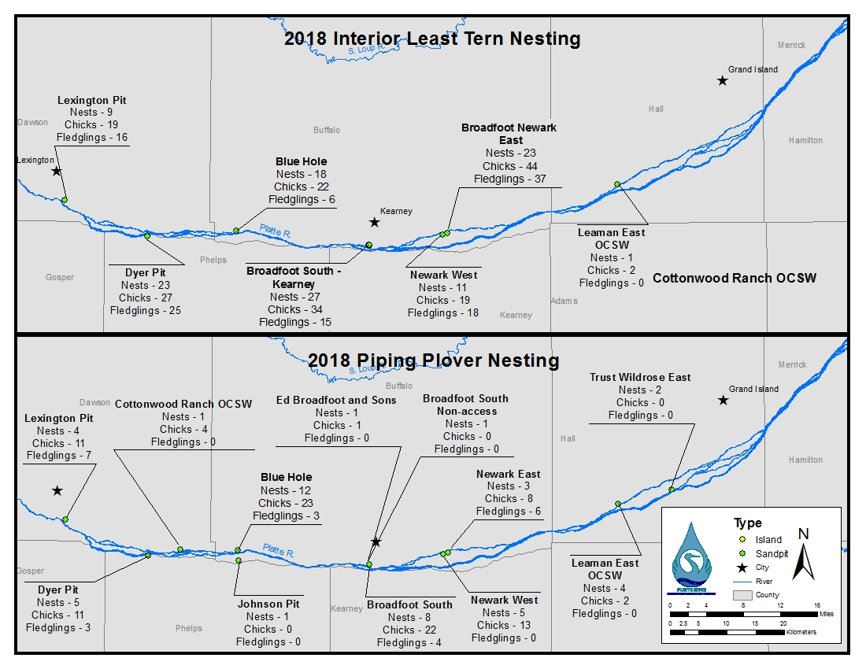
Figure 8. Distribution and numbers of least tern and piping plover nests, chicks, and fledglings observed within Program associated habitats during 2018 surveys of sandpits and naturally occurring river islands. Least tern nests and chicks were observed and monitored at 7 of the 15 sandpits and piping plover nests and chicks were observed and monitored at 12 of the 15 sandpits monitored during 2018.

Table 5. Summary of least tern reproductive success at sandpit and river-island sites on the central Platte River in Nebraska, 2007–2018. Site-specific details on numbers of adults, nest, chicks, and fledglings observed during 2018 are provided in Table 7. Site-specific details of daily, incubation- and brooding-period survival rates for 2018 are provided in Appendices 1-2 and 5-6 (RMark estimates).
 |  |  |  |  |  |  |  |  | Least Tern
 |  | Reproductive Parameter | 2007 |  | 2008 |  | 2009 |  |  | 2010 |  | 2011 |  | 2012 |  | 2013 |  | 2014 |  | 2015 |  |  | 2016 |  |  | 2017 |  |  | 2018
Maximum Adults Observed |  |  |  | 132 |  | 80 |  | 97 |  |  | 123 |  | 125 |  | 116 |  | 136 |  | 166 |  | 224 |  |  | 157 |  |  | 118 |  |  | 174
Breeding Pairs |  |  |  | 39 |  | 37 |  | 42 |  |  | 53 |  | 60 |  | 64 |  | 58 |  | 98 |  | 141 |  |  | 88 |  |  | 77 |  |  | 88
Total Nests Observed |  |  |  | 53 |  | 64 |  | 60 |  |  | 76 |  | 90 |  | 88 |  | 95 |  | 145 |  | 188 |  |  | 119 |  |  | 118 |  |  | 113
Successful Nests (≥1 egg hatched) |  |  |  | 22 |  | 27 |  | 37 |  |  | 43 |  | 52 |  | 63 |  | 51 |  | 80 |  | 116 |  |  | 74 |  |  | 63 |  |  | 79
Apparent Nest Success |  |  |  | 0.42 |  | 0.42 |  | 0.62 |  |  | 0.57 |  | 0.58 |  | 0.72 |  | 0.54 |  | 0.55 |  | 0.62 |  |  | 0.62 |  |  | 0.53 |  |  | 0.67
Daily Nest Survival Rate (All sites) |  |  |  | 0.97 |  | 0.98 |  | 0.99 |  |  | 0.98 |  | 0.97 |  | 0.99 |  | 0.97 |  | 0.97 |  | 0.98 |  |  | 0.98 |  |  | 0.98 |  |  | 0.98
Incubation-period Survival Rate (All sites) |  |  |  | 0.55 |  | 0.61 |  | 0.73 |  |  | 0.64 |  | 0.58 |  | 0.76 |  | 0.56 |  | 0.52 |  | 0.63 |  |  | 0.71 |  |  | 0.61 |  |  | 0.65
Chicks Observed (<15D) |  |  |  | 50 |  | 54 |  | 71 |  |  | 105 |  | 124 |  | 144 |  | 118 |  | 180 |  | 258 |  |  | 170 |  |  | 129 |  |  | 167
Hatch Ratio (<15D Chicks/Total Nests) |  |  |  | 0.94 |  | 0.84 |  | 1.18 |  |  | 1.38 |  | 1.38 |  | 1.64 |  | 1.24 |  | 1.24 |  | 1.37 |  |  | 1.43 |  |  | 1.09 |  |  | 1.48
Hatch Ratio (<15D Chicks/Breeding Pair) |  |  |  | 1.28 |  | 1.46 |  | 1.69 |  |  | 1.98 |  | 2.07 |  | 2.25 |  | 2.03 |  | 1.84 |  | 1.83 |  |  | 1.93 |  |  | 1.68 |  |  | 1.90
Chicks (≥15D) |  |  |  | 40 |  | 44 |  | 48 |  |  | 67 |  | 98 |  | 95 |  | 70 |  | 104 |  | 158 |  |  | 91 |  |  | 78 |  |  | 104
Fledglings (21D) |  |  |  | ----^{A} |  | ----- |  | ---- |  |  | 64 |  | 89 |  | 84 |  | 64 |  | 91 |  | 146 |  |  | 80 |  |  | 76 |  |  | 117
Historic Fledge Ratio (≥15D Chicks/Total Nests) |  |  |  | 0.75 |  | 0.69 |  | 0.80 |  |  | 0.88 |  | 1.09 |  | 1.08 |  | 0.74 |  | 0.72 |  | 0.84 |  |  | 0.76 |  |  | 0.66 |  |  | 0.92
Fledge ratio (21D Chicks/Nest) |  |  |  | ----- |  | ----- |  | ---- |  |  | 0.84 |  | 0.99 |  | 0.95 |  | 0.67 |  | 0.63 |  | 0.78 |  |  | 0.67 |  |  | 0.64 |  |  | 1.04
Historic Fledge Ratio (15D Chicks/Breeding Pair) |  |  |  | 1.03 |  | 1.19 |  | 1.14 |  |  | 1.26 |  | 1.63 |  | 1.48 |  | 1.21 |  | 1.06 |  | 1.12 |  |  | 1.03 |  |  | 1.01 |  |  | 1.18
Fledge Ratio (21D Chicks/Breeding Pair) |  |  |  | ----- |  | ----- |  | ---- |  |  | 1.21 |  | 1.48 |  | 1.31 |  | 1.10 |  | 0.93 |  | 1.04 |  |  | 0.91 |  |  | 0.99 |  |  | 1.33
Daily Brood Survival Rate (All sites) |  |  |  | ----- |  | 0.98 |  | 0.98 |  |  | 0.98 |  | 0.99 |  | 0.99 |  | 0.97 |  | 0.98 |  | 0.98 |  |  | 0.98 |  |  | 0.97 |  |  | 0.98
Brooding-period Survival Rate (All sites) ^{B} |  |  |  | ----- |  | 0.75 |  | 0.79 |  |  | 0.72 |  | 0.89 |  | 0.81 |  | 0.59 |  | 0.69 |  | 0.68 |  |  | 0.61 |  |  | 0.56 |  |  | 0.69
^{A} “-----” indicates these data were not reported.
^{B} Brood survival rates reported in the table are not comparable because estimates are reported as survival for a 15-day interval for least tern chicks during 2007–2009 and in 2010 the Program began to use 21 days as the fledge age for least tern chicks.

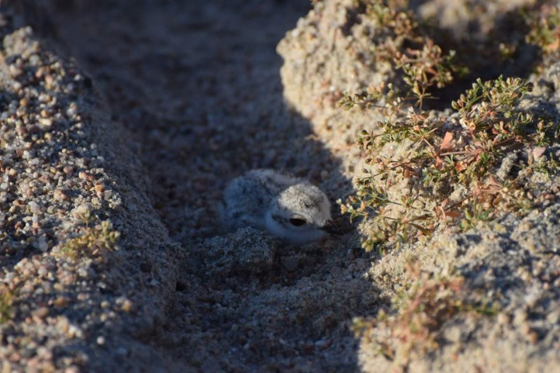
Piping Plovers: Piping plover nests were observed at 12 of 15 sandpits monitored during 2018 (Table 7; Figure 8). The first observation of a piping plover nest was made on 7 May, 2018 and the last nest was first observed on 6 July, 2018. The first observation of a piping plover chick occurred on 7 June, 2018 and the last successful nest observed hatched on 4 August, 2018. At least one egg from 74% (35/47) of piping plover nests hatched, which resulted in 95 chicks and an overall nest-success rate of 2.02 chicks/nest or 2.57 chicks/breeding pair (95 chicks/37 breeding pairs) during 2018 (Table 6). Piping plover daily nest survival rate across all sites during 2018 was 0.9863 (range = 0.6000–1.0000; Appendix 3) with at least one significant difference observed between sites [χ²_{(6, N=47)} = 27.395; p< 0.001]; average incubation-period survival rate was 0.6786 (range = 0.0000–1.0000). We first observed a piping plover fledgling on 5 July, 2018 and the last known piping plover chick to fledge did so on 24 August, 2018. We observed an apparent nest-based fledging rate of 0.49 (23 fledglings/47 nests) and a pair-based fledging rate of 0.62 (23 fledglings/37 breeding pairs) at all sites monitored during 2018 (Table 6). Average daily survival rates for piping plover broods across all sites during 2018 was 0.9566 (range = 0.0000–0.9858; Appendix 4) with at least one significant difference observed between sites [χ²_{(7, N=35)} = 32.306; p< 0.001]; average brooding-period survival rate across all sites was 0.2884 (range = 0.0000–0.6702).
Piping plover chick
We tested for an effect of ownership (i.e., Program or other) on nest and brood survival rates during 2018. Piping plover incubation period survival rates were higher at Program owned and/or managed nesting areas than at non-Program sites. The rates were 0.8776 and 0.3229, with a significant difference observed between them [χ²_{(1, N=47)} = 11.358; p< 0.001]; Piping plover brooding period survival rates were similar at Program sites compared to non-Program owned and/or managed nesting areas; though slightly higher at Program sites, 0.3132 and 0.2201 respectively, this difference was not significant at α=0.05 level [χ²_{(1, N=35)} = 0.288; p = 0.5914; Appendix 8].

Table 6. Summary of piping plover reproductive success at sandpit sites along the central Platte River in Nebraska, 2007–2018. Site-specific details on numbers of adults, nest, chicks, and fledglings observed during 2018 are provided in Table 7. Site-specific details of daily, incubation- and brooding-period survival rates for 2018 are provided in Appendices 3-4 and 7-8 (RMark estimates).
Reproductive Parameter | Piping Plover
 | 2007 | 2008 | 2009 | 2010 | 2011 | 2012 | 2013 | 2014 | 2015 | 2016 | 2017 | 2018
Maximum Adults Observed | 52 | 23 | 31 | 46 | 55 | 60 | 68 | 69 | 74 | 64 | 65 | 74
Breeding Pairs | 19 | 13 | 12 | 20 | 27 | 30 | 27 | 30 | 39 | 43 | 40 | 37
Total Nests Observed | 27 | 21 | 15 | 33 | 34 | 46 | 31 | 43 | 54 | 60 | 51 | 47
Successful Nests (≥1 egg hatched) | 15 | 8 | 9 | 21 | 27 | 32 | 23 | 34 | 34 | 40 | 30 | 35
Apparent Nest Success | 0.56 | 0.38 | 0.60 | 0.64 | 0.79 | 0.70 | 0.74 | 0.79 | 0.63 | 0.68 | 0.59 | 0.74
Daily Nest Survival Rate (All sites) | 0.99 | 0.98 | 0.99 | 0.98 | 0.99 | 0.99 | 0.99 | 0.99 | 0.98 | 0.99 | 0.98 | 0.99
Incubation-period Survival Rate (All sites) | 0.71 | 0.58 | 0.67 | 0.54 | 0.77 | 0.69 | 0.73 | 0.77 | 0.64 | 0.69 | 0.61 | 0.68
Chicks Observed (<15D) | 44 | 26 | 27 | 76 | 87 | 99 | 80 | 116 | 119 | 120 | 92 | 95
Hatch Ratio (<15D Chicks/Nest) | 1.63 | 1.24 | 1.80 | 2.30 | 2.56 | 2.15 | 2.58 | 2.70 | 2.2 | 2.00 | 1.80 | 2.02
Hatch Ratio (<15D Chicks/Breeding Pair) | 2.32 | 1.24 | 2.25 | 3.80 | 3.22 | 3.30 | 2.96 | 3.87 | 3.05 | 2.79 | 2.30 | 2.57
Chicks (≥15D) | 27 | 10 | 18 | 53 | 61 | 68 | 43 | 67 | 73 | 70 | 53 | 32
Fledglings (28D) | -----^{A} | ----- | ----- | 42 | 45 | 59 | 28 | 55 | 52 | 55 | 47 | 23
Historic Fledge Ratio (≥15D Chicks/Nest) | 1.00 | 0.48 | 1.20 | 1.61 | 1.79 | 1.48 | 1.39 | 1.56 | 1.35 | 1.17 | 1.04 | 0.68
Fledge ratio (28D Chicks/Nest) | ----- | ----- | ----- | 1.27 | 1.32 | 1.28 | 0.90 | 1.28 | 0.96 | 0.92 | 0.92 | 0.49
Historic Fledge Ratio (≥15D Chicks/Breeding Pair) | 1.42 | 0.77 | 1.50 | 2.65 | 2.26 | 2.27 | 1.59 | 2.23 | 1.87 | 1.63 | 1.33 | 0.86
Fledge Ratio (28D Chicks/Breeding Pair) | ----- | ----- | ----- | 2.01 | 1.67 | 1.97 | 1.04 | 1.83 | 1.33 | 1.28 | 1.18 | 0.62
Daily Brood Survival Rate (All sites) | ----- | 0.94 | 0.98 | 0.99 | 0.99 | 0.99 | 0.98 | 0.99 | 0.99 | 0.98 | 0.98 | 0.96
Brooding-period Survival Rate (All sites) ^{B} | ----- | 0.42 | 0.79 | 0.70 | 0.73 | 0.78 | 0.62 | 0.69 | 0.68 | 0.55 | 0.63 | 0.29
^{A} “-----” indicates these data were not reported.
^{B} Brood survival rates reported in the table are not comparable because estimates are reported as survival for a 15-day interval for piping plover chicks during 2007–2009 and in 2010 the Program began to use 28 days as the fledge age for piping plover chicks.

Table 7. Site-specific numbers of adults, nests, chicks, and fledglings observed while monitoring sandpits for least tern and piping plover reproduction during 2018. Chick and fledgling counts represent numbers documented as being produced from each site. See the Management Section of this report for a detailed description of management actions taken at each site. Site numbers correspond with Figure 3.
 |  |  |  |  | Least tern |  |  |  |  |  |  |  |  | Piping plover
Site #/Name | Habitat Type ^{A} | Management ^{A} | Surveys | Survey Time (hr.) | Breeding Pairs ^{B} | Bre. Pair (Max) ^{B} | Adults (Max) ^{B} | Nests | Nests Hatched | Chicks 0-14 Days | Chicks 15-21 D. | Fledglings | Breeding Pairs ^{B} |  | Bre. Pair (Max) ^{B} | Adults (Max) ^{B} | Nests | Nests Hatched | Chicks 0-14 Days | Chicks 15-28 D. | Fledglings
1 Lexington Pit | SP | PFT | 33 | 43 | 9 | 9 | 20 | 9 | 8 | 19 | 5 | 16 | 2 |  | 4 | 8 | 4 | 4 | 11 | 3 | 7
2 Dyer Pit | SP | PFTGS | 35 | 34 | 14 | 17 | 22 | 23 | 12 | 27 | 26 | 25 | 5 |  | 5 | 12 | 5 | 4 | 11 | 4 | 3
3 Cottonwood Ranch OCSW | OC | PFTH | 20 | 9 | 0 | 0 | 0 | 0 | 0 | 0 | 0 | 0 | 1 |  | 1 | 2 | 1 | 1 | 4 | 0 | 0
4 Blue Hole | SP | PFT | 37 | 56 | 12 | 16 | 34 | 18 | 10 | 22 | 4 | 6 | 8 |  | 8 | 14 | 12 | 7 | 23 | 5 | 3
5 Johnson Pit | SP | PFT | 16 | 12 | 0 | 0 | 12 | 0 | 0 | 0 | 0 | 0 | 1 |  | 1 | 1 | 1 | 0 | 0 | 0 | 0
6 Ed Broadfoot and Sons^{C} | SP | PFTH | 24 | 4 | 0 | 0 | 2 | 0 | 0 | 0 | 0 | 0 | 1 |  | 1 | 3 | 1 | 1 | 1 | 0 | 0
7 Broadfoot South | SP | PFTHS | 38 | 50 | 19 | 21 | 35 | 27 | 18 | 34 | 16 | 15 | 6 |  | 7 | 11 | 8 | 8 | 22 | 14 | 4
8 Broadfoot South - Non-Access Islands^{C} | SP | FT | 32 | 12 | 0 | 0 | 3 | 0 | 0 | 0 | 0 | 0 | 1 |  | 1 | 2 | 1 | 0 | 0 | 0 | 0
9 Newark West | SP | PFTHS | 30 | 32 | 10 | 11 | 18 | 11 | 10 | 19 | 16 | 18 | 4 |  | 4 | 8 | 5 | 4 | 13 | 0 | 0
10 Newark East | SP | PFTH | 30 | 37 | 23 | 23 | 25 | 24 | 20 | 44 | 37 | 37 | 2 |  | 3 | 5 | 3 | 3 | 8 | 6 | 6
11 Leaman East OCSW | OC | PFTHS | 27 | 15 | 1 | 1 | 3 | 1 | 1 | 2 | 0 | 0 | 2 |  | 2 | 4 | 4 | 3 | 2 | 0 | 0
12 Trust Wild Rose East | SP | N | 11 | 7 | 0 | 0 | 0 | 0 | 0 | 0 | 0 | 0 | 20 |  | 2 | 4 | 2 | 0 | 0 | 0 | 0
13 Follmer-Alda Pit | SP | PFH | 7 | 3 | 0 | 0 | 0 | 0 | 0 | 0 | 0 | 0 | 0 |  | 0 | 0 | 0 | 0 | 0 | 0 | 0
14 Deweese – Alda Pit | SP | N | 7 | 3 | 0 | 0 | 0 | 0 | 0 | 0 | 0 | 0 | 0 |  | 0 | 0 | 0 | 0 | 0 | 0 | 0
15 Hooker Brothers – GI South East Pit | SP | N | 7 | 4 | 0 | 0 | 0 | 0 | 0 | 0 | 0 | 0 | 0 |  | 0 | 0 | 0 | 0 | 0 | 0 | 0
^{A} Habitat types include sandpits (SP), off-channel sand and water (OC), or river islands (RI). Management actions applied to each site following the 2017 nesting season and prior to the 2018 nesting season could include: mowed (M), burned (B), disked (D), graded (G), tree/vegetation removal (R), or contact herbicide (H) during fall 2017; pre-emergent herbicide (P), predator fencing (F), predator trapping (T), or Nest Furniture Distribution (S) during spring 2018; active sand/gravel mining within primary nesting peninsula (A), no management (N); unknown (U); or construction (C) which include monitored sites that were considered non-habitat prior to June 15 due to construction activities.
^{B} Breeding pair counts were determined on 26 June for least terns and 8 June for piping plovers when numbers observed within the Program Associated Habitat area first peaked. Breeding pair counts, however, do not necessarily represent maximum numbers of least tern or piping plover breeding pairs observed at any site throughout the year as some adults are known to have re-nested at different sites after losing their first nest or brood. Bre. Pairs (Max) represents the maximum number of pairs at a site during the nesting season, regardless of Breeding Pair peak dates. Adults (Max) represent the maximum number adults observed during any single survey at the site.
^{C} Includes 1 piping nest that was outside the managed nesting areas and thus not surrounded by electrified fence and water. The nest was determined to be failed.

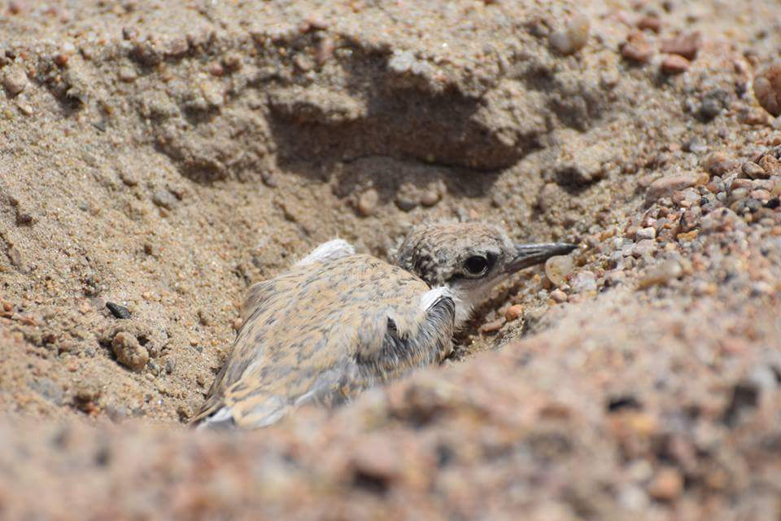
Breeding Pair Counts: We estimated numbers of least tern and piping plover breeding pairs by adding the number of active and recently (within five days) failed nests to the number of active and recently failed least tern and piping plover broods and recently fledged least terns and fledged piping plovers observed on each Least tern breeding pair counts peaked at 88 pairs on 26 June, 2018. Piping plover breeding pair counts peaked at 37 pairs 8 June, 2018. Similar to nest and adult counts, least tern breeding pair counts have increased steadily since 2001 (Figure 9). Piping plover breeding pair counts increased slightly from 2001−2007, declined during 2008 and 2009, and have since increased (Figure 10). We observed an increase in least tern and slight decrease in piping plover breeding pairs in 2018; however, counts are still much higher than counts observed during the years prior to the Program implementation. Though nesting has occurred on riverine sandbars, off-channel sandpits have provided the most consistent nesting habitat for both species to date.
Least Tern Chick Close to Fledge Age

Figure 9. Comparison of cumulative numbers of least tern nests, Program-defined breeding pairs, maximum nest and brood quantities, and the mid-June nest and brood quantities observed within the Program Associated Habitat Area, 2001-2018.

Figure 10. Comparison of numbers of piping plover cumulative nests, Program defined breeding pairs, maximum nest and brood quantities, and the mid-June nest and brood quantities observed within the Program Associated Habitat Area, 2001−2018.

Species Response to Habitat Creation and Maintenance
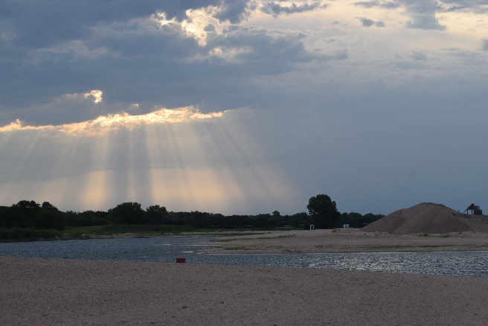
The total number of breeding pairs has increased for both species during the First Increment of the Program (Table 8). In 2018, a total of 88 least tern and 37 piping plover breeding pairs were observed in the AHR (Figure 11). Most of the nesting in the AHR during the First Increment of the Program has occurred on managed off-channel habitats (Figures 12 and 13). The limited amount of on-channel nesting observed at the beginning of the First Increment declined as on-channel habitat was lost during several high flow events (Table 1). Off-channel habitat accounts for most of the nesting in the AHR and the number of breeding pairs has generally increased over the course of the First Increment as the Program has constructed additional off-channel habitats (Tables 1 and 10). Overall, the Program has observed a species response to off-channel habitat construction (Figure 14), while the species response to on-channel habitat construction is still undetermined.
Sun breaking through on an active mine site habitat

Table 8. Least tern and piping plover on- and off-channel nesting incidence by year, 2007−2018.
Year | Least Tern |  |  |  |  | Piping Plover
 | Br.* Pairs | Nests | Succ. Nests | Fledglings | Fledglings Per Pair | Br. Pairs | Nests | Succ. Nests | Fledglings | Fledglings Per Pair
2007 | 42 | 53 | 22 | 40 | 0.95 | 21 | 27 | 15 | 25 | 1.19
2008 | 39 | 64 | 27 | 44 | 1.13 | 14 | 21 | 8 | 10 | 0.71
2009 | 43 | 60 | 36 | 46 | 1.07 | 12 | 15 | 9 | 12 | 1
2010 | 51 | 80 | 44 | 64 | 1.25 | 22 | 33 | 22 | 46 | 2.09
2011 | 62 | 90 | 53 | 89 | 1.44 | 28 | 34 | 27 | 45 | 1.61
2012 | 66 | 88 | 63 | 84 | 1.27 | 30 | 46 | 32 | 59 | 1.97
2013 | 63 | 95 | 51 | 64 | 1.02 | 27 | 31 | 23 | 28 | 1.04
2014 | 98 | 145 | 54 | 91 | 0.93 | 30 | 43 | 25 | 59 | 1.97
2015 | 141 | 188 | 116 | 146 | 1.04 | 39 | 54 | 34 | 52 | 1.33
2016 | 88 | 119 | 74 | 80 | 0.91 | 43 | 60 | 40 | 55 | 1.28
2017 | 77 | 118 | 63 | 76 | 0.99 | 40 | 51 | 30 | 47 | 1.18
2018 | 88 | 113 | 79 | 117 | 1.33 | 37 | 47 | 35 | 23 | 0.62
Mean | 71.5 | 101.08 | 56.83 | 78.42 | 1.11 | 28.58 | 38.5 | 25 | 38.42 | 1.33
*Breeding pairs within table 8 represent numbers of breeding pairs present on in-channel islands and off-channel sites the day breeding pairs within the system were maximized; therefore, nests and fledglings per breeding pair are occasionally disproportionately large.

Table 9. Least tern and piping plover on-channel nesting incidence and productivity by year, 2007−2018.
Year | Least Tern |  |  |  |  | Piping Plover
 | *Br. Pairs | Nests | Succ. Nests | Fledglings | Fledglings Per Pair | *Br. Pairs | Nests | Succ. Nests | Fledglings | Fledglings Per Pair
2007 | 11 | 13 | 2 | 2 | 0.18 | 1 | 4 | 2 | 7 | 7
2008 | 10 | 20 | 7 | 9 | 0.9 | 3 | 5 | 1 | 3 | 1
2009 | 3 | 8 | 5 | 4 | 1.33 | 2 | 2 | 1 | 1 | 0.5
2010 | 0 | 0 | 0 | 0 | 0 | 4 | 11 | 4 | 10 | 2.5
2011 | 0 | 0 | 0 | 0 | 0 | 0 | 0 | 0 | 0 | 0
2012 | 0 | 0 | 0 | 0 | 0 | 1 | 1 | 1 | 4 | 4
2013 | 0 | 0 | 0 | 0 | 0 | 0 | 0 | 0 | 0 | 0
2014 | 0 | 2 | 0 | 0 | 0 | 1 | 2 | 1 | 4 | 4
2015 | 8 | 14 | 3 | 0 | 0 | 5 | 7 | 1 | 1 | 0.2
2016 | 2 | 2 | 0 | 0 | 0 | 2 | 2 | 1 | 1 | 0.5
2017 | 0 | 0 | 0 | 0 | 0 | 0 | 0 | 0 | 0 | 0
2018 | 0 | 0 | 0 | 0 | 0 | 0 | 0 | 0 | 0 | 0
Mean | 2.83 | 4.92 | 1.42 | 1.25 | 0.20 | 1.58 | 2.83 | 1 | 2.58 | 1.64
*Breeding pairs within table 9 represent numbers of breeding pairs present on in-channel islands the day breeding pairs within the system were maximized; therefore, nests and fledglings per breeding pair are occasionally disproportionately large.

Table 10. Least tern and piping plover off-channel nesting incidence and productivity by year, 2007−2018.
Year | Least Tern |  |  |  |  | Piping Plover
 | *Br. Pairs | Nests | Succ. Nests | Fledglings | Fledglings Per Pair | *Br. Pairs | Nests | Succ. Nests | Fledglings | Fledglings Per Pair
2007 | 31 | 40 | 20 | 38 | 1.23 | 20 | 23 | 13 | 18 | 0.90
2008 | 29 | 44 | 20 | 35 | 1.21 | 11 | 16 | 7 | 7 | 0.64
2009 | 40 | 52 | 31 | 42 | 1.05 | 10 | 13 | 8 | 11 | 1.10
2010 | 51 | 80 | 44 | 64 | 1.25 | 18 | 22 | 18 | 36 | 2.00
2011 | 62 | 90 | 53 | 89 | 1.44 | 28 | 34 | 27 | 45 | 1.61
2012 | 66 | 88 | 63 | 84 | 1.27 | 29 | 45 | 31 | 55 | 1.90
2013 | 63 | 95 | 51 | 64 | 1.02 | 27 | 31 | 23 | 28 | 1.04
2014 | 98 | 143 | 54 | 91 | 0.93 | 29 | 41 | 24 | 55 | 1.90
2015 | 133 | 174 | 113 | 146 | 1.09 | 34 | 47 | 33 | 51 | 1.50
2016 | 86 | 117 | 74 | 80 | 0.93 | 42 | 58 | 39 | 54 | 1.29
2017 | 77 | 118 | 63 | 76 | 0.99 | 40 | 51 | 30 | 47 | 1.18
2018 | 88 | 113 | 79 | 117 | 1.33 | 37 | 47 | 35 | 23 | 0.62
Mean | 68.67 | 96.17 | 55.42 | 77.17 | 1.15 | 27.08 | 35.67 | 24 | 35.83 | 1.31
*Breeding pairs within table 10 represent numbers of breeding pairs present on off-channel nesting sites the day breeding pairs within the system were maximized. See Table 8 for maximum off-channel breeding pairs by site.

Figure 11. Comparison of total least tern (blue bars) and piping plover (red bars) nests within the Program Associated Habitat Area, 2001-2018.

Figure 12. Comparison of least tern off-channel (blue bars) and on-channel (red bars) nests within the Program Associated Habitat Area, 2001-2018.

Figure 13. Comparison of piping plover off-channel (blue bars) and on-channel (red bars) nests within the Program Associated Habitat Area, 2001-2018.

Figure 14. Comparison of numbers of least tern (dotted line) and piping plover (dashed line) breeding pairs and availability of off-channel habitat (solid line) within the Program Associated Habitat Area, 2001-2018.
RESEARCH
In addition to implementation of the Program’s surveillance monitoring protocol, conservation monitoring and directed research will be conducted during the course of the Program’s First Increment to provide data to evaluate the Program’s management objectives and priority hypotheses. Design and implementation of research activities will be guided by the ED Office and the TAC, will be reviewed by the Program’s Independent Scientific Advisory Committee (ISAC) and ultimately approved by the Program’s Governance Committee (GC).
FORAGING HABITS STUDY
The first directed research project related to least terns and piping plovers on the central Platte River began in 2009 with the implementation of the Foraging Habits Study. A contract to conduct this study over two field seasons (2009−2010) was awarded to the USGS-NPWRC. The research was jointly funded by the Program and the USGS-NPWRC. Final results of the Foraging Habits Study can be found in the Program Library at the following link:
https://www.platteriverprogram.org/PubsAndData/ProgramLibrary/Forms/DispForm.aspx?ID=158
HABITAT COLONIZATION STUDY
In 2011, the Program and the USGS entered into an agreement for the USGS to conduct a study to evaluate Habitat Colonization and Productivity of Least Terns and Piping Plovers Nesting on Central Platte River sandpits and sandbars. This study was designed to address three specific objectives contributed to the understanding of habitat use by least terns and piping plovers:
- Dispersal
Quantify dispersal of adults between units of nesting habitat on the Central Platte River among years.
- Colonization
Quantify colonization rate of newly constructed or managed nesting habitat by local vs. immigrant adults.
- Renesting
Quantify frequency and location of renesting attempts by adults with failed nests.
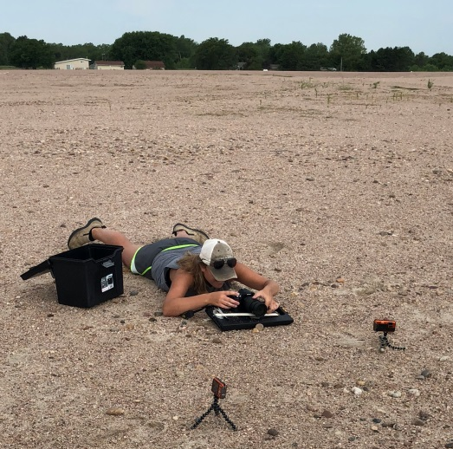
The research was jointly funded by the Program and the USGS-NPWRC. Details about findings of this research can be found in the Final Research Project Report that will be produced after the 2018 nesting season and will include banding and resighting data from continued efforts performed during 2009–2018.

Adult and Chick Band Observations – As part of Program-funded research implemented by USGS field crews, 152 adult and 685 juvenile least terns and 85 adult and 591 juvenile piping plovers were banded along the central Platte River between 2009 and 2016 (Table 11).
Setting up nest cameras for band
re-sighting efforts

Table 11. Numbers of least tern and piping plover adults and chicks banded along the central Platte River, 2009−2016.
Year | Least Tern Adults | Least Tern Chicks | Piping Plover Adults |  | Piping Plover Chicks
2009 | 16 | 35 | 11 | 25
2010 | 7 | 74 | 13 | 64
2011 | 4 | 98 | 2 | 68
2012 | 9 | 103 | 15 | 86
2013 | 32 | 99 | 12 | 64
2014 | 28 | 114 | 11 | 106
2015 | 56 | 162 | 21 | 88
2016 | 39 | 107 | 28 | 90
Total | 152 | 685 | 85 | 591
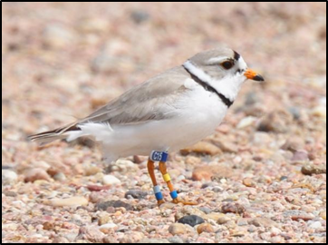
After nine years of band resighting efforts on the central Platte River, we have compiled valuable information regarding site and habitat (sandpit or riverine) fidelity and philopatry, wintering ground locations for central Platte River piping plovers, survival and recruitment, re-nesting events, and disturbance. We have observed several adult least terns and piping plovers return to nest at the site where they were banded (and at other sites). We observed least tern and piping plover fledglings at non-natal sites late in the nesting season on multiple occasions, which may be an indication that fledglings begin selecting nesting habitat for the subsequent year prior to departing for the winter grounds. 2018 band resighting season was a success as a total of 49 (68% of the birds observed) least terns and 15 (41% of the birds observed) piping plover bands were recorded (Table 12 and 13). Of the banded birds observed, 97% least terns and 86% piping plovers were banded within the AHR. A detailed summary of what has been observed and learned from banding efforts will be available in 2019.
Piping Plover that was banded as a chick on the central Platte and returned to nest at Broadfoot South in 2017.

Table 12. Totals for 2018 least tern band resighting efforts with individual totals for each off-channel nesting site.
Interior Least Terns
Sites Monitored | Nests Monitored | Banded Adults | Unbanded Adults | Banded Pairs | Unbanded Pairs | Adult 1 Banded, Adult 2 Unbanded | Adult 1 Banded, Adult 2 Not Observed | Adult 1 Unbanded, Adult 2 Not Observed | Neither Adult Observed
Lexington | 4 | 3 | 2 | 1 | 0 | 1 | 0 | 1 | 1
Dyer | 8 | 9 | 1 | 2 | 0 | 1 | 4 | 0 | 1
Cottonwood Ranch OCSW | 0 | 0 | 0 | 0 | 0 | 0 | 0 | 0 | 0
Blue Hole | 14 | 11 | 8 | 3 | 2 | 0 | 5 | 4 | 0
Johnson | 0 | 0 | 0 | 0 | 0 | 0 | 0 | 0 | 0
Broadfoot South | 7 | 6 | 3 | 1 | 0 | 2 | 3 | 1 | 2
Newark West | 9 | 9 | 2 | 2 | 0 | 0 | 5 | 2 | 0
Newark East | 15 | 9 | 8 | 0 | 1 | 2 | 7 | 4 | 1
Leaman OCSW | 1 | 2 | 0 | 1 | 0 | 0 | 0 | 0 | 0
Trust Wild Rose - East | 0 | 0 | 0 | 0 | 0 | 0 | 0 | 0 | 0
Total | 57 | 49 | 23 | 10 | 3 | 6 | 24 | 12 | 5
Table 13. Totals for 2018 piping plover band resighting efforts with individual totals for each off-channel nesting site.
Piping Plover
 | Sites Monitored | Nests Monitored | Banded Adults | Unbanded Adults | Banded Pairs | Unbanded Pairs | Adult 1 Banded, Adult 2 Unbanded | Adult 1 Banded, Adult 2 Not Observed | Adult 1 Unbanded, Adult 2 Not Observed | Neither Adult Observed
 | Lexington | 3 | 1 | 2 | 0 | 0 | 0 | 1 | 2 | 0
 | Dyer | 5 | 2 | 2 | 0 | 0 | 0 | 2 | 2 | 1
 | Cottonwood Ranch OCSW | 1 | 0 | 0 | 0 | 0 | 0 | 0 | 0 | 0
 | Blue Hole | 5 | 3 | 5 | 0 | 1 | 3 | 0 | 1 | 0
 | Johnson | 0 | 0 | 0 | 0 | 0 | 0 | 0 | 0 | 0
 | Broadfoot South | 6 | 2 | 9 | 1 | 3 | 0 | 0 | 2 | 0
 | Newark West | 4 | 3 | 1 | 1 | 0 | 3 | 0 | 0 | 1
 | Newark East | 1 | 0 | 1 | 0 | 0 | 0 | 0 | 1 | 0
 | Leaman OCSW | 4 | 4 | 2 | 0 | 0 | 2 | 2 | 0 | 0
 | Trust Wild Rose - East | 0 | 0 | 0 | 0 | 0 | 0 | 0 | 0 | 0
 | Total | 29 | 15 | 22 | 2 | 4 | 8 | 5 | 8 | 2

NEST DATA
Over the past eleven years we have collected habitat measures believed to influence nest placement and productivity. We used a GIS and LiDAR to determine elevation of each nest above the waterline and to determine distances to predator perch and nearest waterline for all nests. Summaries of the habitat metrics found to influence nest-site selection by least terns and piping plovers are presented in Tables 12 & 13.
Table 12. Average off-channel least tern nest elevations above water, distances to edge of water, and distances to predator perch by site during 2018. These covariates were found to influence nest site selection by least terns on off-channel sites along the central Platte River (Baasch et al. 2017).
Interior Least Terns
Site Name | Average Elevation Above Water (in) | Average Distance to Edge of Water (yds) | Average Distance to Predator Perch (yds)
Lexington Sandpit | 171.4 | 45 | 153
Dyer Sandpit | 112.8 | 50 | 314
Blue Hole | 91.7 | 36 | 201
Broadfoot - Kearney South | 95.7 | 28 | 279
Newark West | 138.3 | 34 | 194
Newark East | 84.5 | 37 | 219
Leaman East OCSW | 87.4 | 52 | 271
Table 13. Average off-channel piping plover nest elevations above water, distances to edge of water, and distances to predator perch by site during 2018. These covariates were found to influence nest site selection by piping plovers on off-channel sites along the central Platte River (Baasch et al. 2017).
Piping Plover
Site Name | Average Elevation Above Water (in) | Average Distance to Edge of Water (yds) | Average Distance to Predator Perch (yds)
Lexington Sandpit | 142.2 | 37 | 127
Dyer Sandpit | 123.7 | 36 | 293
Cottonwood Ranch Sandpit | 83.4 | 63 | 213
Blue Hole | 41.1 | 32 | 165
Johnson Sandpit | 328.0 | 16 | 312
Ed Broadfoot and Sons | 114.2 | 35 | 132
Broadfoot - Kearney South | 94.0 | 31 | 288
Broadfoot South - Non-Access Islands | 91.2 | 15 | 244
Newark West | 133.0 | 34 | 200
Newark East | 90.2 | 23 | 199
Leaman East OCSW | 83.0 | 51 | 251
Trust Wildrose East | 61.9 | 22 | 202

HABITAT SELECTION STUDY
The EDO used resource selection functions and 15 years of data to assess the influence physical site attributes and inter- and intra-specific interactions have on nest site selection by least terns and piping plovers on off-channel nesting sites (Baasch et al. 2017). We found nest site selection by least terns and piping plovers was influenced by factors the Program can manage such as distance to predator perch and elevation above waterline as well as factors that cannot be managed. The relative probability of use for both species was maximized when distance to the nearest predator perch was ≥150 m and elevation above the waterline was ≥3 m. Probability of use for nesting by least terns increased as distance to water increased whereas the probability of use by piping plovers was maximized when distance to water was ~50 m. In addition, we found piping plovers avoided nesting near each other, whereas colonial least terns selected nest sites near those of conspecifics. Our results suggest that important features of constructed, off-channel nesting sites for both species should include no potential predator perches within 150 m of nesting habitat and nesting areas at least 3 m above the waterline. Efficient site designs for least terns would be circular, maximizing the area of nesting habitat away from the shoreline whereas an effective site design for piping plovers would be more linear, maximizing the area of nesting habitat near the waterline. An efficient site design for both species would be lobate, incorporating centralized nesting habitat for least terns and increased access to foraging areas for nesting and brood-rearing piping plovers.
OFF-CHANNEL NEST AND BROOD SURVIVAL
The Program and its partners have invested substantial resources in creating and managing off-channel nesting habitat for least terns and piping plovers along the central Platte River. Among other things, management activities implemented at nesting sites to increase nest and brood survival included tree removal, predator trapping, construction of a water barrier surrounding the nesting area and installation of predator fences. We used 15 years of data at off-channel sites along the central Platte River to assess the influence of several biotic and abiotic factors on the survival of least tern and piping plover nests and broods (Farrell et al. 2018). We found productivity of least terns and piping plovers was reduced during both the nesting and brood rearing stage by climactic factors rather than factors the Program can manage. As such, we conclude habitat management activities implemented at off-channel sites to date are sufficient for maintaining high levels of productivity for least terns and piping plovers along the central Platte River.
INSIDE VERSUS OUTSIDE MONITORING
The Program implemented four years of season-long monitoring from within (inside) and outside the nesting colonies at off-channel least tern and piping plover nesting sites along the central Platte River to compare these monitoring techniques and their influence on productivity estimates. We found inside monitoring efforts resulted in more nests and early-development chicks being detected so excluding these from nest and chick survival analyses would result in estimates of nest and chick survival rates that are higher for outside monitoring crews. However, more chicks ≥15 days old were observed by outside monitoring crews. While fledgling counts between methods were similar for piping plovers, more least tern fledglings were observed from outside the nesting colony which, when combined with lower breeding pair counts, would result in higher productivity measures such as fledge ratios. The most appropriate method of survey appears to depend on the objectives of the study and availability of resources. If resources are limited, monitoring from outside the colony can result in reasonable estimates of abundance and productivity measures, provided a majority of the nesting area can be observed from outside the nesting colony and an appropriate estimate of the proportion of nests and breeding pairs that are not observed is available.
PREDATOR CAMERA STUDIES
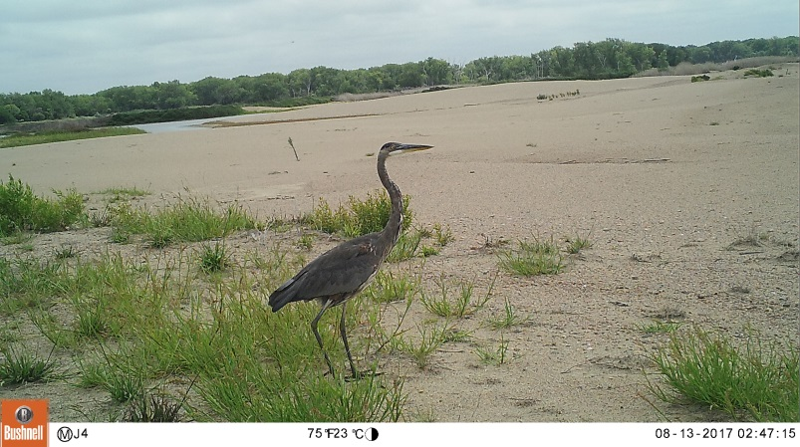
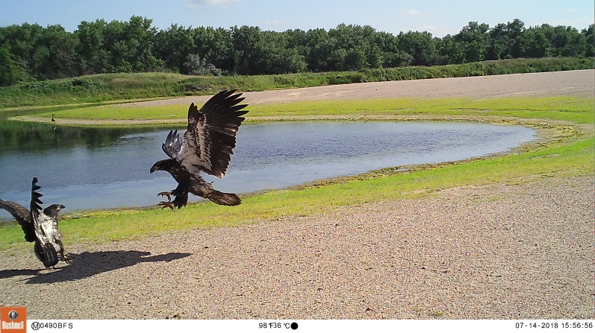
2018 was the second year that predator identification research was conducted at off-channel nesting sites. Prevention of predation by terrestrial predators is an important objective for increasing productivity of least terns and piping plovers. As such, permanent electrified fences are in place on the entrance of each off-channel nesting site. Non-electrified panel wings are positioned on the ends of the permanent fence and extend 2–3 meters into the water. However, predation is still a factor for reducing productivity at off-channel nesting sites. Predation events and predator species type are truly unknown factors because it is difficult to determine those specifics when the event was not seen firsthand. The purpose of the study is to investigate predator presence and possible predation events at off-channel nesting sites and the effectiveness of panel wings. Both of these tasks will be executed using remote cameras. Results from the study will help to identify possible actions that can be implemented to help prevent future predation. Based on 2017 field results, the most common potential predator present at off-channel nesting sites are juvenile bald eagles, followed by the other potential predators (Figure 15). No evidence was found of juvenile bald eagles depredating nests or chicks.
Great Blue Heron
Juvenile Bald Eagles

Figure 15. Number of most common animals present on off-channel nesting sites during 2017.
TRAPPING DATA
2018 marked the 7th year of predator trapping on Program-owned off-channel nesting sites. Though the number of Program-owned off-channel nesting sites has increased during this time, the average number of predators caught at each site decreased in 2018 as compared to the previous year (Figure 16).

Figure 16. Numbers of predators trapped at Program-owned off-channel nesting sites, 2012–2018. Predators trapped include bull snake, raccoon, weasel, opossum, skunk, fox, coyote, and bobcat. Predator trapping efforts at off-channel sites increased substantially in 2017. Trapping did not occur at Broadfoot South during 2012 or at Follmer-Alda during 2012−2014 or 2018.

REFERENCES CITED
Baasch D.M., P.D. Farrell, J.M Farnsworth, and C.S. Smith. 2017. Interior least tern and piping plover nest site selection at managed sandpit sites along the central Platte River, Nebraska, USA. Journal of Field Ornithology DOI: 10.1111/jofo.12206.
Baasch D.M., T.J. Hefley, S.D. Cahis. 2015. A comparison of breeding population estimators using nest and brood monitoring data. Ecology and Evolution. 4197:4209. Available at: http://onlinelibrary.wiley.com/doi/10.1002/ece3.1680/epdf.
Farrell P.D., D.M. Baasch, J.M Farnsworth, and C.S. Smith. 2018. Least tern and piping plover nest success and brood survival at off channel sites in the Central Platte River. Avian Conservation and Ecology 13:1. https://doi.org/10.5751/ACE-01133-130101.
Platte River Recovery Implementation Program. 2017. 2017 Central Platte River Tern and Plover Monitoring and Research Protocol. Available at: https://www.platteriverprogram.org/PubsAndData/ProgramLibrary/PRRIP%202017%20Central%20Platte%20River%20Tern%20and%20Plover%20Monitoring%20and%20Research%20Protocol.pdf.

ACKNOWLEDGEMENTS
Support for monitoring and research activities outlined in this report were provided by the Central Platte Natural Resources District, Nebraska Public Power District, and the Platte River Recovery Implementation Program. We extend a special thanks to non-governmental agencies and private landowners that allowed access to their properties and the many people who assisted in collecting data and provided technical guidance during the past nine years.

We would also like to acknowledge the privately-owned sand and gravel mining companies who allowed us access to their property to monitor and collect data on interior least tern and piping plover activities. These companies included Broadfoot Sand and Gravel Corporation and Hooker Brothers Sand and Gravel.

Appendices

Program RMark Survival Estimates

Appendix 1. Daily and incubation-period survival rates for least tern nests monitored on sandpit sites during 2018. Incubation-period nest survival rate = (daily nest survival rate)²¹.
Site | # Nests | # Nests Lost | Exposure Days | Daily Nest Survival Rate | Daily Nest Survival SE | Daily Brood Survival Rate 95% CI |  | Incubation Period Survival Rate | Incubation Period Survival Rate 95% CI
 |  |  |  |  |  | Lower | Upper |  | Lower | Upper
Lexington | 9 | 1 | 150.5 | 0.9927 | 0.0073 | 0.9500 | 0.9990 | 0.8574 | 0.4205 | 0.9803
Dyer | 23 | 11 | 350.5 | 0.9672 | 0.0097 | 0.9417 | 0.9817 | 0.4963 | 0.3021 | 0.6916
Blue Hole | 18 | 8 | 266.5 | 0.9685 | 0.0109 | 0.9384 | 0.9842 | 0.5111 | 0.2875 | 0.7303
Broadfoot South | 27 | 9 | 408.0 | 0.9769 | 0.0076 | 0.9563 | 0.9880 | 0.6127 | 0.4090 | 0.7833
Newark West | 11 | 1 | 170.0 | 0.9937 | 0.0063 | 0.9567 | 0.9991 | 0.8759 | 0.4654 | 0.9828
Newark East | 23 | 3 | 372.0 | 0.9913 | 0.0050 | 0.9734 | 0.9972 | 0.8326 | 0.5905 | 0.9450
Leaman East OCSW | 1 | 0 | 21.0 | 1.0000 | 0.0000 | 1.0000 | 1.0000 | 1.0000 | 1.0000 | 1.0000
All Sites | 112 | 33 | 1738.5 | 0.9799 | 0.0035 | 0.9719 | 0.9857 | 0.653 | 0.5531 | 0.7410

Appendix 2. Daily and brooding-period survival rates for observed least tern broods (1 or more chicks) monitored on sandpit sites during 2018. Brooding-period brood survival rate = (daily brood survival rate)²¹.
Site | # Broods | # Broods Lost | Exposure Days | Daily Brood Survival Rate | Daily Brood Survival SE | Daily Brood Survival Rate 95% CI |  | Brooding Period Survival Rate | Brooding Period Survival Rate 95% CI
 |  |  |  |  |  | Lower | Upper |  | Lower | Upper
Lexington | 8 | 0 | 136.5 | 1.0000 | 0.0000 | 1.0000 | 1.0000 | 1.0000 | 0.0000 | 1.0000
Dyer | 12 | 0 | 221.0 | 1.0000 | 0.0000 | 1.0000 | 1.0000 | 1.0000 | 0.0000 | 1.0000
Blue Hole | 10 | 7 | 86.0 | 0.9146 | 0.0313 | 0.8301 | 0.9591 | 0.1535 | 0.0333 | 0.4886
Broadfoot South | 18 | 8 | 237.0 | 0.9641 | 0.0125 | 0.9298 | 0.9820 | 0.4640 | 0.2428 | 0.7004
Newark West | 10 | 1 | 153.0 | 0.9930 | 0.0070 | 0.9517 | 0.9990 | 0.8621 | 0.4313 | 0.9810
Newark East | 20 | 2 | 343.5 | 0.9938 | 0.0044 | 0.9756 | 0.9984 | 0.8775 | 0.6203 | 0.9692
Leaman East OCSW | 1 | 1 | 1.5 | 0.5000 | 0.3536 | 0.0589 | 0.9411 | 0.0000 | 0.0000 | 1.0000
All Sites | 79 | 19 | 1178.5 | 0.9827 | 0.0039 | 0.973 | 0.9889 | 0.6931 | 0.5689 | 0.7944

Appendix 3. Daily and incubation-period survival rates for piping plover nests monitored on sandpit sites during 2018. Incubation-period nest survival rate = (daily nest survival rate)²⁸.
Site | # Nests | # Nests Lost | Exposure Days | Daily Nest Survival Rate | Daily Nest Survival SE | Daily Nest Survival Rate 95% CI |  | Incubation Period Survival Rate | Incubation Period Nest Survival Rate 95% CI
 |  |  |  |  |  | Lower | Upper |  | Lower | Upper
Lexington | 4 | 0 | 99.0 | 1.0000 | 0.0000 | 1.0000 | 1.0000 | 1.0000 | 1.0000 | 1.0000
Dyer | 5 | 1 | 114.5 | 0.9909 | 0.0091 | 0.9381 | 0.9987 | 0.7735 | 0.2700 | 0.9692
Cottonwood Ranch OCSW | 1 | 0 | 11.5 | 1.0000 | 0.0000 | 1.0000 | 1.0000 | 1.0000 | 1.0000 | 1.0000
Blue Hole | 12 | 5 | 168.5 | 0.9694 | 0.0135 | 0.9285 | 0.9872 | 0.4187 | 0.1622 | 0.7282
Johnson | 1 | 1 | 23.5 | 0.9578 | 0.0415 | 0.7517 | 0.9942 | 0.2993 | 0.0141 | 0.9272
Ed Broadfoot and Sons | 1 | 0 | 27.5 | 1.0000 | 0.0000 | 1.00001 | 1.0000 | 1.0000 | 1.0000 | 1.0000
Broadfoot South | 8 | 0 | 196.5 | 1.0000 | 0.0000 | 1.00001 | 1.0000 | 1.0000 | 0.0000 | 1.0000
Broadfoot South Non-access | 1 | 1 | 8.0 | 0.8801 | 0.1136 | 0.4708 | 0.9838 | 0.0280 | 0.0000 | 0.9768
Newark West | 5 | 1 | 111.5 | 0.9900 | 0.0099 | 0.9328 | 0.9986 | 0.7558 | 0.2464 | 0.9670
Newark East | 3 | 0 | 65.0 | 1.0000 | 0.0000 | 1.0000 | 1.0000 | 1.0000 | 1.0000 | 1.0000
Leaman East OCSW | 4 | 1 | 87.0 | 0.9881 | 0.0118 | 0.9203 | 0.9983 | 0.7150 | 0.1998 | 0.9618
Trust Wildrose East | 2 | 2 | 4.0 | 0.6000 | 0.2191 | 0.2004 | 0.8998 | 0.0000 | 0.0000 | 0.9968
All Sites | 47 | 12 | 916.5 | 0.9863 | 0.0039 | 0.9759 | 0.9922 | 0.6786 | 0.5162 | 0.8069

Appendix 4. Daily and brooding-period survival rates for observed piping plover broods (1 or more chicks) monitored on sandpit sites during 2018. Brooding-period survival rate = (daily brood survival rate)²⁸.

Site | # Broods | # Broods Lost | Exposure Days | Daily Brood Survival Rate | Daily Brood Survival SE | Daily Brood Survival Rate 95% CI |  | Brooding Period Survival Rate | Brooding Period Survival Rate 95% CI
 |  |  |  |  |  | Lower | Upper |  | Lower | Upper
Lexington | 4 | 1 | 70.5 | 0.9851 | 0.0148 | 0.9016 | 0.9979 | 0.6564 | 0.1475 | 0.9547
Dyer | 4 | 1 | 75.0 | 0.9858 | 0.0141 | 0.9061 | 0.9980 | 0.6702 | 0.1585 | 0.9564
Cottonwood Ranch OCSW | 1 | 1 | 8.0 | 0.8801 | 0.1136 | 0.4708 | 0.9838 | 0.0280 | 0.0000 | 0.9768
Blue Hole | 7 | 5 | 114.5 | 0.9558 | 0.0194 | 0.8979 | 0.9816 | 0.2822 | 0.0769 | 0.6496
Ed Broadfoot and Sons | 1 | 1 | 0.5 | 0.0000 | 0.0002 | 0.0000 | 1.0000 | 0.0000 | 0.0000 | 0.0000
Broadfoot South | 8 | 4 | 154.5 | 0.9731 | 0.0132 | 0.9306 | 0.9899 | 0.4667 | 0.1774 | 0.7803
Newark West | 4 | 4 | 11.5 | 0.7018 | 0.1254 | 0.4210 | 0.8839 | 0.0000 | 0.0000 | 0.4728
Newark East | 3 | 1 | 55.5 | 0.9815 | 0.0183 | 0.8799 | 0.9974 | 0.5925 | 0.1050 | 0.9474
Leaman East OCSW | 3 | 3 | 5.5 | 0.5468 | 0.2006 | 0.1980 | 0.8550 | 0.0000 | 0.0000 | 0.9621
All Sites | 35 | 21 | 495.5 | 0.9566 | 0.0093 | 0.9343 | 0.9715 | 0.2884 | 0.1609 | 0.4613

Appendix 5. Daily and incubation-period survival rates for least tern nests monitored on Program and non-Program sites during 2018. Incubation-period nest survival rate = (daily nest survival rate)²¹.
Site | # Nests | # Nests Lost | Exposure Days | Daily Nest Survival Rate | Daily Nest Survival SE | Daily Brood Survival Rate 95% CI |  | Incubation Period Survival Rate | Brooding Period Survival Rate 95% CI
 |  |  |  |  |  | Lower | Upper |  | Lower | Upper
Non-Program | 18 | 8 | 266.5 | 0.9685 | 0.0109 | 0.9384 | 0.9842 | 0.5111 | 0.2875 | 0.7303
Program | 94 | 25 | 1472.0 | 0.9820 | 0.0036 | 0.9735 | 0.9878 | 0.6827 | 0.5732 | 0.7752
All Sites | 112 | 33 | 1738.5 | 0.9799 | 0.0035 | 0.9719 | 0.9857 | 0.6530 | 0.5531 | 0.7410

Program sites: Dyer, Broadfoot South, Newark West, Newark East, & Leaman OCSW.
Non-Program sites: Lexington & Blue Hole.
Appendix 6. Daily and brooding-period survival rates for least tern broods (1 or more chicks) monitored on Program and non-Program sites during 2018. Brooding-period brood survival rate = (daily brood survival rate)²¹.

Site | # Broods | # Broods Lost | Exposure Days | Daily Brood Survival Rate | Daily Brood Survival SE | Daily Brood Survival Rate 95% CI |  | Brooding Period Survival Rate | Brooding Period Survival Rate 95% CI
 |  |  |  |  |  | Lower | Upper |  | Lower | Upper
Non-Program | 10 | 7 | 86.0 | 0.9146 | 0.0313 | 0.8301 | 0.9591 | 0.1535 | 0.0333 | 0.4886
Program | 69 | 12 | 1092.5 | 0.9882 | 0.0034 | 0.9793 | 0.9933 | 0.7789 | 0.6501 | 0.8697
All Sites | 79 | 19 | 1178.5 | 0.9827 | 0.0039 | 0.9730 | 0.9889 | 0.6931 | 0.5689 | 0.7944

Program sites: Dyer, Broadfoot South, Newark West, Newark East, & Leaman OCSW.
Non-Program sites: Lexington & Blue Hole.

Appendix 7. Daily and incubation-period survival rates for piping plover nests monitored on Program and non-Program sites during 2018. Incubation-period nest survival rate = (daily nest survival rate)²⁸.

Site | # Nests | # Nests Lost | Exposure Days | Daily Nest Survival Rate | Daily Nest Survival SE | Daily Brood Survival Rate 95% CI |  | Incubation Period Survival Rate | Brooding Period Survival Rate 95% CI
 |  |  |  |  |  | Lower | Upper |  | Lower | Upper
Non-Program | 17 | 9 | 231.5 | 0.9604 | 0.0129 | 0.9257 | 0.9793 | 0.3229 | 0.1379 | 0.5870
Program | 30 | 3 | 685.0 | 0.9953 | 0.0027 | 0.9857 | 0.9985 | 0.8776 | 0.6820 | 0.9600
All Sites | 47 | 12 | 916.5 | 0.9863 | 0.0039 | 0.9759 | 0.9922 | 0.6786 | 0.5162 | 0.8069

Program sites: Dyer, Cottonwood Ranch OCSW, Broadfoot South, Broadfoot South Non-access, Newark West, Newark East, & Leaman OCSW.
Non-Program sites: Lexington, Blue Hole, Johnson, Ed Broadfoot & Sons, & Trust Wild Rose East Sandpit
Appendix 8. Daily and brooding-period survival rates for piping plover broods (1 or more chicks) monitored on Program and non-Program sites during 2018. Brooding-period brood survival rate = (daily brood survival rate)²⁸.

Site | # Broods | # Broods Lost | Exposure Days | Daily Brood Survival Rate | Daily Brood Survival SE | Daily Brood Survival Rate 95% CI |  | Brooding Period Survival Rate | Brooding Period Survival Rate 95% CI
 |  |  |  |  |  | Lower | Upper |  | Lower | Upper
Non-Program | 8 | 6 | 115.0 | 0.9474 | 0.0210 | 0.8874 | 0.9763 | 0.2201 | 0.0560 | 0.5732
Program | 27 | 15 | 380.5 | 0.9594 | 0.0103 | 0.9337 | 0.9754 | 0.3132 | 0.1623 | 0.5176
All Sites | 35 | 21 | 495.5 | 0.9566 | 0.0093 | 0.9343 | 0.9715 | 0.2884 | 0.1609 | 0.4613

Program sites: Dyer, Cottonwood Ranch OCSW, Broadfoot South, Broadfoot South Non-access, Newark West, Newark East, & Leaman OCSW.
Non-Program sites: Lexington, Blue Hole, Johnson, Ed Broadfoot & Sons, & Trust Wild Rose East Sandpit

