**TO:** Technical Advisory Committee

**FROM:** Executive Director’s Office

**SUBJECT:** Dippel Off-channel Sand and Water Design

**DATE:**  April 15, 2019

**Background**

In 2016, the Program concluded a tern and plover structured decision-making process that shifted the Program’s tern and plover focus to creation and maintenance of OCSW nesting habitat. During this process the Governance Committee (GC) made a formal decision to (a) construct an additional 60 acres of off-channel habitat on a mixture of leased land, purchased land, and land already owned by the Program, (b) commit to a budget of $26,000 for developing on channel habitat using the Moving Complexes Approach (MCA), and (c) recommend to the U.S. Fish and Wildlife Service (FWS) that water should not be used solely for the purpose of nest initiation flows for piping plover. The FWS further concluded that creating an additional 60 acres of off-channel nesting habitat would meet their criterion of achieving “stable or increasing populations” of terns and plovers within the AHR.

The Executive Director’s Office (EDO) has been considering several alternatives for obtaining an additional 60-acres of Off-channel Sand and Water (OCSW) nesting habitat as directed by the GC in 2016. Several options have been considered including rehabilitating existing sand and gravel mines, working with existing sand and gravel mining operations to incorporate nesting habitat within their mining operation sites, mechanical creation of OCSW habitat on the cropland portion of the Dippel tract, and building a 30 to 40-acre nesting site at the Lakeside Tract if the GC decided to forego construction of the Lakeside Slurry Wall pit at this site. At the March 2019 GC meeting the GC decided to finalize the design plans for the Lakeside Slurry Wall project and postpone construction of the pit for at least 2 years while the Program investigates the development of alternative (less expensive) water projects. EDO investigations indicate that no viable rehabilitation sites currently exist which means the only viable options are construction of OCSW at the Dippel or other tract or working with miners to mine new habitat over the course of 15-20 years.

At the May 2018 Technical Advisory Committee meeting the EDO presented a conceptual design plan for the construction of a 65-acre OCSW nesting area for terns and plovers. The discussion at that meeting was largely centered around concerns about the high elevations of the nesting area. As such, the EDO has updated the design plan to address these concerns by making the maximum elevation of the nesting area 10-feet high which is supported by tern and plover nesting elevation data as outlined below. In addition to this consideration, the current preliminary design plan incorporates a lobate design and elevation gradients to increase the foraging and nesting area near the water line for plovers (Figures 1 and 2). The preliminary design plan includes a trapezoidal road/berm being constructed around the outside of the water area that would be approximately 8 feet tall and have a 50-foot top width (~100-foot bottom width). This feature would allow easy access to and complete visibility of the 65-acre nesting area for documenting tern and plover productivity.

**EDO Recommendation**

The EDO is seeking a TAC recommendation on whether to proceed with development of a final engineering design plan for a ~65-acre site at the Dippel tract. If the Program decides to proceed with the engineering design plan, the EDO recommends development of an ad-hoc group to work with EDO to develop a site design based on Program learning.

**Figure 1.** Preliminary Dippel OCSW Design Plan

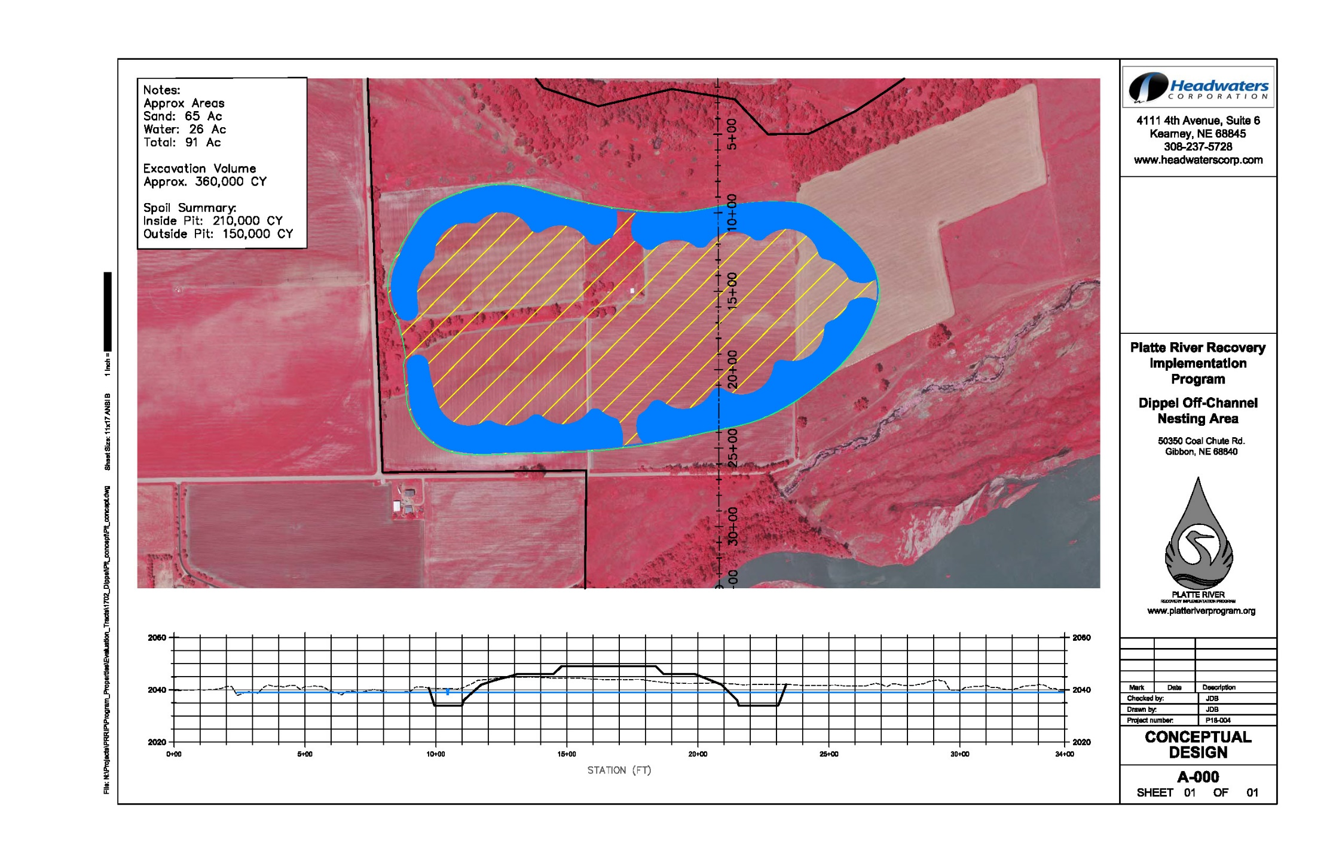

**Figure 2.** Conceptual Dippel OCSW Cross Section



Existing ground level

**Dippel OCSW Preliminary Design Considerations**

**Resource Selection-Based Design Criteria for Piping Plover**

* Territory size: 3.2 acres (~420 ft diameter circle)
* Nest distance to water
  + Probability of use maximized @ ~180 ft (Average ~ 118 ft)
* Waterline length in territory:
  + Average ~ 436 ft (32% of territory boundary)
* Elevation above water
  + Probability of use maximized @ ~9.8 ft (Average ~ 6.8 ft; Median ~ 6.6 ft)
  + Highest use occurs between 7 and 10 feet (Figure 3)
* Distance from piping plover nest
  + Average ~ 430 ft
  + Selection maximized @ 1,148 ft

**Resource Selection-Based Design Criteria for Least Terns**

* Nest distance to water
  + Probability of use increases with increasing distance to edge of water.
* Elevation above water
  + Probability of use increases with elevation above water (Average ~ 7.0 ft; Median ~ 6.7 ft)
  + Highest use occurs between 7 and 10 feet (Figure 4)

**Figure 3.** Density of piping plover use minus available nesting areas

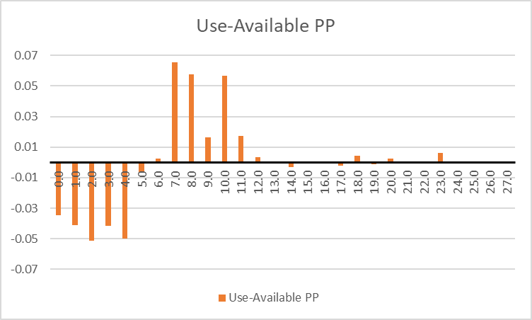

**Figure 4.** Density of least tern use minus available nesting areas

