2018-19 Hunter User on PRRA
Allowed Activities: deer hunting, turkey hunting, waterfowl hunting, small game hunting, fishing, mushroom collecting, birdwatching, and hiking. Waterfowl hunting is not allowed on Areas A and G. Deer hunting is not allowed on Areas M and O.
Area A
- September 1- October 8, 2018
  - 10 Different users
  - 21 Reservations issued
  - 152 Available reservations (38 days X 4 possible daily reservations)
  - 13.8% Reserved
- November 19, 2018- February 9, 2019
  - 4 Different users
  - 6 Reservations issued
  - 336 Available reservations (84 days X 4 possible daily reservations)
  - 1.8% Reserved
Area B
- September 1- October 8, 2018
  - 10 Different users
  - 20 Reservations issued
  - 84 Available reservations (14 days X 6 possible daily reservations)
  - 23.8% Reserved
- Closed to all access due to construction starting September 15
Area C
- September 1- October 8, 2018
  - 21 Different users
  - 78 Reservations issued
  - 152 Available reservations (38 days X 4 possible daily reservations)
  - 51.3% Reserved
- November 19, 2018- February 9, 2019
  - 33 Different users
  - 152 Reservations issued
  - 336 Available reservations (84 days X 4 possible daily reservations)
  - 45.2% Reserved

Area D
- September 1- October 8, 2018
  - 17 Different users
  - 43 Reservations issued
  - 76 Available reservations (38 days X 2 possible daily reservations)
  - 56.6% Reserved
- November 19, 2018- February 9, 2019
  - 35 Different users
  - 102 Reservations issued
  - 168 Available reservations (84 days X 2 possible daily reservations)
  - 60.7% Reserved
Area E
- September 1- October 8, 2018
  - 13 Different users
  - 31 Reservations issued
  - 152 Available reservations (38 days X 4 possible daily reservations)
  - 20.4% Reserved
- November 19, 2018- February 9, 2019
  - 63 Different users
  - 225 Reservations issued
  - 336 Available reservations (84 days X 4 possible daily reservations)
  - 67.0% Reserved
Area F
- September 1- October 8, 2018
  - 2 Different users
  - 4 Reservations issued
  - 76 Available reservations (38 days X 2 possible daily reservations)
  - 5.3% Reserved
- November 19, 2018- February 9, 2019
  - 16 Different users
  - 26 Reservations issued
  - 168 Available reservations (84 days X 2 possible daily reservations)
  - 15.5% Reserved

Area G
- September 1- October 8, 2018
  - 0 Different users
  - 0 Reservations issued
  - 152 Available reservations (38 days X 4 possible daily reservations)
  - 0.0% Reserved
- November 19, 2018- February 9, 2019
  - 2 Different users
  - 4 Reservations issued
  - 336 Available reservations (84 days X 4 possible daily reservations)
  - 1.2% Reserved
Area H
- September 1- October 8, 2018
  - 18 Different users
  - 48 Reservations issued
  - 152 Available reservations (38 days X 4 possible daily reservations)
  - 31.6% Reserved
- November 19, 2018- February 9, 2019
  - 38 Different users
  - 168 Reservations issued
  - 336 Available reservations (84 days X 4 possible daily reservations)
  - 50.0% Reserved
Area I
- September 1- October 8, 2018
  - 18 Different users
  - 32 Reservations issued
  - 190 Available reservations (38 days X 5 possible daily reservations)
  - 16.8% Reserved
- November 19, 2018- February 9, 2019
  - 41 Different users
  - 152 Reservations issued
  - 420 Available reservations (84 days X 5 possible daily reservations)
  - 36.2% Reserved

Area J
- September 1- October 8, 2018
  - 28 Different users
  - 103 Reservations issued
  - 152 Available reservations (38 days X 4 possible daily reservations)
  - 67.8% Reserved
- November 19, 2018- February 9, 2019
  - 44 Different users
  - 148 Reservations issued
  - 336 Available reservations (84 days X 4 possible daily reservations)
  - 44.0% Reserved
Area L
- September 1- October 8, 2018
  - 8 Different users
  - 15 Reservations issued
  - 342 Available reservations (38 days X 9 possible daily reservations)
  - 4.4% Reserved
- November 19, 2018- February 9, 2019
  - 27 Different users
  - 113 Reservations issued
  - 756 Available reservations (84 days X 9 possible daily reservations)
  - 14.9% Reserved
Area M (No deer hunting; open to other uses during November rifle season)
- September 1- October 8, 2018
  - 0 Different users
  - 0 Reservations issued
  - 76 Available reservations (38 days X 2 possible daily reservation)
  - 0.0% Reserved
- November 19, 2018- February 9, 2019
  - 7 Different users
  - 9 Reservations issued
  - 168 Available reservations (84 days X 2 possible daily reservation)
  - 5.4% Reserved

Area N
- September 1- October 8, 2018
  - 8 Different users
  - 25 Reservations issued
  - 228 Available reservations (38 days X 6 possible daily reservations)
  - 11.0% Reserved
- November 19, 2018- February 9, 2019
  - 16 Different users
  - 25 Reservations issued
  - 504 Available reservations (84 days X 6 possible daily reservations)
  - 5.0% Reserved
Area O (No deer hunting; open to other uses during November rifle season)
- September 1- October 8, 2018
  - 1 Different users
  - 1 Reservations issued
  - 76 Available reservations (38 days X 2 possible daily reservation)
  - 1.3% Reserved
- December 30, 2018- February 9, 2019
  - 4 Different users
  - 5 Reservations issued
  - 168 Available reservations (84 days X 2 possible daily reservation)
  - 3.0% Reserved
Area P
- September 1- October 8, 2018
  - 13 Different users
  - 25 Reservations issued
  - 228 Available reservations (38 days X 6 possible daily reservation)
  - 11.0% Reserved
- November 19, 2018- February 9, 2019
  - 49 Different users
  - 153 Reservations issued
  - 504 Available reservations (84 days X 6 possible daily reservation)
  - 30.4% Reserved

-Access is by written permission only, granted through online system at www.platteaccess.org.
-Allowed activities: deer hunting, turkey hunting, waterfowl hunting, small game hunting, fishing, mushroom collecting, birdwatching, and hiking. Some sites may have additional restrictions.
-A limited number of people are granted access per day, determined by size of properties (generally one person per 100 acres).
-Properties are owned by Platte River Recovery Implementation Program and managed for the benefit of threatened and endangered species: Whooping Crane, Least Tern, and Piping Plover.
-Recreation access is managed by Nebraska Game and Parks. Access is allowed during periods when it won’t interfere with target species.
More Information about PRRIP:
308-237-5728
www.platteriverprogram.org
Recreation Access Questions:
Andrew Furman
308-865-5338
ngpc.platteaccess@nebraska.gov
Area | Acres | Users | Users (Rifle Season)
A | 303 | 4 | 4
B | 565 | 6 | 4
C | 330 | 4 | 4
D | 200 | 2 | 2
E | 455 | 4 | 4
F | 180 | 2 | 2
G | 330 | 4 | 4
H | 374 | 4 | 4
I | 640 | 7 | 6
J | 323 | 4 | 4
L | 949 | 9 | 8
M | 153 | 2 | -
N | 564 | 6 | 5
O | 100 | 2 | -
P | 590 | 6 | 4

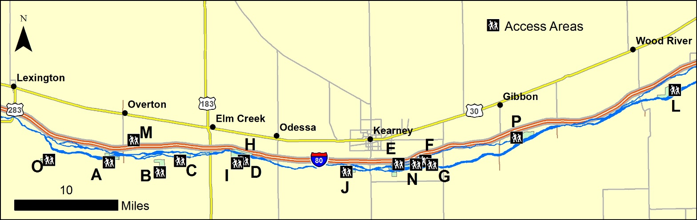
CALENDAR OF ACCESS
2019
January 1- March 5- Open Access
March 6- April 29- No Access
April 30- August 15- Limited Access
August 16- October 8- Open Access
October 9- November 15- No Access
November 16- November 24- Access by Lottery Drawing
November 25- December 31- Open Access
Rifle Application Period- September 1-30
Website Dates- Added on July 1, 2018 through June 30, 2019
Reservation Rate (permission slips issued/available reservations)
 | September-October |  |  | November-February
 | 2016 | 2017 | 2018 | 2016-2017 | 2017-2018 | 2018-2019
A (Cook/Dyer) | 28.3% | 15.8% | 13.8% | 7.4% | 4.9% | 1.8%
B (Morse) | 0.6% | 7.0% | 23.8% | 42.2% | 35.2% | -
C (Stall) | 37.5% | 34.2% | 51.3% | 50.9% | 39.3% | 45.2%
D (McCormick) | 71.7% | 60.5% | 56.6% | 66.7% | 57.3% | 60.7%
E (Wyoming) | 24.2% | 21.7% | 20.4% | 60.5% | 55.8% | 67.0%
F (Fox) | 20.0% | 9.2% | 5.3% | 41.4% | 9.1% | 15.5%
G (Hostetler) | 0.8% | 0.0% | 0.0% | 4.6% | 2.1% | 1.2%
H (Sull./Bart.) | - | 33.6% | 31.6% | 42.9% | 36.6% | 50.0%
I (Johns) | 34.8% | 14.3% | 16.8% | 40.9% | 46.9% | 36.2%
J (BELF/Vole.) | - | 46.1% | 67.8% | 58.3% | 63.7% | 44.0%
L (Binfield S) | 19.6% | 5.6% | 4.4% | 26.5% | 20.9% | 14.9%
M (Liehs) | 0.0% | 0.0% | 0.0% | 20.9% | 4.3% | 5.4%
N (Speidell) | - | 7.0% | 11.0% | 6.6% | 7.7% | 5.0%
O (DeBoer) | - | - | 1.3% | - | 7.1% | 3.0%
P (Dippel) | - | - | 11.0% | - | - | 30.4%

Individual Users
 | September-October |  |  | November-February
 | 2016 | 2017 | 2018 | 2016-2017 | 2017-2018 | 2018-2019
A (Cook/Dyer) | 11 | 11 | 10 | 9 | 10 | 4
B (Morse) | 1 | 5 | 10 | 39 | 29 | 0
C (Stall) | 9 | 15 | 21 | 51 | 35 | 33
D (McCormick) | 14 | 14 | 17 | 35 | 37 | 35
E (Wyoming) | 15 | 7 | 13 | 46 | 48 | 63
F (Fox) | 5 | 3 | 2 | 22 | 10 | 16
G (Hostetler) | 1 | 0 | 0 | 12 | 7 | 2
H (Sull./Bart.) | - | 13 | 18 | 37 | 35 | 38
I (Johns) | 20 | 15 | 18 | 64 | 61 | 41
J (BELF/Vole.) | - | 21 | 28 | 48 | 45 | 44
L (Binfield S) | 14 | 9 | 8 | 40 | 33 | 27
M (Liehs) | 0 | 0 | 0 | 8 | 3 | 7
N (Speidell) | - | 8 | 8 | 19 | 17 | 16
O (DeBoer) | - | - | 1 | - | 5 | 4
P (Dippel) | - | - | 13 | - | - | 49

Survey Response Rate
 | 2016 | 2017 | 2018
Rifle Season | 34 responses/ 56 users= 60.7% | 25 responses/ 56 users= 44.6% | 24 responses/ 42 users= 57.1%
General Access | 112 responses/ 330 users= 33.9% | 93 responses/ 281 users= 33.1% | 138 responses/ 374 users= 36.8%

2018-2019
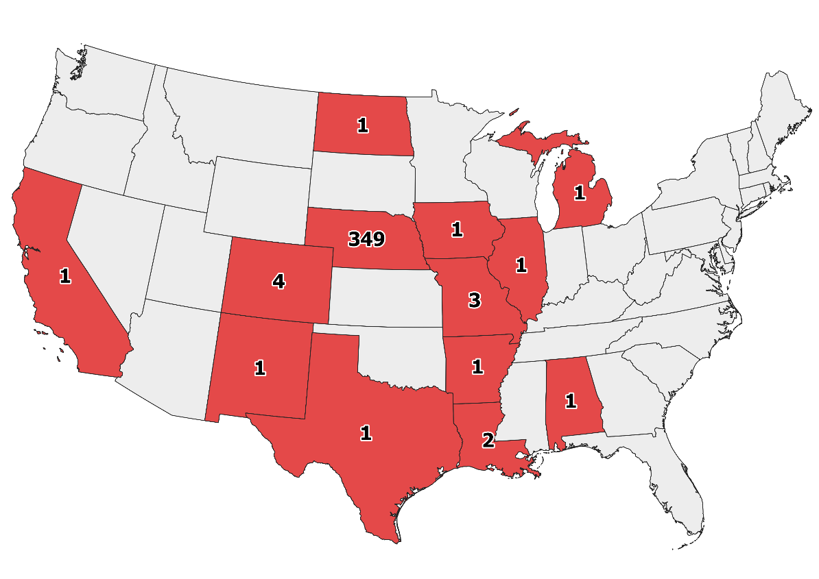

All Years
