IMPLEMENTATION OF THE WHOOPING CRANE
MONITORING PROTOCOL
2018 FALL DRAFT REPORT

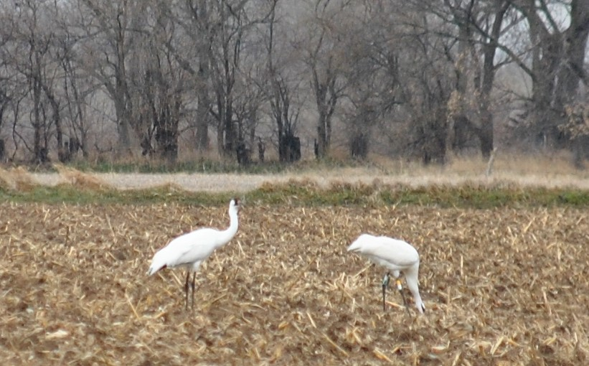

Prepared by
Dave Fehlhafer and
Brian Peterson

Ecological Solutions
203 W. Bartelt Ave
Doniphan, NE 68832

Date: XXXXX

Implementation of the Whooping Crane Monitoring Protocol
Fall 2018

Prepared by
Ecological Solutions

For
The Committees of the
Platte River Recovery Implementation Program

Date: XXXXX

Summary

The Ecological Solutions (ES) team conducted the whooping crane monitoring effort for the 2018 fall migration following the protocols detailed in the Platte River Recovery Implementation Program – Whooping Crane Monitoring Protocol – rev. June 8, 2017.
The fall migration monitoring took place from October 9th through November 15th. Surveys were conducted using systematic flight transects along the Platte River from Chapman to Lexington. Systematic along with opportunistic sightings, resulted in 21 unique whooping cranes observed within the transect boundaries during the 38-day survey period. Below includes survey methodology, results, and supporting data.
Equipment/Materials, Personnel, and Study Area
Two Cessna 172 aircrafts, crewed by a pilot and two observers, were used to make observations along predetermined flight transects. The pilot utilized a GPS unit to follow the pre-loaded route, as well as to mark any observed objects with a waypoint. The aerial observers utilized binoculars, a Canon EOS 6D camera equipped with a 24 x 105 mm lens, and mobile phones for communication.
Ecological Solutions documented information using data sheets provided by the Platte River Recovery Implementation Program (PRRIP) Executive Director’s Office (EDO), which included aerial flight logs, aerial observations, ground search efforts, and use site monitoring logs.
The area of study stretched from the Highway 283 Platte River bridge near Lexington, Nebraska to the Platte River bridge near Chapman, Nebraska and focused on the Platte River channels and the adjacent wetlands, ponds, and waterways extending 3.5 miles out on each side of the outermost channels. The total length of the coverage area was approximately 90 miles and was divided into two routes, an east route and a west route. Observations outside the study area were not included in the data.
Implementation and Methodology
Systematic aerial transects were flown daily, conditions permitting, at an altitude of approximately 750 feet unless conditions demanded higher altitudes. Two flights were initiated each morning, one from Grand Island (east route) and one from Kearney (west route). Planes were required to be at transect starting points ½ hour before sunrise. Flights were typically completed in less than two hours. In the event of adverse weather, crews were required to wait up to two hours after sunrise for conditions to improve before cancelling the flight, that is unless the pilot cancelled the flight for the day prior to that using their best judgement. River transects were flown east to west and the plane was oriented south of the southern-most river channel to reduce the effect of sun glare. Each riverine transect had two daily alternating starting points. The alternating starting points were implemented to allow different sections of the study area to be observed as early as possible in the flight times.
The east route day one started at the Platte River bridge near Chapman (Chapman bridge) and followed the river transect (0SE) to the Highway 10 bridge (Minden bridge). The pilots would then follow the targeted Primary Wetland Return Transect (PWRTE) back to the Chapman bridge, turn and follow the targeted Secondary Wetland Return Transect (CSRT) to the Highway 34 bridge. For the east route day two, flights would start at the Platte River bridge near Wood River (Wood River bridge) and follow the 0SE to the Minden bridge, then follow the PWRTE back to the Chapman bridge. The pilots would then follow the 0SE to the Wood River bridge, then return on the Secondary Wetland Return Transect (WSRT) that stretched from HWY 10 near Wood River to the Highway 34 – Platte River bridge.
The west route day one started at the Minden bridge and followed the river transect (0SW) to the Highway 283 bridge (Lexington bridge). The pilots would then follow the targeted Primary Wetland Return Transect (PWRTW) back to the Minden bridge. For the west route day two, flights would start at the Platte River bridge near Odessa (Odessa bridge) and follow the 0SW to the Lexington bridge. They would turn and follow the PWRTW back to the Minden bridge and then return on the 0SW to the Odessa bridge. Pilots would then follow the Secondary Wetland Return Transect (ESRT) from HWY 183 near Elm Creek to the HWY 40 near the Platte River bridge.
At the beginning of each transect and at turn around points, the aerial crews would relay their position via mobile phone to the nearby ground crews so the ground crews could maintain a relatively close proximity. If an aerial crew spotted any potential whooping crane(s), they would take photos of the object(s) and the surrounding area to confirm the identity and location. If additional confirmation was needed, they would contact the nearest ground observer, who would then position themselves to make a positive identification of the object without disturbance. If the object was determined to be a whooping crane(s), personnel at the EDO as well as the U.S. Fish and Wildlife Service (USFWS) would be immediately notified so they could take appropriate measures to minimize disturbance if needed. Otherwise, they were notified of results of surveys on a daily basis following the completion of both flights.
In addition to the systematic flights, the aerial and ground crews also confirmed and reported opportunistic sightings. Immediately after receiving a report, depending on the situation, either a plane would be deployed from the airport and/or ground personnel would systematically survey the area until the cranes were located and confirmed, or sufficient search time was allocated to confirm the cranes had left and/or were not present in the immediate area.
Using Geographic Information System (GIS) and facilitated by the in-flight photos and/or GPS waypoints, UTM coordinates were determined for each crane or crane group and recorded with the rest of the data.
All data was later translated from the completed data sheets to the program database via electronic form on a web-based server using Microsoft SharePoint software that was developed for PRRIP by Riverside Technology, Inc. It was then subjected to Quality Assurance/Quality Control (QA/QC) checks by Ecological Solutions to insure accuracy.
Results
Confirmed Whooping Crane Sightings
A total of 21 unique whooping cranes were confirmed during the 38-day monitoring effort. Sixteen documented crane groups, comprised of 4 unique groups, were observed and each was given an individual crane group ID (e.g. 2018FA01 = year-season-number). A crane group consisted of any individual or group of whooping cranes observed once daily and would be re-labeled as a new group and given a new crane group ID the next day if they were still in the area. Use site #’s were notated either as a numerical value if the crane group was observed in a riverine, lacustrine, or palustrine environment or with the location’s land cover classification (or “AIR” if in flight) at the time of sighting.
Table 1 includes unique crane group icons, observation dates, the number of cranes in each group, crane group ID’s, use site designations, the type of observation during each sighting instance, and total crane use days. To facilitate cross-referencing, the crane group icons can be found in Tables 1, 2, 3, 4 and 5 as well as the collective crane group location maps in Figures 6 - 8 and the individual crane group location maps, shown along with a photo of each unique crane group, in Figures 9 - 16.

TABLE 1. Observation data of each crane group during the 2018 fall survey including unique group identifier icons, the date of observation, the number cranes in each group, crane group ID’s, use site designation, GPS locations, and the type of observation at time of sighting.
SPRING | Unique Group Icon | Obs. Dates | # of Cranes Adult:Juv | Crane Group ID | Use Site # | UTMx | UTMy | Observation Type | See Figures
 |  | 10/18/18 | 2:1 | 2018FA01 | 1 | 516883 | 4505201 | Systematic | 9, 10
 |  | 10/19/18 | 2:1 | 2018FA02 | 2 | 516704 | 4505074 | Systematic | 9, 10
 |  | 10/20/18 | 2:1 | 2018FA03 | 1 | 516883 | 4505201 | Systematic | 9, 10
 |  | 10/24/18 | 10:0 | 2018FA04 | 3 | 459380 | 4503677 | Systematic | 11, 12
 |  | 10/25/18 | 10:0 | 2018FA05 | 4 | 459613 | 4503664 | Systematic | 11, 12
 |  | 10/26/18 | 10:0 | 2018FA06 | 5 | 461930 | 4503854 | Systematic | 11, 12
 |  | 10/26/18 | 2:0 | 2018FA07 | 6 | 520136 | 4506725 | Systematic | 13, 14
 |  | 10/29/18 | 2:0 | 2018FA08 | 7 | 519725 | 4506560 | Systematic | 13, 14
 |  | 10/31/18 | 2:0 | 2018FA09 | 7 | 519725 | 4506560 | Systematic | 13, 14
 |  | 11/1/18 | 2:0 | 2018FA10 | 8 | 519632 | 4506545 | Systematic | 13, 14
 |  | 11/1/18 | 6:0 | 2018FA11 | 9 | 545468 | 4514622 | Systematic | 15, 16
 |  | 11/2/18 | 2:0 | 2018FA12 | 10 | 519802 | 4506709 | Systematic | 13, 14
 |  | 11/3/18 | 2:0 | 2018FA13 | 11 | 521429 | 4507009 | Ground | 13, 14
 |  | 11/4/18 | 2:0 | 2018FA14 | Corn | 519706 | 4504818 | Ground | 13, 14
 |  | 11/5/18 | 2:0 | 2018FA15 | Corn | 519706 | 4504818 | Ground | 13, 14
 |  | 11/6/18 | 2:0 | 2018FA16 | Corn | 519706 | 4504818 | Ground | 13, 14
 | Crane Use Days |  | 90

Crane use days were calculated by multiplying the number of individual cranes in each group by the number of days the group was observed or known to be in the area, plus one day, as each group was assumed to have been present the evening prior to the morning of the first observation. This resulted in a total of 90 crane use days during the fall survey. Whooping cranes were observed on 14 of the 38 days of the survey effort (36.8% of the days), Table 1.
According to the surveys conducted by the U.S. Fish and Wildlife Service during the winter of 2017 – 2018, the Aransas – Wood Buffalo migratory whooping crane population was estimated to be 505 birds. The 21 individuals observed by this monitoring effort constitutes approximately 4.2% of the migratory population using the Platte River survey area during the 2018 fall migration; however, at the time of this report writing it is unknown how many whooping cranes were in the population during the winter of 2018–2019.
Observed whooping crane use of the Great Bend region of the Platte River during fall systematic surveys of the associated habitat reach for the PRRIP has remained steady since the initiation of monitoring efforts in 2001 (Figure 1).

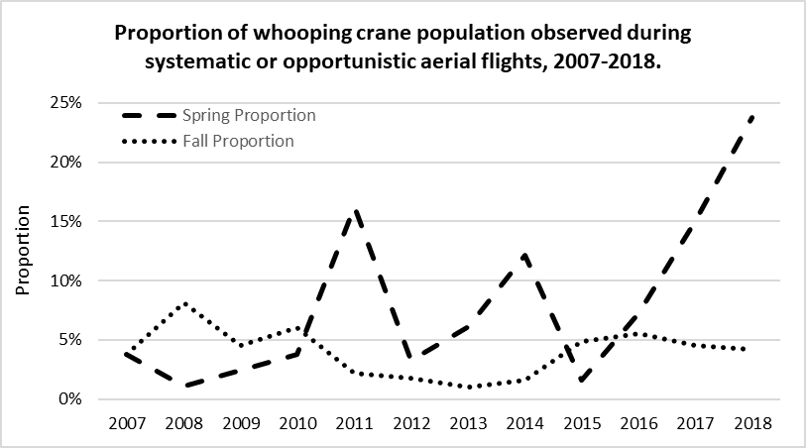Figure 1. Observed use of the central Platte River during spring and fall migration seasons, 2001-2018.

Streamflow and Unobstructed Channel Width at Whooping Crane Use Locations
According to USGS streamflow data, the Platte River streamflow was generally higher than the median daily levels (16 years at Cottonwood, 11 years at Kearney, and 77 years at Grand Island). The intentional streamflow fluctuation is becoming apparent in the increasingly variable median daily streamflow statistics at the relatively short-termed Cottonwood station – 16 years, and Kearney station – 11 years (Figures 2 & 3) as opposed to the more static mean daily rate at the Grand Island station – 77 years (Figure 4).
The discharge rates used in Table 2 were obtained from the USGS gauging station nearest in location and time of measurement to each associated crane group and time of observation. The discharge ranged from a low of 39 cubic feet per second (cfs) at Cottonwood on 10/9 to a high of 1,900 cfs at Grand Island on 11/6 during the survey period. At the specific crane group observation times, streamflow ranged from 144 cfs – 1,900 cfs. Table 3 includes unobstructed channel width, as measured in GIS, at each in-channel use location. Unobstructed channel widths at riverine use sites ranged from 283 – 1,157 feet (average = 742 feet).

TABLE 2. Associated crane group use sites and streamflow discharge (cfs) based on nearest gauging station.

Unique Group Icon | Date | Gauging station | Discharge (cfs) | Crane Group ID | Use Site # | # of Cranes Adults:Juv
 | 3/7/18 | Kearney | 1630 | 2018FA01 | 1 | 2:1
 | 3/8/18 | Kearney | 1820 | 2018FA02 | 2 | 2:1
 | 3/9/18 | Kearney | 547 | 2018FA03 | 1 | 2:1
 | 3/10/18 | Cottonwood | 1230 | 2018FA04 | 3 | 10:0
 | 3/11/18 | Cottonwood | 936 | 2018FA05 | 4 | 10:0
 | 3/12/18 | Cottonwood | 857 | 2018FA06 | 5 | 10:0
 | 3/13/18 | Kearney | 1220 | 2018FA07 | 6 | 2:0
 | 3/14/18 | Kearney | 1880 | 2018FA08 | 7 | 2:0
 | 3/16/18 | Kearney | 1860 | 2018FA09 | 7 | 2:0
 | 3/17/18 | Kearney | 1980 | 2018FA10 | 8 | 2:0
 | 3/18/18 | Grand Island | 1830 | 2018FA11 | 9 | 6:0
 | 3/19/18 | Kearney | 1510 | 2018FA12 | 10 | 2:0
 | 3/20/18 | Kearney | 1440 | 2018F13 | 11 | 2:0

TABLE 3. Unobstructed channel width at each in-channel crane use location.

Unique Group Icon | Group ID # | Use Site # | UTMx | UTMy | Unobstructed Channel Width (ft)
 | 2018FA01, 03 | 1 | 516883 | 4505201 | 977
 | 2018FA02 | 2 | 516704 | 4505074 | 1157
 | 2018FA04 | 3 | 459380 | 4503677 | 955
 | 2018FA05 | 4 | 459613 | 4503664 | 720
 | 2018FA06 | 5 | 461930 | 4503854 | 1039
 | 2018FA07 | 6 | 520136 | 4506725 | 283
 | 2018FA08, 09 | 7 | 519725 | 4506560 | 909
 | 2018FA10 | 8 | 519632 | 4506545 | 993
 | 2018FA11 | 9 | 545468 | 45146  22 | 330
 | 2018FA12 | 10 | 519802 | 4506709 | 354
 | 2018FA13 | 11 | 521429 | 4507009 | 444

Figure 2
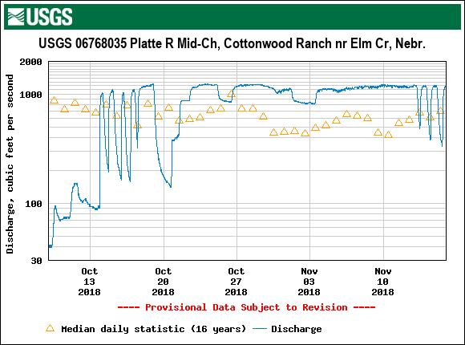
Figure 3
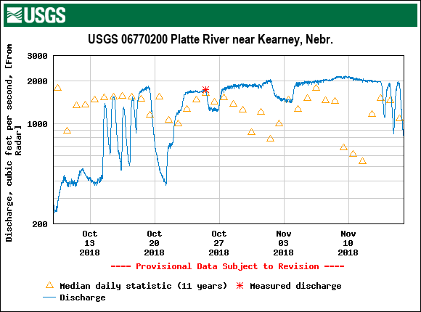
Figure 4
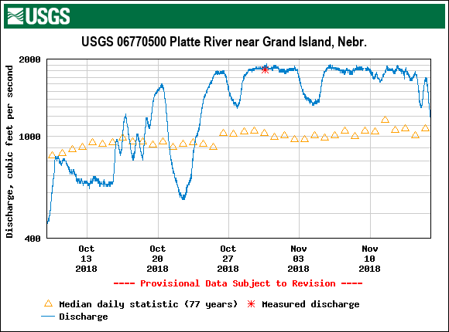

USFWS/PRRIP Data Comparison
This section will only be referencing USFWS ID #’s. Table 4 compares the USFWS whooping crane sighting data (provided by Matt Rabbe – USFWS whooping crane lead) to the PRRIP survey effort. Included are the icons associated with each unique crane group, the date(s) the group was observed, the number of individuals in the group and each agency’s identification numbers assigned to the respective groups.
The difference in ID #’s is due to the USFWS data operating on an “initial sighting” basis of identification, whereas PRRIP assigns a new crane group ID number each day observed.
There were two instances where crane groups (18B-10 & 18B-40; Table 4) were reported directly to USFWS, and therefore are not included in the PRRIP data. Both groups were observed after the survey flight period. In addition, 18B-10 was in flight during the observation.

TABLE 4. USFWS/PRRIP Whooping Crane Group ID Comparisons
Unique Group Icon | Date | # of WC Ad:Juv | USFWS  ID # | PRRIP  ID #
 | 10/18 – 10/20 | 2:1 | 18B-06 | 2018FA01 - 03
N/A | 10/18 – 10/18 | 7:0 | 18B-10 | N/A
 | 10/24 – 10/26 | 10:0 | 18B-24 | 2018FA04 - 06
 | 10/26 – 11/6 | 2:0 | 18B-30 | 2018FA07 – 10 & 12, 13
N/A | 11/1 – 11/1 | 5:0 | 18B-40 | N/A
 | 11/1 – 11/1 | 6:0 | 18B-47 | 2018FA11

Ground Search Effort and Opportunistic Observations
There were fourteen instances where ground crews either acted on a confirmation request to verify a public sighting or a white object spotted by aerial crews, or opportunistically observed a WC group within the survey area during the 38-day monitoring effort. In Table 5, the “Miles Driven” column indicates the total miles driven in the effort to locate a potential crane group, starting from the location of the last reported sighting or known location based on previous days’ observations, then continuing until the crane group or white object is located and identified or a reasonable amount of effort has been put forth. In five instances the crane groups were observed by air crews and confirmed by ground crews. There were four instances in which crane groups were observed by ground crews only. The remaining five ground searches resulted in no whooping crane observation or confirmations.
TABLE 5. Ground search effort and opportunistic observations.
Unique Group Icon | Date | Source | WC Confirmed Ad:Juv | Miles Driven | Aerial/Ground Effort
N/A | 10/9 | Public | None | 32 | Ground
N/A | 10/12 | Air | None | 3 | Both
N/A | 10/21 | Air | None | 1 | Both
N/A | 10/23 | Air | None | 1 | Both
 | 10/24 | Air | 10:0 | 2 | Both
 | 10/25 | Known | 10:0 | 2 | Ground
 | 10/29 | Known | 2:0 | 2 | Both
 | 10/31 | Known | 2:0 | 1 | Both
 | 11/1 | Known | 2:0 | 4 | Both
N/A | 11/1 | Air | None | 32 | Both
 | 11/3 | Known | 2:0 | 35 | Ground
 | 11/4 | Known | 2:0 | 35 | Ground
 | 11/5 | Known | 2:0 | 2 | Ground
 | 11/6 | Known | 2:0 | 1 | Both

Incidental Take
The USFWS requests information and documentation of any human activity that occurred in the proximity of Whooping Cranes that could constitute “take” as defined by the Endangered Species Act i.e. “…to harass, harm, pursue, hunt, shoot, wound, kill, capture, or collect, or attempt to engage in any such conduct”. Because harassment interrupts essential feeding or sheltering behaviors, the definition includes disturbance of Whooping Cranes sufficient to result in cranes taking flight.

Lethal or Crippling Take

There were no observations of crippling or lethal take of Whooping Cranes this season as a result of the monitoring conducted by ES.

Harassment

Ecological Solutions staff did not observe or engage in any activity that could be construed as harassment as defined by USFWS.

Public Disturbance

Ecological Solutions staff did not observe any incident of public disturbance of whooping cranes.

Observation Efficiency Trials

Twenty-five whooping crane decoys were randomly placed by PRRIP personnel along the aerial transects. Flight crews spotted 3 in wetted channel (30.0%), 0 in corn/ag (0.0%), 0 in lowland grassland (0.0%), and 0 in open water pit/pond/lake (0.0%), for an overall spotting efficiency of 12.0% (Table 6).

TABLE 6. Observation Efficiency Trials Using Whooping Crane Decoys

Decoy | Date Placed | Date Tested | UTMx | UTMy | Type | Detected
1 | 10/8/2018 | 10/10/2018 | 452775 | 4503465 | Wetted channel | NO
2 | 10/8/2018 | 10/10/2018 | 452814 | 4503504 | Wetted channel | NO
3 | 10/10/2018 | 10/11/2018 | 544282 | 4514217 | Wetted channel | YES
4 | 10/10/2018 | 10/11/2018 | 449437 | 4503433 | Wetted channel | YES
5 | 10/15/2018 | 10/16/2018 | 510549 | 4503013 | Wetted channel | YES
6 | 10/18/2018 | 10/19/2018 | 443132 | 4504960 | Wetted channel | NO
7 | 10/19/2018 | 10/20/2018 | 447053 | 4504797 | Wetted channel | NO
8 | 10/22/2018 | 10/23/2018 | 526414 | 4507401 | Wetted channel | NO
9 | 10/26/2018 | 10/29/2018 | 564866 | 4530134 | Wetted channel | NO
10 | 10/30/2018 | 10/31/2018 | 568804 | 4534238 | Wetted channel | NO
11 | 10/16/2018 | 10/17/2018 | 456182 | 4506021 | Ag - corn | NO
12 | 10/17/2018 | 10/18/2018 | 527014 | 4504648 | Ag - corn | NO
13 | 10/25/2018 | 10/26/2018 | 467428 | 4500325 | Ag - corn | NO
14 | 10/26/2018 | 10/29/2018 | 547921 | 4512802 | Ag - corn | NO
15 | 11/5/2018 | 11/6/2018 | 560789 | 4522930 | Ag - corn | NO
16 | 10/19/2018 | 10/20/2018 | 542682 | 4515152 | Grassland-lowland | NO
17 | 10/19/2018 | 10/20/2018 | 486232 | 4503190 | Grassland-lowland | NO
18 | 10/30/2018 | 11/1/2018 | 559008 | 4523758 | Grassland-lowland | NO
19 | 11/1/2018 | 11/11/2018 | 564080 | 4533591 | Grassland-lowland | NO
20 | 11/6/2018 | 11/7/2018 | 488127 | 4503535 | Grassland-lowland | NO
21 | 10/11/2018 | 10/12/2018 | 463427 | 4502617 | Open water pit/pond/lake | NO
22 | 10/22/2018 | 10/23/2018 | 448363 | 4501014 | Open water pit/pond/lake | NO
23 | 10/29/2018 | 10/30/2018 | 548251 | 4511674 | Open water pit/pond/lake | NO
24 | 10/30/2018 | 10/31/2018 | 450847 | 4499389 | Open water pit/pond/lake | NO
25 | 11/13/2018 | 11/14/2018 | 524539 | 4504710 | Open water pit/pond/lake | NO

Flight Statistics and Sighting Frequency
Of the 76 scheduled flights, there were 58 instances when crews were able to depart the airport, of which 57 were completed, resulting in an overall completion of 75.0% (Table 7). Sixteen flights were cancelled or incomplete due to inclement weather, one to mechanical issues, and two to logistical issues.
TABLE 7. Flight Completion Rates
 |  | East | West | Totals
COMPLETED |  | 26 | 31 | 57
CANC./INCOMP. |  | 12 | 7 | 19
SEASON TOTAL |  | 38 | 38 | 76
% COMPLETED |  | 68.4% | 81.6% | 75%

FLIGHT RESULTS
Of the 209 scheduled systematic transects, 157 (75.1%) were completed. During this time, twelve whooping crane groups were observed from the air while conducting systematic flights for an overall sighting-per-transect frequency of 5.7% (Table 8). Four crane groups were observed by ground crews only (See Table 5), so were not included in this chart.

TABLE 8. Whooping Crane Sighting Frequency per Transect

 | Transects |  |  |  | # WC  Groups¹ | Frequency
 |  | Completed | Cancel/Incomp. | TOTAL
SPRING | 0SE, 0SW² | 58 | 18 | 76 | 12 | 15.8%
 | PWRTE, PWRTW³ | 58 | 18 | 76 | 0 | 0.0%
 | WSRT/CSRT, ESRT⁴ | 41 | 16 | 57 | 0 | 0.0%
TOTAL |  | 157 | 52 | 209 | 12 | 5.7%
¹These groups may or may not consist of crane(s) observed on previous days. See crane group ID designation on page 4 under “Confirmed Whooping Crane Sightings”.
²Primary Transect (Riverine), (East – 0SE, West – 0SW)
³Primary Return transect, (East – PWRTE, West – PWRTW)
⁴Secondary Return transect, (East – WSRT and CSRT, West – ESRT)

Supplements
QA/QC of database was performed by ES
Original datasheets – Retained at PRRIP

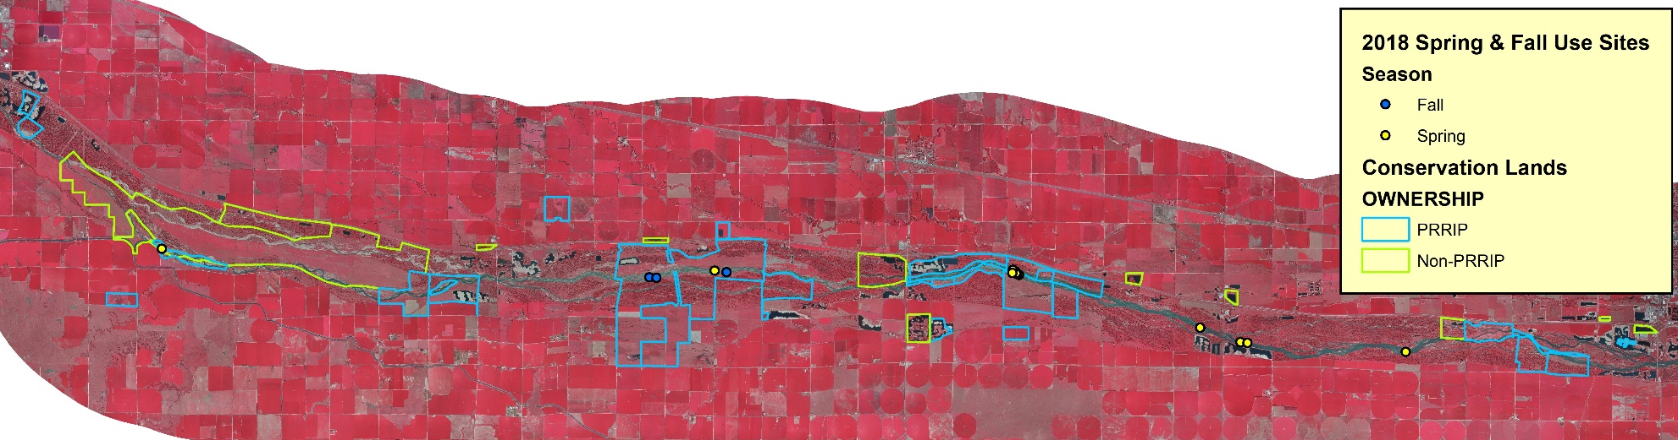
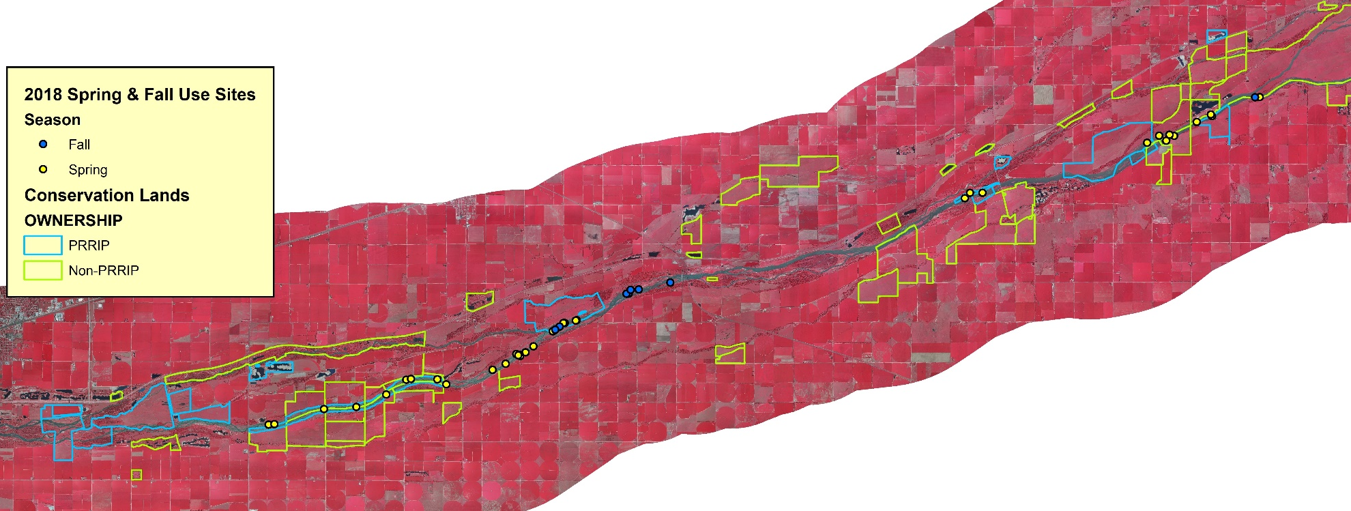
FIGURE 5. Distribution of initial whooping crane group observations within the western (top) and eastern (bottom) half of the AHR during the 2018 spring (yellow) and fall (blue) survey periods in relation to the PRRIP lands (blue) and other conservation lands (green).

FIGURE 6. Observed whooping crane locations. 1 of 3 collective crane group maps. See Table 1 for color icon coding and details.
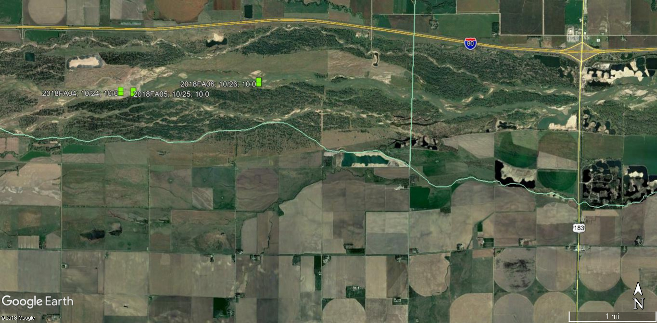

FIGURE 7. Observed whooping crane locations. 2 of 3 collective crane group maps. See Table 1 for icon color coding and details.
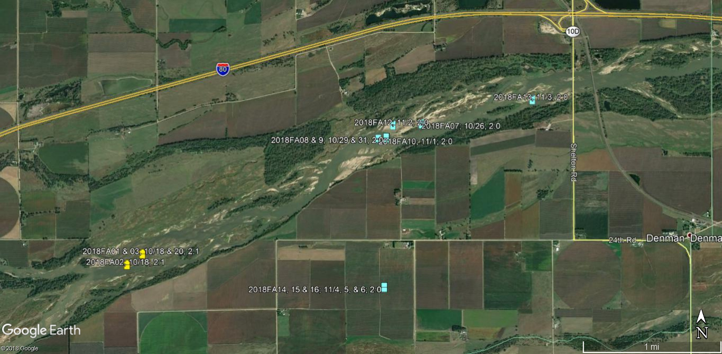
FIGURE 8. Observed whooping crane locations. 3 of 3 collective crane group maps. See Table 1 for icon color coding and details.
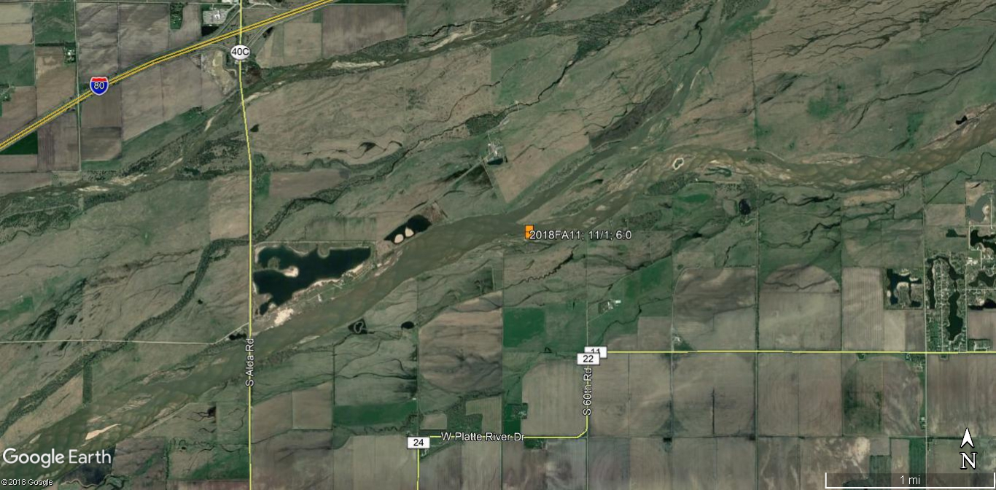

FIGURE 9. Observed locations of the 2:1 crane group designated with ID #’s: 2018FA01-03. This group was observed in the survey area 10/18 – 10/20.
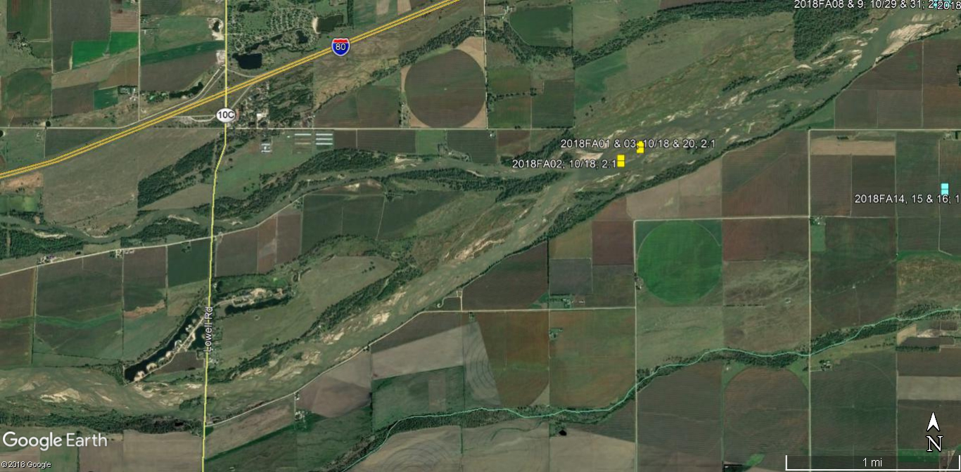
FIGURE 10. This photo was taken during a systematic observation of the 2:1 crane group 2018FA01 at Use Site 1 on 10/18 in the main channel of the Platte River.
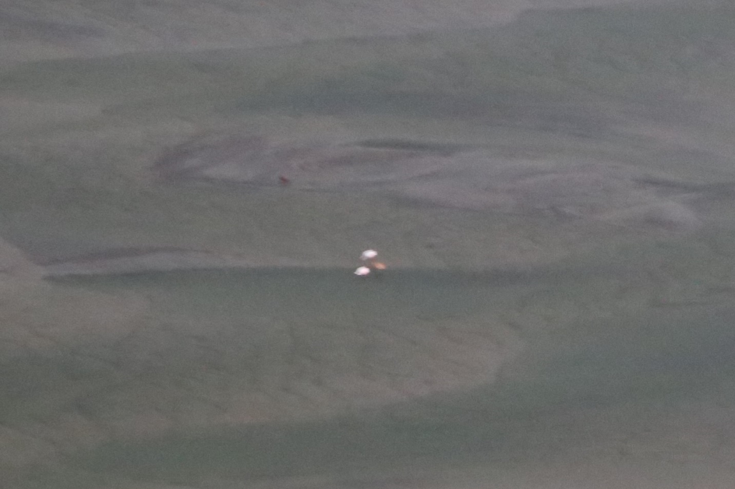
FIGURE 11. Observed locations of the 10:0 crane group designated with ID #’s: 2018FA04 - 06. This group was observed in the survey area 10/24 – 10/26.
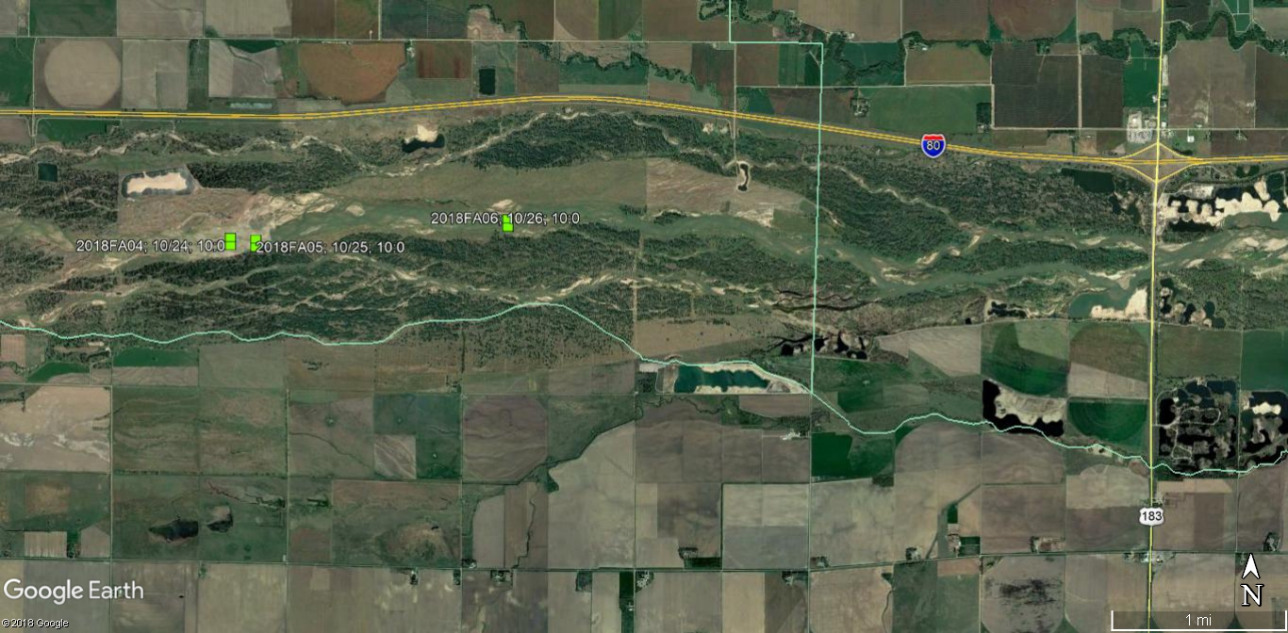
FIGURE 12. This photo was taken during a systematic observation of the 10:0 crane group 2018FA04 at Use Site 3 on 10/24 in the main channel of the Platte River.
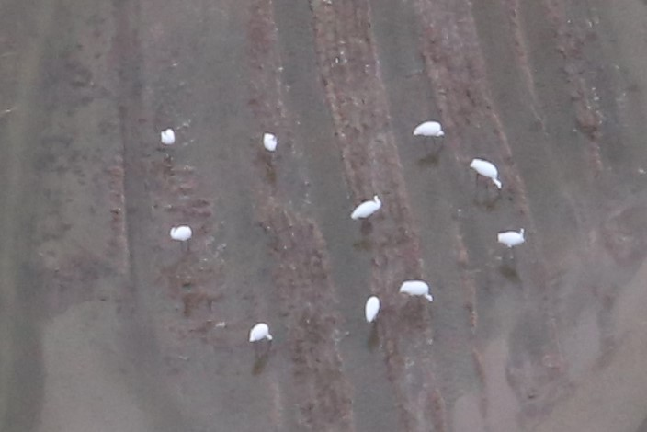
FIGURE 13. Observed locations of the 2:0 crane group designated with ID #’s: 2018FA07 – 10 & 2018FA12 – 16. This group was observed in the survey area 10/26, 29 & 10/31 – 11/6.
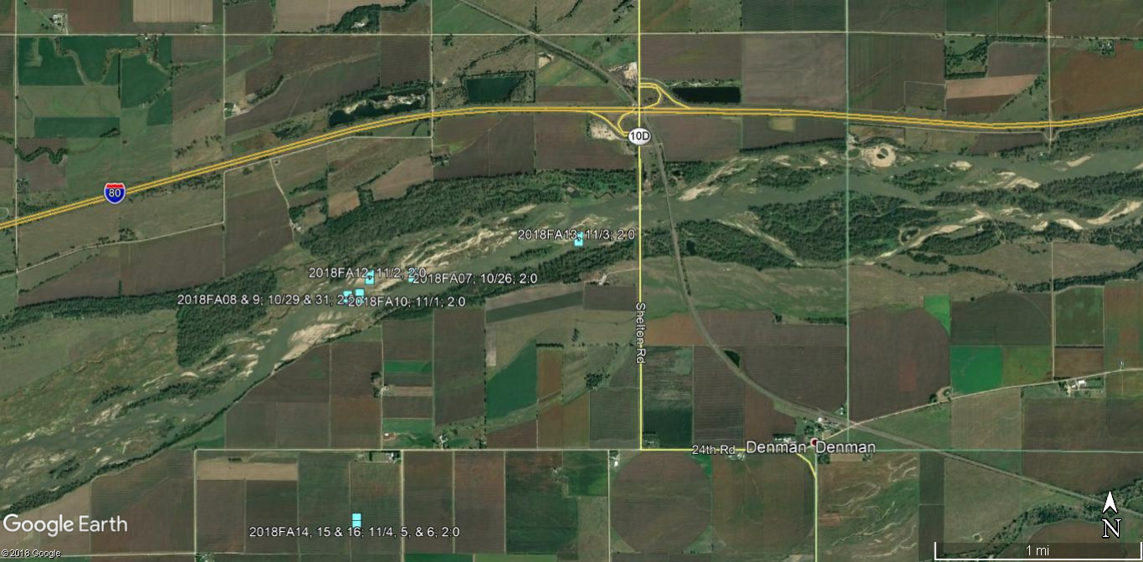
FIGURE 14. This photo was taken during a systematic observation of the 2:0 crane group 2018FA13 at Use Site 11 on 11/3 in the main channel of the Platte River.
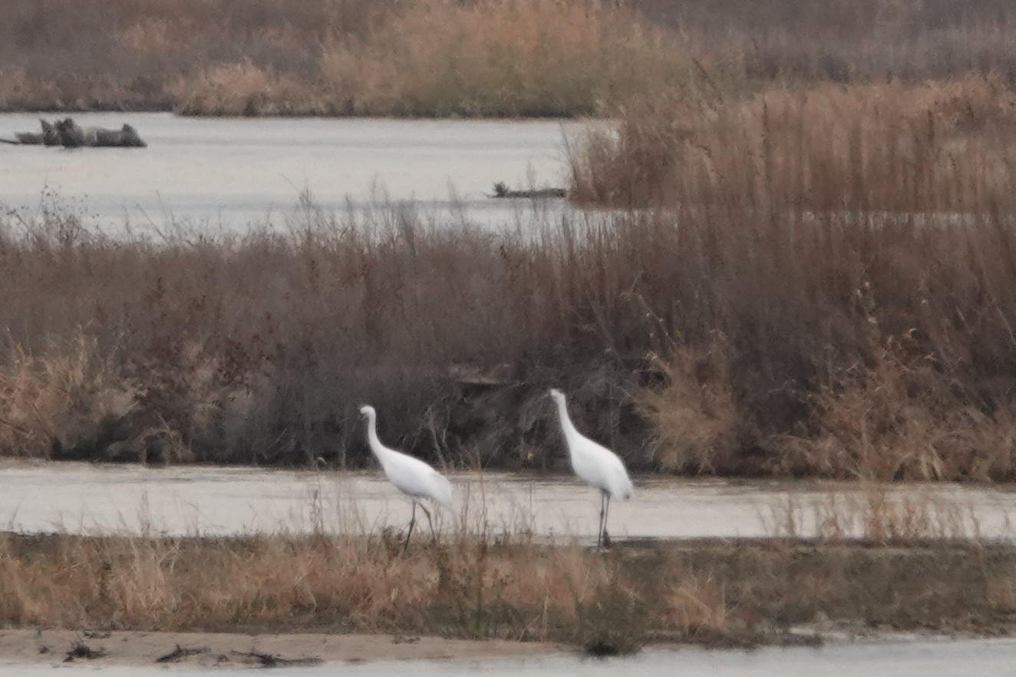
FIGURE 15. Observed location of the 6:0 crane group designated with ID # 2018FA11. This group was observed in the survey area on 11/1.
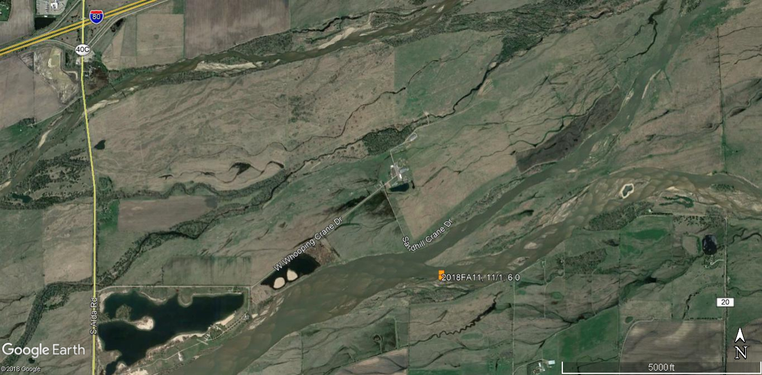
FIGURE 16. This photo was taken during a systematic observation of the 6:0 crane group 2018FA11 at Use Site 9 on 11/1 in the main channel of the Platte River.
