IMPLEMENTATION OF THE WHOOPING CRANE
MONITORING PROTOCOL
2018 SPRING – DRAFT REPORT

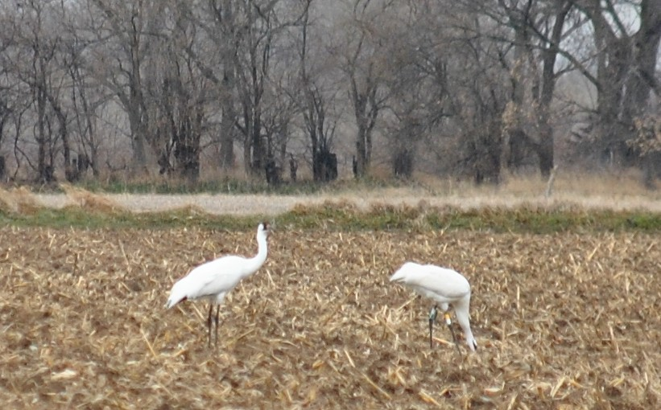

Prepared by
Dave Fehlhafer and
Brian Peterson

Ecological Solutions
203 W. Bartelt Ave
Doniphan, NE 68832

Date XXXX

Implementation of the Whooping Crane Monitoring Protocol
Spring 2018

Prepared by
Ecological Solutions

For
The Committees of the
Platte River Recovery Implementation Program

Date XXXX

Summary

The Ecological Solutions (ES) team conducted the whooping crane monitoring effort for the 2018 spring migration following the protocols detailed in the Platte River Recovery Implementation Program – Whooping Crane Monitoring Protocol – rev. May 2015.
The spring migration monitoring took place from March 6th through April 29th. Surveys were conducted using systematic flight transects along the Platte River from Chapman to Lexington. Systematic along with opportunistic sightings, resulted in 118 unique whooping cranes observed within the transect boundaries during the 55-day survey period. Below includes survey methodology, results, and supporting data.
Equipment/Materials, Personnel, and Study Area
Two Cessna 172 aircrafts, crewed by a pilot and two observers, were used to make observations along predetermined flight transects. The pilot utilized a GPS unit to follow the pre-loaded route, as well as to mark any observed objects with a waypoint. The aerial observers utilized binoculars, a Canon EOS 6D camera equipped with a 24 x 105 mm lens, and mobile phones for communication.
Ecological Solutions documented information using data sheets provided by the Platte River Recovery Implementation Program (PRRIP) Executive Director’s Office (EDO), which included aerial flight logs, aerial observations, ground search efforts, and use site monitoring logs.
The area of study stretched from the Highway 283 Platte River bridge near Lexington, Nebraska to the Platte River bridge near Chapman, Nebraska and focused on the Platte River channels and the adjacent wetlands, ponds, and waterways extending 3.5 miles out on each side of the outermost channels. The total length of the coverage area was approximately 90 miles and was divided into two routes, an east route and a west route. Observations outside the study area were not included in the data.
Implementation and Methodology
Systematic aerial transects were flown daily conditions permitting, at an air speed of approximately 100 MPH and an altitude of approximately 1,000 – 2,000 feet from March 6 – 12 due to collision risk with snow geese, thereafter at an altitude of approximately 750 feet unless conditions demanded higher altitudes. Two flights were initiated each morning, one from Grand Island (east route) and one from Kearney (west route). Planes were required to be at transect starting points ½ hour before sunrise. Flights were typically completed in less than two hours. In the event of adverse weather, crews were required to wait up to two hours after sunrise for conditions to improve before cancelling the flight, that is unless the pilot cancelled the flight for the day prior to that using their best judgement. River transects were flown east to west and the plane was oriented south of the southern-most river channel to reduce the effect of sun glare. Each riverine transect had two daily alternating starting points. The alternating starting points were implemented to allow different sections of the study area to be observed as early as possible in the flight times.
The east route day one started at the Platte River bridge near Chapman (Chapman bridge) and followed the river transect (0SE) to the Highway 10 bridge (Minden bridge). The pilots would then follow the targeted Primary Wetland Return Transect (PWRTE) back to the Chapman bridge, turn and follow the targeted Secondary Wetland Return Transect (CSRT) to the Highway 34 bridge. For the east route day two, flights would start at the Platte River bridge near Wood River (Wood River bridge) and follow the 0SE to the Minden bridge, then follow the PWRTE back to the Chapman bridge. The pilots would then follow the 0SE to the Wood River bridge, then return on the Secondary Wetland Return Transect (WSRT) that stretched from HWY 10 near Wood River to the Highway 34 – Platte River bridge.
The west route day one started at the Minden bridge and followed the river transect (0SW) to the Highway 283 bridge (Lexington bridge). The pilots would then follow the targeted Primary Wetland Return Transect (PWRTW) back to the Minden bridge. For the west route day two, flights would start at the Platte River bridge near Odessa (Odessa bridge) and follow the 0SW to the Lexington bridge. They would turn and follow the PWRTW back to the Minden bridge and then return on the 0SW to the Odessa bridge. Pilots would then follow the Secondary Wetland Return Transect (ESRT) from HWY 183 near Elm Creek to the HWY 40 near the Platte River bridge.
At the beginning of each transect and at turn around points, the aerial crews would relay their position via mobile phone to the nearby ground crews so the ground crews could maintain a relatively close proximity. If an aerial crew spotted any potential whooping crane(s), they would take photos of the object(s) and the surrounding area to confirm the identity and location. If additional confirmation was needed, they would contact the nearest ground observer, who would then position themselves to make a positive identification of the object without disturbance. If the object was determined to be a whooping crane(s), personnel at the EDO as well as the U.S. Fish and Wildlife Service (USFWS) would be immediately notified so they could take appropriate measures to minimize disturbance if needed. Otherwise, they were notified of results of surveys on a daily basis following the completion of both flights.
In addition to the systematic flights, the aerial and ground crews also confirmed and reported opportunistic sightings. Immediately after receiving a report, depending on the situation, either a plane would be deployed from the airport and/or ground personnel would systematically survey the area until the cranes were located and confirmed, or sufficient search time was allocated to confirm the cranes had left and/or were not present in the immediate area.
Using metrics developed by the EDO, in conjunction with a Geographic Information System (GIS), and facilitated by the in-flight photos and/or GPS waypoints, UTM coordinates were determined for each crane or crane group and recorded with the rest of the data.
All data was later translated from the completed data sheets to the program database via electronic form on a web-based server using Microsoft SharePoint software that was developed for PRRIP by Riverside Technology, Inc. It was then subjected to Quality Assurance/Quality Control (QA/QC) checks by Ecological Solutions to insure accuracy.
Results
Confirmed Whooping Crane Sightings
A total of 118 unique whooping cranes were confirmed during the 55-day monitoring effort. One hundred and four documented crane groups, comprised of 26 unique groups, were observed and each was given an individual crane group ID (e.g. 2018SP01 = year-season-number). A crane group consisted of any individual or group of whooping cranes observed once daily and would be re-labeled as a new group and given a new crane group ID the next day if they were still in the area. Use site #’s were notated either as a numerical value if the crane group was observed in a riverine, lacustrine, or palustrine environment or with the location’s land cover classification (or “AIR” if in flight) at the time of sighting.
Table 1 includes unique crane group icons, observation dates, the number of cranes in each group, crane group ID’s, use site designations, the type of observation during each sighting instance, and total crane use days. All groups associated with a larger group were given the same icon as the larger group (e.g. – The 3:0 and 5:0 groups observed on 4/9 were observed as an 8:0 group on 4/10 with the blue/white icon indicating their association). To facilitate cross-referencing, the crane group icons can be found in Tables 1, 2, 3, 4 and 5 as well as the collective crane group location maps in Figures 7 - 17 and the individual crane group location maps, shown along with a photo of each unique crane group, in Figures 18 – 71.

TABLE 1. Observation data of each crane group during the 2018 spring survey including unique group identifier icons, the date of observation, the number cranes in each group, group ID’s, use site designation, GPS locations, and the type of observation at time of sighting.
SPRING  SPRING | Unique Group Icon | Obs. Dates | # of Cranes Adult:Juv | Group ID # | Use Site # | UTMx | UTMy | Observation Type | See Figures
 |  | 3/7/18 | 1:0 | 2018SP01 | 1 | 545654 | 4514624 | Systematic | 18
 |  | 3/8/18 | 1:0 | 2018SP02 | 2 | 543695 | 4513845 | Systematic | 18, 19
 |  | 3/9/18 | 1:0 | 2018SP03 | 2 | 543695 | 4513845 | Systematic | 18
 |  | 3/10/18 | 1:0 | 2018SP04 | 2 | 543695 | 4513845 | Systematic | 18
 |  | 3/11/18 | 1:0 | 2018SP05 | 2 | 543695 | 4513845 | Ground | 18
 |  | 3/12/18 | 1:0 | 2018SP06 | 3 | 543648 | 4513912 | Systematic | 18
 |  | 3/13/18 | 1:0 | 2018SP07 | 3 | 543648 | 4513912 | Systematic | 18
 |  | 3/14/18 | 1:0 | 2018SP08 | 3 | 543648 | 4513912 | Systematic | 18
 |  | 3/16/18 | 1:0 | 2018SP09 | 4 | 542139 | 4513032 | Ground | 18
 |  | 3/17/18 | 1:0 | 2018SP10 | 5 | 541948 | 4513087 | Ground | 18
 |  | 3/18/18 | 1:0 | 2018SP11 | 2 | 543695 | 4513845 | Ground | 18
 |  | 3/19/18 | 1:0 | 2018SP12 | 3 | 543648 | 4513912 | Ground | 18
 |  | 3/20/18 | 1:0 | 2018SP13 | 6 | 543067 | 4513607 | Systematic | 18
 |  | 3/20/18 | 1:0 | 2018SP14 | Ag/corn | 504585 | 4502256 | Ground | 20-23
 |  | 3/21/18 | 1:0 | 2018SP15 | 7 | 508529 | 4501898 | Systematic | 20-23
 |  | 3/21/18 | 1:0 | 2018SP16 | 5 | 541948 | 4513087 | Ground | 18
 |  | 3/22/18 | 1:0 | 2018SP17 | 5 | 541948 | 4513087 | Systematic | 18
 |  | 3/22/18 | 1:0 | 2018SP18 | 8 | 515102 | 4504073 | Systematic | 20-24
 |  | 3/24/18 | 2:1 | 2018SP19 | 9 | 459353 | 4501104 | Ground | 25
 |  | 3/25/18 | 2:1 | 2018SP20 | Ag/corn | 457804 | 4502042 | Ground | 25
 |  | 3/25/18 | 1:0 | 2018SP21 | Ag/corn | 518819 | 4504822 | Ground | 20-23
 |  | 3/25/18 | 1:0 | 2018SP22 | Ag/beans | 543019 | 4510947 | Ground | 18
 |  | 3/25/18 | 11:0 | 2018SP23 | Ag/corn | 462103 | 4501981 | Ground | 27
 |  | 3/26/18 | 1:0 | 2018SP24 | 2 | 543695 | 5413845 | Ground | 18
 |  | 3/26/18 | 2:1 | 2018SP25 | 9 | 459353 | 4501104 | Ground | 25
 |  | 3/26/18 | 11:0 | 2018SP26 | Ag/corn | 461928 | 4501709 | Ground | 27
 |  | 3/27/18 | 1:0 | 2018SP27 | 3 | 543648 | 4513912 | Systematic | 18
 |  | 3/27/18 | 11:0 | 2018SP28 | 10 | 461540 | 4503904 | Systematic | 27,28
 |  | 3/27/18 | 2:1 | 2018SP29 | 9 | 459353 | 4501104 | Ground | 25
 | ¹ | 3/27/18 | 2:1 | 2018SP29a | 11 | 457804 | 4502042 | Systematic | 25, 26
 |  | 3/28/18 | 2:1 | 2018SP30 | AIR | 459594 | 4500974 | Ground | 25
 |  | 3/28/18 | 1:0 | 2018SP31 | 12 | 541817 | 4512835 | Systematic | 18
 |  | 3/28/18 | 11:0 | 2018SP32 | 10 | 461540 | 4503904 | Systematic | 27
 |  | 3/28/18 | 1:0 | 2018SP33 | 13 | 511858 | 4503037 | Systematic | 20-23
 |  | 3/29/18 | 1:0 | 2018SP34 | 5 | 541948 | 4513087 | Ground | 18
 |  | 3/29/18 | 1:0 | 2018SP35 | Ag/corn | 515750 | 4502485 | Ground | 20-23
 | ² | 3/30/18 | 5:0 | 2018SP36 | 14 | 504921 | 4501171 | Systematic | 29, 30
 |  | 3/30/18 | 1:0 | 2018SP37 | 4 | 542139 | 4513032 | Systematic | 18
Continued on next page
Continued from previous page
SPRING  SPRING | Unique Group Icon | Obs. Dates | # of Cranes Adult:Juv | Group ID # | Use Site # | UTMx | UTMy | Observation Type | See Figure
 |  | 3/30/18 | 1:0 | 2018SP38 | 15 | 515484 | 4504139 | Systematic | 20-23
 |  | 3/31/18 | 1:0 | 2018SP39 | 16 | 510578 | 4503017 | Systematic | 20-23
 | ³ | 4/2/18 | 2:0 | 2018SP40 | Ag/beans | 500063 | 4498552 | Ground | 31
 |  | 4/4/18 | 1:0 | 2018SP41 | 17 | 515247 | 4504037 | Systematic | 20-23
 |  | 4/4/18 | 2:0 | 2018SP42 | 18 | 505164 | 4501188 | Systematic | 31,32
 |  | 4/5/18 | 4:0 | 2018SP43 | 19 | 534264 | 4510698 | Systematic | 33, 34
 |  | 4/5/18 | 7:0 | 2018SP44 | 20 | 533757 | 4510698 | Systematic | 35, 36
 |  | 4/5/18 | 1:0 | 2018SP45 | 21 | 515267 | 4503987 | Systematic | 20-23
 |  | 4/5/18 | 16:0 | 2018SP46 | 22 | 514668 | 4503674 | Systematic | 37, 38
 |  | 4/5/18 | 4:0 | 2018SP47 | 23 | 514127 | 4503424 | Systematic | 39, 40
 |  | 4/5/18 | 3:0 | 2018SP48 | 24 | 507201 | 4501815 | Systematic | 41, 42
 |  | 4/6/18 | 8:0 | 2018SP49 | Ag/corn | 471476 | 4501883 | Ground | 43
 |  | 4/7/18 | 2:0 | 2018SP50 | 25 | 484395 | 4501202 | Systematic | 46, 47
 |  | 4/7/18 | 2:0 | 2018SP51 | 26 | 478925 | 4501533 | Systematic | 54, 55
 |  | 4/7/18 | 8:0 | 2018SP52 | 27 | 471395 | 4503839 | Systematic | 43, 45
 |  | 4/7/18 | 2:0 | 2018SP53 | 28 | 516671 | 4505049 | Systematic | 48, 49
 |  | 4/7/18 | 9:0 | 2018SP54 | 29 | 516604 | 4505003 | Systematic | 50, 51
 |  | 4/7/18 | 2:0 | 2018SP55 | 30 | 509760 | 4502410 | Systematic | 52, 53
 |  | 4/8/18 | 1:0 | 2018SP56 | 17 | 515247 | 4504037 | Systematic | 20-23
 |  | 4/8/18 | 2:0 | 2018SP57 | 31 | 479159 | 4501505 | Opp. Air | 48
 |  | 4/8/18 | 8:0 | 2018SP58 | 32 | 471603 | 4503755 | Opp. Air | 43
 |  | 4/8/18 | 9:0 | 2018SP59 | Grassland | 538125 | 4512093 | Opp. Air | 56, 57
 |  | 4/9/18 | 2:0 | 2018SP60 | 33 | 541528 | 4513044 | Ground | 56
 |  | 4/9/18 | 2:0 | 2018SP61 | Ag/corn | 481319 | 4500271 | Ground | 48
 |  | 4/9/18 | 1:0 | 2018SP62 | 34 | 515190 | 4504024 | Opp. Air | 20-23
 |  | 4/9/18 | 2:0 | 2018SP63 | AIR | 508023 | 4502120 | Opp. Air | 54, 55
 |  | 4/9/18 | 5:0 | 2018SP64 | Ag/corn | 471211 | 4501764 | Systematic | 43
 |  | 4/9/18 | 3:0 | 2018SP65 | Grassland | 470689 | 4500003 | Ground | 43
 |  | 4/10/18 | 8:0 | 2018SP66 | 35 | 471495 | 4503871 | Systematic | 43
 |  | 4/10/18 | 7:0 | 2018SP67 | 36 | 541028 | 4512749 | Ground | 56
 |  | 4/10/18 | 2:0 | 2018S68 | Ag/corn | 481855 | 4500298 | Ground | 48
 |  | 4/10/18 | 1:0 | 2018SP69 | 8 | 515102 | 4504073 | Systematic | 20-23
 |  | 4/10/18 | 2:0 | 2018SP70 | Ag/corn | 537809 | 4509902 | Systematic | 56
 |  | 4/11/18 | 6:0 | 2018SP71 | 37 | 471534 | 4503783 | Systematic | 43
 |  | 4/11/18 | 4:0 | 2018SP72 | 38 | 517582 | 4505465 | Systematic | 58, 59
 |  | 4/11/18 | 3:0 | 2018SP73 | 39 | 517097 | 4505349 | Systematic | 60, 61
 |  | 4/11/18 | 4:0 | 2018SP74 | 40 | 517061 | 4505342 | Systematic | 62, 63
 |  | 4/11/18 | 1:0 | 2018SP75 | 41 | 515810 | 4504390 | Systematic | 20-23
 |  | 4/12/18 | 8:0 | 2018SP76 | 42 | 471503 | 4503804 | Systematic | 43
 |  | 4/12/18 | 1:0 | 2018SP77 | Ag/corn | 516514 | 4503285 | Ground | 20-23
 |  | 4/12/18 | 2:0 | 2018SP78 | Ag/corn | 516432 | 4504285 | Ground | 58
 |  | 4/13/18 | 6:0 | 2018SP79 | 43 | 471397 | 4503923 | Ground | 43
Continued on next page
Continued from previous page
SPRING | Unique Group Icon | Obs. Dates | # of Cranes Adult:Juv | Group ID # | Use Site # | UTMx | UTMy | Observation Type | See Figure
 |  | 4/13/18 | 1:0 | 2018SP80 | Ag/wheat | 515520 | 4504424 | Ground | 20-23
 |  | 4/16/18 | 6:0 | 2018SP81 | 44 | 471383 | 4503827 | Systematic | 43
 | ⁴ | 4/16/18 | 3:0 | 2018SP81a | 45 | 470350 | 4502174 | Systematic | 43
 |  | 4/16/18 | 1:0 | 2018SP82 | 46 | 533539 | 4510471 | Systematic | 64, 65
 |  | 4/16/18 | 2:0 | 2018SP83 | 47 | 443256 | 4504626 | Systematic | 66, 67
 |  | 4/16/18 | 8:1 | 2018SP84 | 48 | 517555 | 4505444 | Systematic | 68
 |  | 4/16/18 | 1:0 | 2018SP85 | 49 | 512226 | 4502831 | Systematic | 20-23
 |  | 4/17/18 | 6:0 | 2018SP86 | Ag/beans | 470527 | 4501273 | Ground | 43, 45
 | ⁵ | 4/17/18 | 10:1 | 2018SP87 | Ag/corn | 516475 | 4504407 | Ground | 68, 69
 |  | 4/17/18 | 1:0 | 2018SP88 | Ag/corn | 514326 | 4502840 | Ground | 20-23
 |  | 4/18/18 | 3:0 | 2018SP89 | Ag/corn | 470332 | 4501058 | Ground | 43
 |  | 4/18/18 | 6:1 | 2018SP90 | Ag/corn | 516520 | 4504424 | Ground | 68
 |  | 4/18/18 | 2:0 | 2018SP91 | Ag/corn | 477456 | 4999951 | Ground | 70
 |  | 4/18/18 | 2:0 | 2018SP92 | Ag/corn | 516651 | 4504321 | Ground | 68
 |  | 4/18/18 | 1:0 | 2018SP93 | Ag/corn | 516708 | 4501758 | Ground | 20-23
 |  | 4/19/18 | 3:0 | 2018SP94 | 50 | 471526 | 4505349 | Systematic | 43
 |  | 4/19/18 | 2:0 | 2018SP95 | 51 | 517035 | 4505349 | Systematic | 68
 |  | 4/19/18 | 2:0 | 2018SP96 | Ag/corn | 477431 | 4500207 | Ground | 70
 |  | 4/19/18 | 1:0 | 2018SP97 | 52 | 510781 | 4503047 | Systematic | 20-23
 |  | 4/19/18 | 6:1 | 2018SP98 | Ag/corn | 516520 | 4504424 | Systematic | 68
 |  | 4/20/18 | 6:1 | 2018SP99 | Ag/corn | 516520 | 4504424 | Ground | 68
 |  | 4/20/18 | 1:0 | 2018SP100 | 49 | 512226 | 4502831 | Ground | 20-23
 |  | 4/20/18 | 2:0 | 2018SP101 | Ag/corn | 477198 | 4500281 | Ground | 70
 |  | 4/21/18 | 2:0 | 2018SP102 | Ag/corn | 477456 | 4499951 | Ground | 70
 |  | 4/22/18 | 2:0 | 2018SP103 | 53 | 477593 | 4502005 | Ground | 70, 71
 |  | 4/22/18 | 4:0 | 2018SP104 | Ag/corn | 514594 | 4504397 | Ground | 68
 | Crane Use Days |  | 492
¹ Same day, secondary use site observation of 2018SP29 – 2:1. Note the new use site #.
² 2018SP36 was also observed opportunistically by the west aerial crew, as noted in the datasheets and database.
³ 2018SP40 was an evening observation, therefore is assumed to have arrived on 4/2.
⁴ Same day, secondary use site observation of part of the 2018SP81 – 6:0 group. Note the new use site #.
⁵ The 2018SP84 – 8:1 group observed on 4/16 was joined by a 2:0 group on 4/17, forming the 2018SP87 – 10:1 group.

Crane use days were calculated by multiplying the number of individual cranes in each group by the number of days the group was observed or known to be in the area, plus one day, as each group was assumed to have been present the evening prior to the morning of the first observation. This resulted in a total of 492 crane use days during the spring survey. Whooping cranes were observed on 41 of the 55 days of the survey effort (74.5% of the days; Table 1).
According to the surveys conducted by the U.S. Fish and Wildlife Service during the winter of 2017 – 2018, the Aransas – Wood Buffalo migratory whooping crane population was estimated to be 505 birds (See the following web link for source). The 118 individuals observed by this monitoring effort constitutes approximately 23.4% of the migratory population using the Platte River survey area during the 2018 spring migration.
https://www.fws.gov/uploadedFiles/WHCR%20Update%20Winter%202017-2018.pdf
Observed whooping crane use of the Great Bend region of the Platte River during spring systematic surveys of the associated habitat reach for the PRRIP has increased significantly (P=0.04) since the initiation of monitoring efforts in 2001 (Figure 1).

Figure 1. Observed use of the central Platte River during spring and fall migration seasons, 2001-2018.

Streamflow and Unobstructed Channel Width at Whooping Crane Use Locations
According to USGS streamflow data, the Platte River streamflow was generally higher than the median daily levels (76 years at Overton, 16 years at Cottonwood, 10 years at Kearney, and 76 years at Grand Island). The intentional streamflow fluctuation is becoming apparent in the increasingly variable median daily streamflow statistics at the relatively short-termed Cottonwood station – 16 years, and Kearney station – 10 years (Figures 3 & 4) as opposed to the more static mean daily rates at the Overton and Grand Island stations – 76 years (Figures 2 & 5).
The discharge rates used in Table 2 were obtained from the USGS gauging station nearest in location and time of measurement to each associated crane group and time of observation. The discharge ranged from a low of 171 cfs at Cottonwood on 4/14 to a high of 2,580 cubic feet per second (cfs) at Grand Island on 3/06 during the survey period. At the specific crane group observation times, streamflow ranged from 892 cfs – 2360 cfs. Table 3 includes unobstructed channel width, as measured in GIS, at each in-channel use location. Unobstructed channel widths at riverine use sites ranged from 32 – 1,448 feet (average = 764 feet).

TABLE 2. Associated crane group use sites and streamflow discharge (cfs) based on nearest gauging station.

Unique Group Icon | Date | Gauging station | Discharge (cfs) | Crane Group ID | Use Site # | # of Cranes Adults:Juv
 | 3/7/18 | Grand Island | 2,310 | 2018SP01 | 1 | 1:0
 | 3/8/18 | Grand Island | 2,160 | 2018SP02 | 2 | 1:0
 | 3/9/18 | Grand Island | 2,360 | 2018SP03 | 2 | 1:0
 | 3/10/18 | Grand Island | 2,310 | 2018SP04 | 2 | 1:0
 | 3/11/18 | Grand Island | 2,230 | 2018SP05 | 2 | 1:0
 | 3/12/18 | Grand Island | 1,960 | 2018SP06 | 3 | 1:0
 | 3/13/18 | Grand Island | 1,920 | 2018SP07 | 3 | 1:0
 | 3/14/18 | Grand Island | 1,780 | 2018SP08 | 3 | 1:0
 | 3/16/18 | Grand Island | 1,730 | 2018SP09 | 4 | 1:0
 | 3/17/18 | Grand Island | 1,200 | 2018SP10 | 5 | 1:0
 | 3/18/18 | Grand Island | 1,780 | 2018SP11 | 2 | 1:0
 | 3/19/18 | Grand Island | 1,130 | 2018SP12 | 3 | 1:0
 | 3/20/18 | Grand Island | 2,210 | 2018SP13 | 6 | 1:0
 | 3/21/18 | Kearney | 2,220 | 2018SP15 | 7 | 1:0
 | 3/21/18 | Grand Island | 2,160 | 2018SP16 | 5 | 1:0
 | 3/22/18 | Grand Island | 2,180 | 2018SP17 | 4 | 1:0
 | 3/22/18 | Kearney | 1,810 | 2018SP18 | 8 | 1:0
 | 3/26/18 | Grand Island | 1,850 | 2018SP24 | 2 | 1:0
 | 3/27/18 | Grand Island | 1,730 | 2018SP27 | 3 | 1:0
 | 3/27/18 | Cottonwood | 892 | 2018SP28 | 10 | 11:0
 | 3/28/18 | Grand Island | 1,730 | 2018SP31 | 12 | 1:0
 | 3/28/18 | Cottonwood | 938 | 2018SP32 | 10 | 11:0
 | 3/28/18 | Kearney | 1,690 | 2018SP33 | 13 | 1:0
 | 3/29/18 | Grand Island | 1,820 | 2018SP34 | 5 | 1:0
 | 3/30/18 | Kearney | 1,400 | 2018SP36 | 14 | 5:0
 | 3/30/18 | Grand Island | 1,710 | 2018SP37 | 4 | 1:0
 | 3/30/18 | Kearney | 1,400 | 2018SP38 | 15 | 1:0
 | 3/31/18 | Kearney | 1,710 | 2018SP39 | 16 | 1:0
 | 4/4/18 | Kearney | 2,120 | 2018SP41 | 17 | 1:0
 | 4/4/18 | Kearney | 2,140 | 2018SP42 | 18 | 2:0
 | 4/5/18 | Grand Island | 2,110 | 2018SP43 | 19 | 4:0
Continued on next page
Continued from previous page
Unique Group Icon | Date | Gauging station | Discharge (cfs) | Crane Group ID | Use Site # | # of Cranes Adults:Juv
 | 4/5/18 | Grand Island | 2,110 | 2018SP44 | 20 | 7:0
 | 4/5/18 | Kearney | 2,170 | 2018SP45 | 21 | 1:0
 | 4/5/18 | Kearney | 2,170 | 2018SP46 | 22 | 16:0
 | 4/5/18 | Kearney | 2,170 | 2018SP47 | 23 | 4:0
 | 4/5/18 | Kearney | 2,170 | 2018SP48 | 24 | 3:0
 | 4/7/18 | Kearney | 1,700 | 2018SP50 | 25 | 2:0
 | 4/7/18 | Kearney | 1,700 | 2018SP51 | 26 | 2:0
 | 4/7/18 | Cottonwood | 1,380 | 2018SP52 | 27 | 8:0
 | 4/7/18 | Kearney | 1,700 | 2018SP53 | 28 | 2:0
 | 4/7/18 | Kearney | 1,700 | 2018SP54 | 29 | 9:0
 | 4/7/18 | Kearney | 1,700 | 2018SP55 | 30 | 2:0
 | 4/8/18 | Kearney | 2,260 | 2018SP56 | 17 | 1:0
 | 4/8/18 | Kearney | 2,260 | 2018SP57 | 31 | 2:0
 | 4/8/18 | Cottonwood | 1,350 | 2018SP58 | 32 | 2:0
 | 4//9/18 | Grand Island | 1,920 | 2018SP60 | 33 | 2:0
 | 4/9/18 | Kearney | 2,120 | 2018SP62 | 34 | 1:0
 | 4/10/18 | Cottonwood | 1,380 | 2018SP66 | 35 | 8:0
 | 4/10/18 | Grand Island | 2,160 | 2018SP67 | 36 | 7:0
 | 4/10/18 | Kearney | 2,090 | 2018SP69 | 8 | 1:0
 | 4/11/18 | Cottonwood | 1,400 | 2018SP71 | 37 | 6:0
 | 4/11/18 | Kearney | 2,120 | 2018SP72 | 38 | 4:0
 | 4/11/18 | Kearney | 2,120 | 2018SP73 | 39 | 3:0
 | 4/11/18 | Kearney | 2,120 | 2018SP74 | 40 | 4:0
 | 4/11/18 | Kearney | 2,120 | 2018SP75 | 41 | 1:0
 | 4/11/18 | Cottonwood | 1,350 | 2018SP76 | 42 | 8:0
 | 4/13/18 | Cottonwood | 1,330 | 2018SP79 | 43 | 6:0
 | 4/16/18 | Cottonwood | 1,200 | 2018SP81 | 44 | 6:0
 | 4/16/18 | Cottonwood | 1,220 | 2018SP81a | 45 | 3:0
 | 4/16/18 | Grand Island | 1,110 | 2018SP82 | 46 | 1:0
 | 4/16/18 | Overton | 2,070 | 2018SP83 | 47 | 2:0
 | 4/16/18 | Kearney | 2,140 | 2018SP84 | 48 | 8:1
 | 4/16/18 | Kearney | 2,140 | 2018SP85 | 49 | 1:0
 | 4/19/18 | Cottonwood | 1,180 | 2018SP94 | 50 | 3:0
 | 4/19/18 | Kearney | 2,230 | 2018SP95 | 51 | 2:0
 | 4/19/18 | Kearney | 2,190 | 2018SP97 | 52 | 1:0
 | 4/20/18 | Kearney | 2,170 | 2018SP100 | 49 | 1:0
 | 4/22/18 | Kearney | 2,130 | 2018SP103 | 53 | 2:0

TABLE 3. Unobstructed channel width at each in-channel crane use location.
Unique Group Icon | Group ID # | Use Site # | UTMx | UTMy | Unobstructed Channel Width (ft)
 | 2018SP01 | 1 | 545654 | 4514624 | 616
 | 2018SP02-05, 11, 24 | 2 | 543695 | 4513845 | 832
 | 2018SP06-08, 12, 27 | 3 | 543648 | 4513912 | 832
 | 2018SP09, 37 | 4 | 542139 | 4513032 | 824
 | 2018SP10, 16-17 | 5 | 541948 | 4513087 | 1,015
 | 2018SP13 | 6 | 543067 | 4513607 | 716
 | 2018SP15 | 7 | 508529 | 4501898 | 896
 | 2018SP18, 69 | 8 | 515102 | 4504073 | 830
 | 2018SP19, 25, 29 | 9 | 459353 | 4501104 | NA
 | 2018SP28, 32 | 10 | 461540 | 4503904 | 626
 | 2018SP29a | 11 | 457804 | 4502042 | NA
 | 2018SP31 | 12 | 541817 | 4512835 | 673
 | 2018SP33 | 13 | 511858 | 4503037 | 788
 | 2018SP36 | 14 | 504921 | 4501171 | 906
 | 2018SP38 | 15 | 515484 | 4504139 | 463
 | 2018SP39 | 16 | 510578 | 4503017 | 361
 | 2018SP41, 56 | 17 | 515247 | 4504037 | 830
 | 2018SP42 | 18 | 505164 | 4501188 | 817
 | 2018SP43 | 19 | 534264 | 4510698 | 997
 | 2018SP44 | 20 | 533757 | 4510698 | 799
 | 2018SP45 | 21 | 515267 | 4503987 | 830
 | 2018SP46 | 22 | 514668 | 4503674 | 569
 | 2018SP47 | 23 | 514127 | 4503424 | 628
 | 2018SP48 | 24 | 507201 | 4501815 | 978
 | 2018SP50 | 25 | 484395 | 4501202 | 582
 | 2018SP51 | 26 | 478925 | 4501533 | 524
 | 2018SP52 | 27 | 471395 | 4503839 | 968
 | 2018SP53 | 28 | 516671 | 4505049 | 999
 | 2018SP54 | 29 | 516604 | 4505003 | 999
 | 2018SP55 | 30 | 509760 | 4502410 | 577
 | 2018SP57 | 31 | 479159 | 4501505 | 417
 | 2018SP58 | 32 | 471603 | 4503755 | 968
 | 2018SP60 | 33 | 541528 | 4513044 | 551
 | 2018SP62 | 34 | 515190 | 4504024 | 520
 | 2018SP66 | 35 | 471495 | 4503871 | 968
 | 2018SP67 | 36 | 541028 | 4512749 | 1,448
 | 2018SP71 | 37 | 471534 | 4503783 | 968
Continued on next page
Continued from previous page
Unique Group Icon | Group ID # | Use Site # | UTMx | UTMy | Unobstructed Channel Width (ft)
 | 2018SP72 | 38 | 517582 | 4505465 | 512
 | 2018SP73 | 39 | 517097 | 4505349 | 621
 | 2018SP74 | 40 | 517061 | 4505342 | 925
 | 2018SP75 | 41 | 515810 | 4504390 | 556
 | 2018SP76 | 42 | 471503 | 4503804 | 968
 | 2018SP78 | 43 | 471397 | 4503923 | 968
 | 2018SP81 | 44 | 471383 | 4503827 | 968
 | 2018SP81a | 45 | 470350 | 4502174 | 32
 | 2018SP82 | 46 | 533539 | 4510471 | 546
 | 2018SP83 | 47 | 443256 | 4504626 | 476
 | 2018SP84 | 48 | 517555 | 4505444 | 512
 | 2018SP85, 100 | 49 | 512226 | 4502831 | 703
 | 2018SP94 | 50 | 471526 | 4503788 | 968
 | 2018SP95 | 51 | 517035 | 4505349 | 925
 | 2018SP97 | 52 | 510781 | 4503047 | 295
 | 2018SP103 | 53 | 477593 | 4502005 | 625

Figure 2
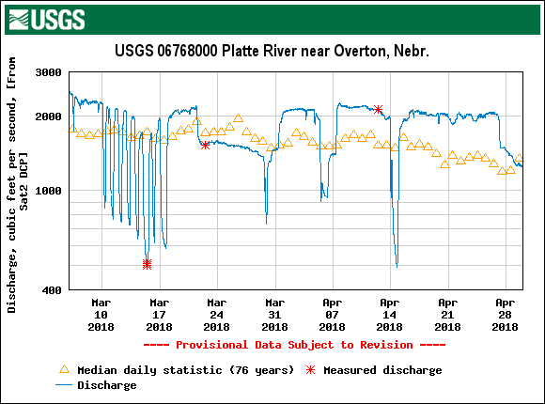
Figure 3
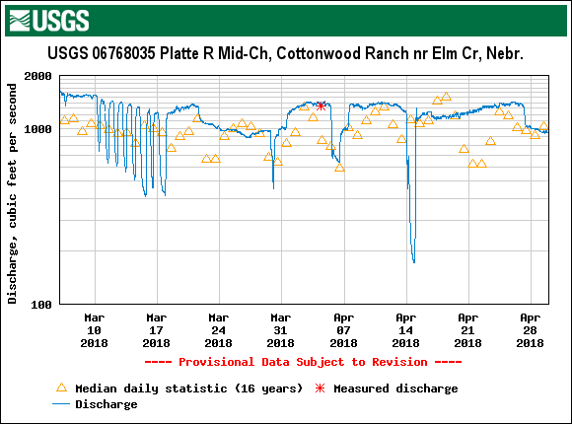
Figure 4
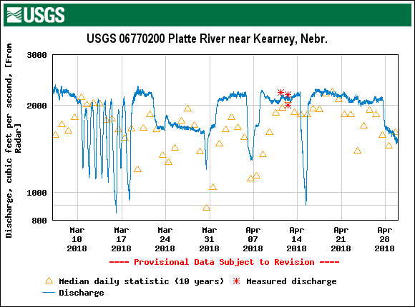
Figure 5
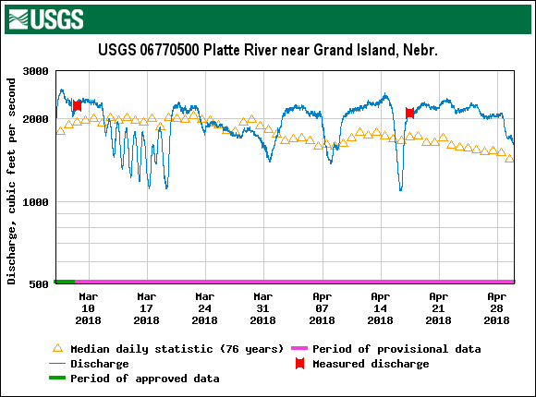

USFWS/PRRIP Data Comparison
This section will only be referencing USFWS ID #’s. Table 4 compares the USFWS whooping crane sighting data (provided by Matt Rabbe – USFWS whooping crane lead) to the PRRIP survey effort. Included are the icons associated with each unique crane group, the date(s) the group was observed, the number of individuals in the group and each agency’s identification numbers assigned to the respective groups.
The difference in ID #’s is due to the USFWS data operating on an “initial sighting” basis of identification, whereas PRRIP assigns a new crane group ID number each day observed.
There were four instances where crane groups (18A-05, 27, 47, and 48; Table 4) were reported directly to USFWS, and therefore are not included in the PRRIP data. Groups 18A-01, 07, 15, 16, 34, 39, and 40 were reported to USFWS on dates prior to ES/EDO staff observations. Of note, 18A-01 was observed prior to the scheduled start of the PRRIP survey, and 18A-15, 16, and 34 were observed on days that flights were cancelled due to inclement weather. Groups 18A-15, 16, 30, 39, 40, 46, 51, and 59 either split into smaller groups, joined up with one or more other groups, and/or re-joined with a previous, larger group. The observed group variations can be noted by cross-referencing matching icons and/or PRRIP ID #’s in Table 1.

TABLE 4. USFWS/PRRIP Whooping Crane Group ID Comparisons
Unique Group Icon | Date | # of WC Ad:Juv | USFWS  ID # | PRRIP  ID #
 | 2/28 – 3/30 | 1:0 | 18A-01 | 2018SP01-13, 16, 17, 22, 24, 27, 31, 34 & 37
 | 3/20 – 4/20 | 1:0 | 18A-03 | 2018SP14, 15, 18, 21, 33, 35, 38, 39, 41, 45, 56, 62, 69, 75, 77, 80, 85, 88, 93, 97 & 100
N/A | 3/21 – 3/22 | 3:0 | 18A-05 | N/A
 | 3/24 – 3/28 | 2:1 | 18A-06 | 2018SP19, 20, 25, 29, 29a & 30
 | 3/20 – 3/28 | 11:0 | 18A-07 | 2018SP23, 26, 28 & 32
 | 3/29 – 3/30 | 2:0 | 18A-15 | 2018SP36
 | 3/29 – 3/30 | 3:0 | 18A-16 | 2018SP36
 | 4/02 – 4/04 | 2:0 | 18A-20 | 2018SP40 & 42
 | 4/05 – 4/05 | 7:0 | 18A-23 | 2018SP44
 | 4/05 – 4/05 | 4:0 | 18A-24 | 2018SP43
 | 4/05 – 4/05 | 16:0 | 18A-25 | 2018SP46
 | 4/05 – 4/05 | 4:0 | 18A-26 | 2018SP47
N/A | 4/05 – 4/05 | 2:0 | 18A-27 | N/A
 | 4/05 – 4/05 | 3:0 | 18A-28 | 2018SP48
 | 4/06 – 4/19 | 8:0 | 18A-30 | 2018SP49, 52, 58, 64-66, 71, 76, 79, 81, 81a, 86, 89 & 94
 | 4/07 – 4/07 | 9:0 | 18A-32 | 2018SP54
 | 4/07 – 4/07 | 2:0 | 18A-33 | 2018SP53
 | 4/06 – 4/09 | 2:0 | 18A-34 | 2018SP55 & 63
 | 4/07 – 4/07 | 2:0 | 18A-35 | 2018SP50
 | 4/07 – 4/10 | 2:0 | 18A-36 | 2018SP51, 57, 61, & 68
 | 4/07 – 4/10 | 7:0 | 18A-39 | 2018SP59 & 67
 | 4/07 – 4/10 | 2:0 | 18A-40 | 2018SP59, 60 & 70
 | 4/11 – 4/11 | 4:0 | 18A-41 | 2018SP74
 | 4/11 – 4/11 | 3:0 | 18A-42 | 2018SP73
 | 4/11 – 4/12 | 4:0 | 18A-46 | 2018SP72 & 78
N/A | 4/11 – 4/11 | 1:0 | 18A-47 | N/A
N/A | 4/12 – 4/12 | 14:0 | 18A-48 | N/A
 | 4/16 – 4/16 | 2:0 | 18A-50 | 2018SP83
 | 4/16 – 4/22 | 8:1 | 18A-51 | 2018SP84, 87, 90, 92, 95, 98, 99 & 104
 | 4/16 – 4/16 | 1:0 | 18A-52 | 2018SP82
 | 4/17 – 4/17 | 2:0 | 18A-59 | 2018SP87
 | 4/18 – 4/22 | 2:0 | 18A-81 | 2018SP91, 96 & 101-103

Ground Search Effort and Opportunistic Observations
There were 83 instances where ground crews either independently observed a WC group or they acted on a confirmation request to verify either a public sighting or a white object spotted by aerial crews within the survey area during the 55-day monitoring effort. In Table 5, the “miles driven” column indicates the total miles driven in the effort to locate a potential crane group, starting from the location of the last reported sighting or known location based on previous days’ observations, then continuing until the crane group or white object is located and identified or a reasonable amount of effort has been put forth. In 19 instances the crane groups were observed by air crews and confirmed by ground crews. There were 50 instances in which crane groups were observed by ground crews only, with 16 of those representing roost or use sites (Table 1). There were ten instances of same-day repeated group sightings. They were: 2018SP14 on 3/20, 2018SP30 on 3/28, 2018SP59 on 4/8, 2018SP60 on 4/9, 2018SP67 on 4/10, 2018SP79 on 4/13, 2018SP81 on 4/16, 2018SP98 on 4/19, 2018SP99 on 4/20, and 2018SP100 on 4/20. The remaining eleven ground searches resulted in no whooping crane observation or confirmations.
As can be noted in Table 5, the crane groups represented with the blue/white, orange/black, and orange/yellow icons varied in number of individuals from day to day. This illustrates how these groups split up, joined and/or rejoined. A unique group icon was assigned to all groups that were a part of or the entirety of a common crane group.

TABLE 5. Ground search effort and opportunistic observations.
Unique Group Icon | Date | Source | WC Confirmed Ad:Juv | Miles Driven | Aerial/Ground Effort
N/A | 3/7 | Air crew | None | 13 | Both
 | 3/9 | Known | 1:0 | 1 | Both
 | 3/10 | Known | 1:0 | 1 | Both
 | 3/11 | Known | 1:0 | 1 | Ground
 | 3/12 | Known | 1:0 | 1 | Both
N/A | 3/15 | Known | None | 20 | Ground
 | 3/16 | Known | 1:0 | 1 | Ground
 | 3/17 | Known | 1:0 | 1 | Ground
 | 3/18 | Known | 1:0 | 1 | Ground
 | 3/19 | Known | 1:0 | 1 | Ground
 | 3/20 | Known | 1:0 | 1 | Both
 | 3/20 | USFWS | 1:0 | 1 | Ground
 | 3/20 | USFWS | 1:0 | 3 | Ground
N/A | 3/21 | Known | None | 22 | Ground
 | 3/21 | Public | 1:0 | 1 | Ground
N/A | 3/22 | ES staff | None | 36 | Ground
N/A | 3/23 | Air crew | None | 25 | Ground
Continued on next page
Continued from previous page
 | 3/24 | PRRIP staff | 2:1 | 1 | Ground
 | 3/25 | Known | 2:1 | 2 | Ground
 | 3/25 | Known | 1:0 | 1 | Ground
 | 3/25 | Known | 1:0 | 4 | Ground
 | 3/25 | Public | 11:0 | 1 | Ground
 | 3/26 | Known | 2:1 | 4 | Ground
 | 3/26 | Known | 1:0 | 1 | Ground
 | 3/26 | Known | 11:0 | 3 | Ground
 | 3/27 | Known | 1:0 | 1 | Both
 | 3/27 | Known | 2:1 | 2 | Ground
 | 3/27 | Known | 11:0 | 2 | Both
 | 3/28 | Known | 2:1 | 1 | Both
 | 3/28 | Known | 2:1 | 1 | Both
 | 3/28 | Known | 1:0 | 1 | Both
 | 3/29 | Known | 1:0 | 1 | Ground
N/A | 3/29 | Known | None | 29 | Ground
 | 3/29 | Known | 1:0 | 1 | Ground
 | 3/30 | Air crew | 5:0 | 1 | Both
 | 4/2 | Public | 2:0 | 5 | Ground
N/A | 4/3 | Known | None | 35 | Ground
N/A | 4/5 | Public | None | 39 | Ground
 | 4/5 | Known | 3:0 | 1 | Both
 | 4/6 | PRRIP staff | 8:0 | 1 | Ground
 | 4/7 | Known | 8:0 | 1 | Both
 | 4/8 | Known | 9:0 | 23 | Both
 | 4/8 | Known | 9:0 | 1 | Both
 | 4/9 | Known | 2:0 | 1 | Ground
 | 4/9 | Known | 2:0 | 3 | Ground
 | 4/9 | Known | 5:0 | 1 | Both
 | 4/9 | Known | 3:0 | 2 | Ground
 | 4/9 | Known | 2:0 | 7 | Ground
 | 4/10 | Known | 7:0 | 1 | Ground
 | 4/10 | Known | 2:0 | 2 | Ground
 | 4/10 | Known | 8:0 | 7 | Both
 | 4/10 | Known | 7:0 | 1 | Ground
 | 4/11 | Known | 6:0 | 3 | Both
 | 4/12 | Known | 1:0 | 1 | Ground
 | 4/12 | Known | 2:0 | 1 | Ground
N/A | 4/12 | Public | None | 65 | Ground
 | 4/13 | Known | 6:0 | 3 | Ground
 | 4/13 | Known | 6:0 | 2 | Ground
 | 4/13 | Known | 1:0 | 1 | Ground
 | 4/16 | Known | 3:0 | 5 | Both
 | 4/16 | Known | 3:0 | 26 | Both
 | 4/17 | Known | 6:0 | 2 | Ground
Continued on next page
Continued from previous page
 | 4/17 | Known | 10:1 | 1 | Ground
 | 4/17 | Known | 1:0 | 1 | Ground
 | 4/18 | Known | 3:0 | 2 | Ground
 | 4/18 | Known | 6:1 | 1 | Ground
 | 4/18 | Known | 2:0 | 1 | Ground
 | 4/18 | Known | 1:0 | 1 | Ground
 | 4/18 | Known | 2:0 | 1 | Ground
N/A | 4/18 | Known | None | 10 | Ground
 | 4/19 | Known | 2:1 | 1 | Both
 | 4/19 | Known | 4:0 | 1 | Both
 | 4/19 | Known | 3:0 | 2 | Both
 | 4/19 | Known | 2:0 | 2 | Ground
 | 4/20 | Known | 1:0 | 1 | Ground
 | 4/20 | Known | 2:0 | 10 | Ground
 | 4/20 | Known | 4:1 | 5 | Ground
 | 4/20 | Known | 2:0 | 2 | Ground
 | 4/20 | Known | 1:0 | 1 | Ground
 | 4/21 | Known | 2:0 | 4 | Ground
N/A | 4/21 | Known | None | 20 | Ground
 | 4/22 | Known | 2:0 | 1 | Ground
 | 4/22 | Known | 4:0 | 40 | Ground

Incidental Take
The USFWS requests information and documentation of any human activity that occurred in the proximity of Whooping Cranes that could constitute “take” as defined by the Endangered Species Act i.e. “…to harass, harm, pursue, hunt, shoot, wound, kill, capture, or collect, or attempt to engage in any such conduct”. Because harassment interrupts essential feeding or sheltering behaviors, the definition includes disturbance of Whooping Cranes sufficient to result in cranes taking flight.

Lethal or Crippling Take

There were no observations of crippling or lethal take of Whooping Cranes this season as a result of the monitoring conducted by ES.

Harassment

Ecological Solutions staff did not observe or engage in any activity that could be construed as harassment as defined by USFWS.

Public Disturbance

Ecological Solutions staff did not observe any incident of public disturbance of whooping cranes.

Observation Efficiency Trials

Twenty-five whooping crane decoys were randomly placed by PRRIP personnel along the aerial transects. Flight crews spotted 7 in wetted channel (70.0%), 1 in corn/ag (20.0%), 0 in lowland grassland (0.0%), and 3 in open water pit/pond/lake (60.0%), for an overall spotting efficiency of 44.0% (Table 6).

TABLE 6. Observation Efficiency Trials Using Whooping Crane Decoys

Decoy | Date Placed | Date Tested | UTMx | UTMy | Type | Detected
1 | 3/7/2018 | 3/8/2018 | 446654 | 4504971 | Wetted channel | YES
2 | 3/7/2018 | 3/8/2018 | 516514 | 4505004 | Wetted channel | NO
3 | 3/8/2018 | 3/9/2018 | 438692 | 4508285 | Wetted channel | YES
4 | 3/12/2018 | 3/13/2018 | 559170 | 4522485 | Wetted channel | YES
5 | 3/14/2018 | 3/15/2018 | 561728 | 4526881 | Wetted channel | NO
6 | 3/21/2018 | 3/22/2018 | 467438 | 4503704 | Wetted channel | YES
7 | 3/22/2018 | 3/23/2018 | 564910 | 4530034 | Wetted channel | YES
8 | 4/9/2018 | 4/10/2018 | 444123 | 4504168 | Wetted channel | NO
9 | 4/11/2018 | 4/12/2018 | 554475 | 4503975 | Wetted channel | YES
10 | 4/11/2018 | 4/16/2018 | 550990 | 4516100 | Wetted channel | YES
11 | 3/6/2018 | 3/8/2018 | 564794 | 4535478 | Ag - corn | NO
12 | 3/6/2018 | 3/7/2018 | 483154 | 4499330 | Ag - corn | NO
13 | 4/11/2018 | 4/16/2018 | 536936 | 4507467 | Ag - corn | NO
14 | 4/16/2018 | 4/19/2018 | 547020 | 4512093 | Ag - corn | NO
15 | 4/18/2018 | 4/19/2018 | 455036 | 4505166 | Ag - corn | YES
16 | 3/6/2018 | 3/7/2018 | 460011 | 4501470 | Grassland-lowland | NO
17 | 3/8/2018 | 3/9/2018 | 500558 | 4502054 | Grassland-lowland | NO
18 | 3/12/2018 | 3/13/2018 | 524429 | 4506663 | Grassland-lowland | NO
19 | 4/19/2018 | 4/23/2018 | 545283 | 4514067 | Grassland-lowland | NO
20 | 4/23/2018 | 4/24/2018 | 486228 | 4503128 | Grassland-lowland | NO
21 | 3/12/2018 | 3/13/2018 | 569859 | 4533704 | Open water pit/pond/lake | YES
22 | 3/13/2018 | 3/14/2018 | 569225 | 4532892 | Open water pit/pond/lake | YES
23 | 4/18/2018 | 4/19/2018 | 499487 | 4496390 | Open water pit/pond/lake | YES
24 | 4/18/2018 | 4/19/2018 | 564504 | 4535926 | Open water pit/pond/lake | NO
25 | 4/19/2018 | 4/22/2018 | 500329 | 4496093 | Open water pit/pond/lake | NO

Flight Statistics and Sighting Frequency
Of the 110 scheduled flights, there were 61 instances when crews were able to depart the airport, of which 56 were completed, resulting in an overall completion of 50.9% (Table 7). Fifty flights were cancelled or incomplete due to inclement weather, three to mechanical issues, and one to logistical issues.
TABLE 7. Flight Completion Rates
 |  | East | West | Totals
COMPLETED |  | 27 | 29 | 56
CANC./INCOMP. |  | 28 | 26 | 54
SEASON TOTAL |  | 55 | 55 | 110
% COMPLETED |  | 49.1% | 52.7% | 50.9%

FLIGHT RESULTS
Of the 302 scheduled systematic transects, 156 (51.6%) were completed. During this time, 56 whooping crane groups were observed from the air while conducting systematic flights for an overall sighting-per-transect frequency of 18.5% (Table 8). Fifty crane groups were observed by ground crews only (See Table 5), so were not included in this chart. Five additional crane groups (2018SP57-59, 62 and 63) were observed during opportunistic flights.

TABLE 8. Whooping Crane Sighting Frequency per Transect

 | Transects |  |  |  |  |  |  | # WC  Groups¹ |  | Frequency
 |  | Completed |  | Cancel/Incomp. |  | TOTAL
SPRING | 0SE, 0SW² | 56 |  | 54 |  | 110 |  | 52 |  | 47.3%
 | PWRTE, PWRTW³ | 57 |  | 53 |  | 110 |  | 4 |  | 3.6%
 | WSRT/CSRT, ESRT⁴ | 43 |  | 39 |  | 82 |  | 0 |  | 0.0%
TOTALS |  |  | 156 |  | 146 |  | 302 |  | 56 |  | 18.5%
¹These groups may or may not consist of crane(s) observed on previous days. See crane group ID designation on page 4 under “Confirmed Whooping Crane Sightings”.
²Primary Transect (Riverine), (East – 0SE, West – 0SW)
³Primary Return transect, (East – PWRTE, West – PWRTW)
⁴Secondary Return transect, (East – WSRT and CSRT, West – ESRT)

Supplements
QA/QC of database was performed by ES
Original datasheets – Retained at PRRIP

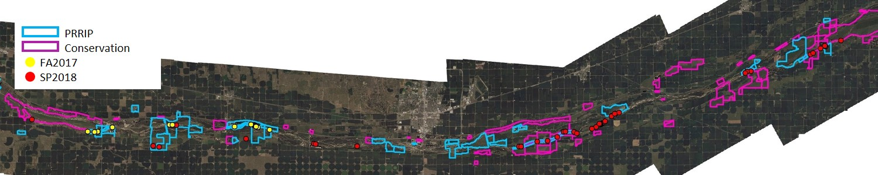

FIGURE 6. The distribution of initial whooping crane group observations during the 2017 fall survey (yellow) and 2018 spring survey (red) in relation to the PRRIP lands (highlighted in blue) and all other conservation lands (highlighted in purple).

FIGURE 7. Observed whooping crane locations. 1 of 11 collective crane group maps. See Table 1 for color icon coding and details.
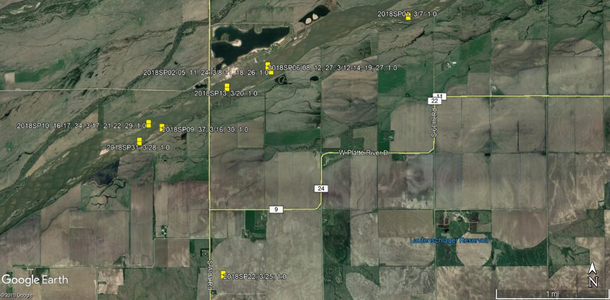

FIGURE 8. Observed whooping crane locations. 2 of 11 collective crane group maps. See Table 1 for icon color coding and details.
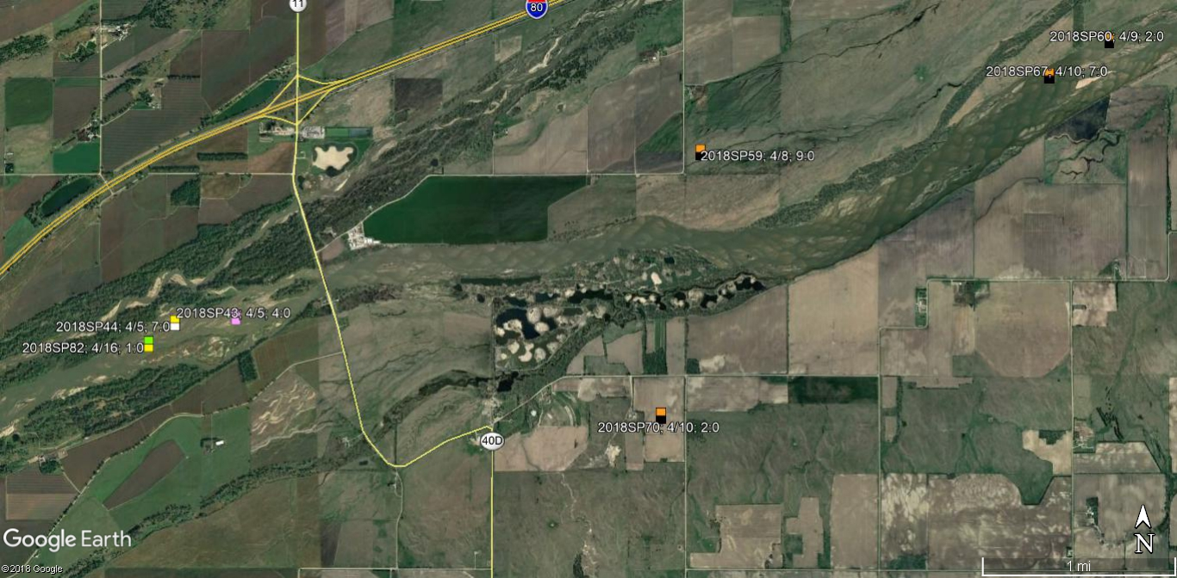

FIGURE 9. Observed whooping crane locations. 3 of 11 collective crane group maps. See Table 1 for icon color coding and details.
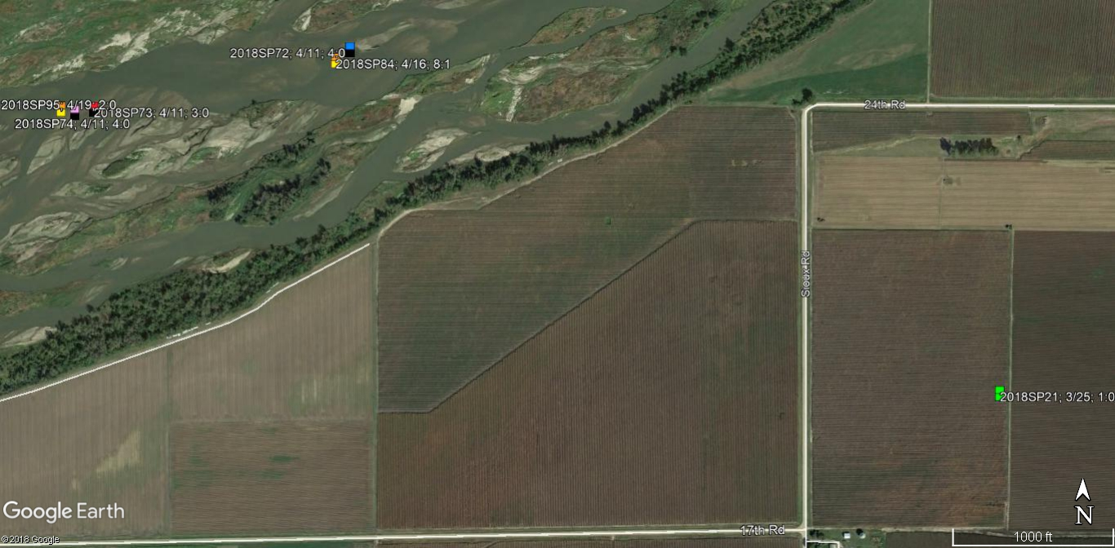

FIGURE 10. Observed whooping crane locations. 4 of 11 collective crane group maps. See Table 1 for icon color coding and details.
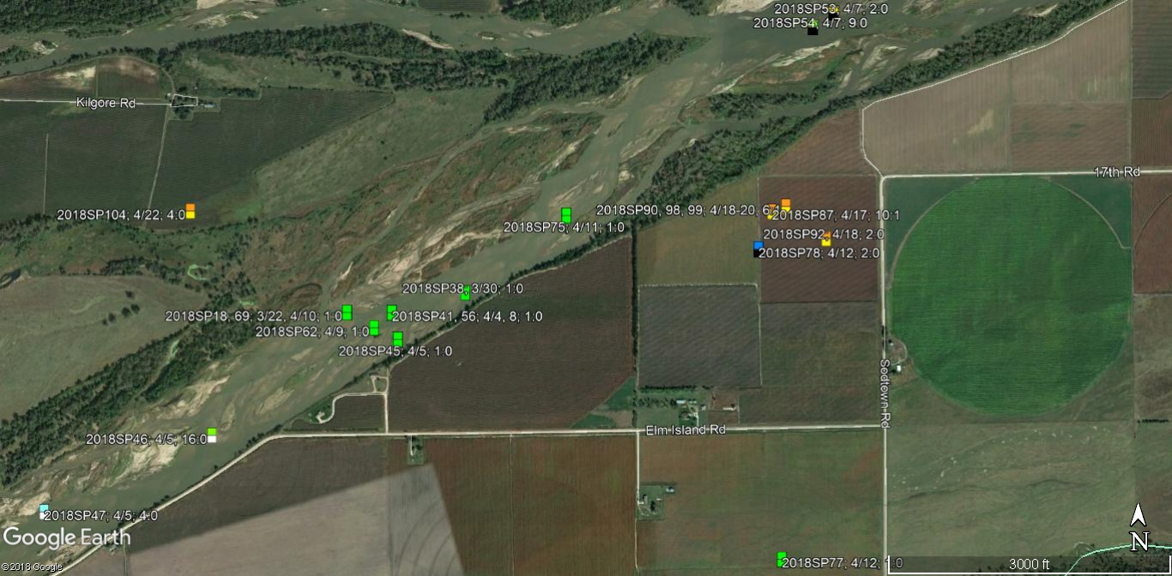

FIGURE 11. Observed whooping crane locations. 5 of 11 collective crane group maps. See Table 1 for icon color coding and details.
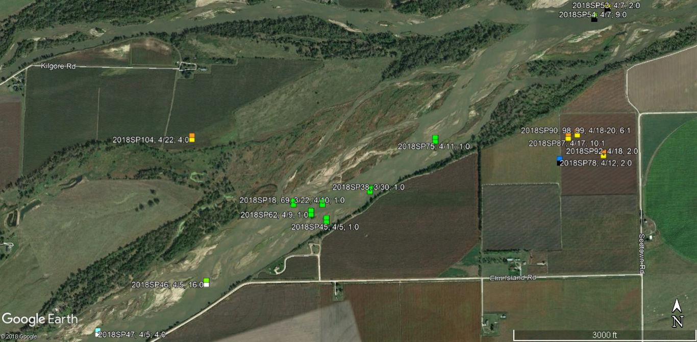

FIGURE 12. Observed whooping crane locations. 6 of 11 collective crane group maps. See Table 1 for icon color coding and details.
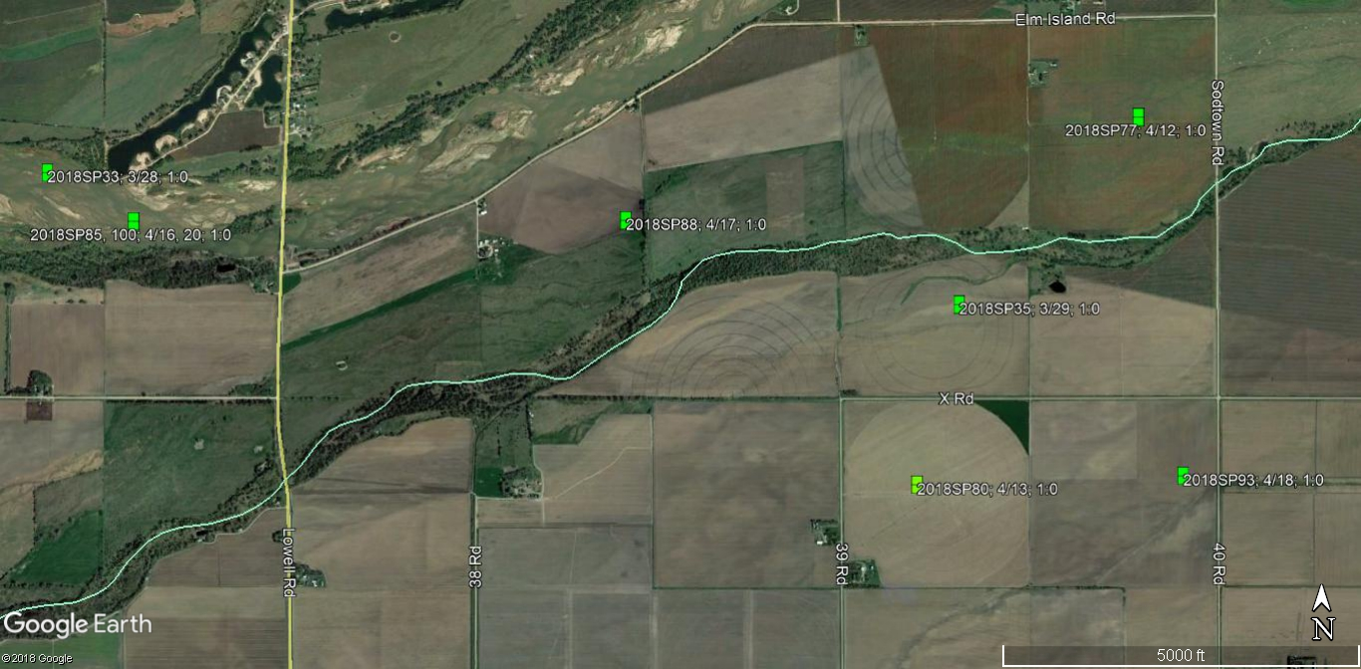

FIGURE 13. Observed whooping crane locations. 7 of 11 collective crane group maps. See Table 1 for icon color coding and details.
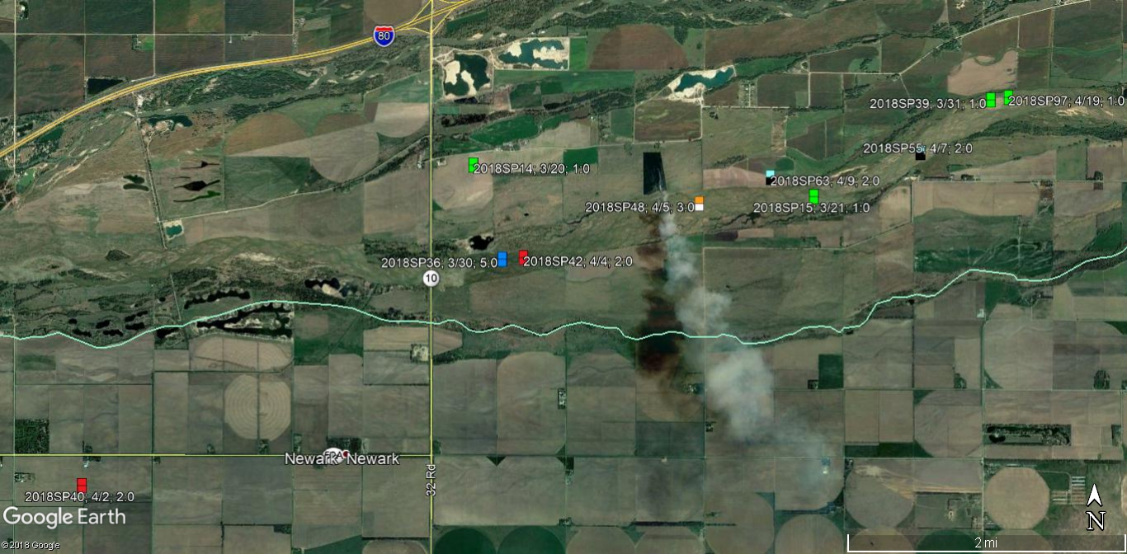

FIGURE 14. Observed whooping crane locations. 8 of 11 collective crane group maps. See Table 1 for icon color coding and details.
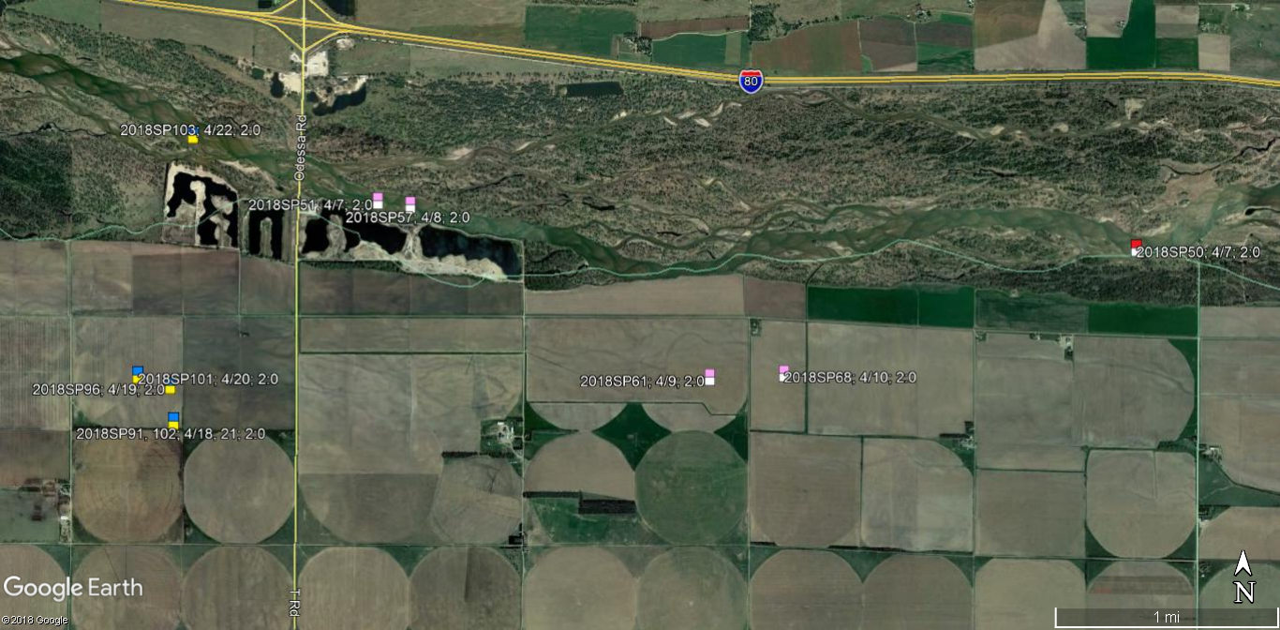

FIGURE 15. Observed whooping crane locations. 9 of 11 collective crane group maps. See Table 1 for icon color coding and details.
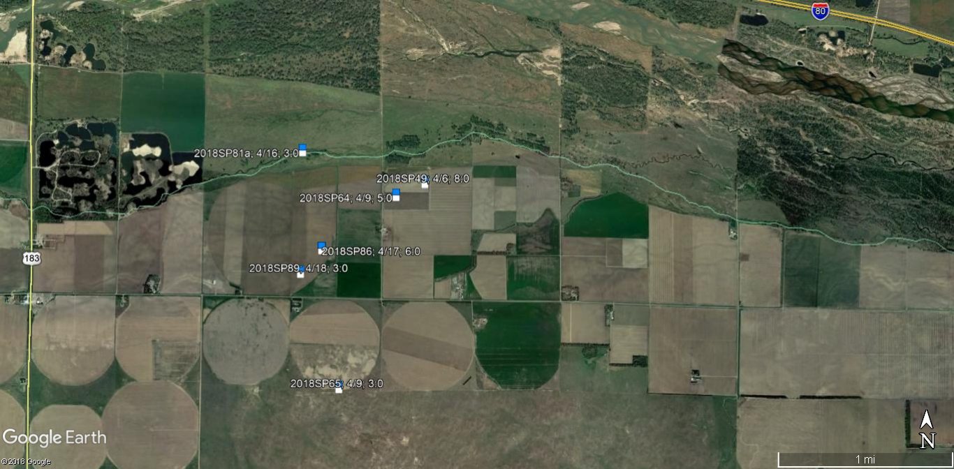

FIGURE 16. Observed whooping crane locations. 10 of 11 collective crane group maps. See Table 1 for icon color coding and details.
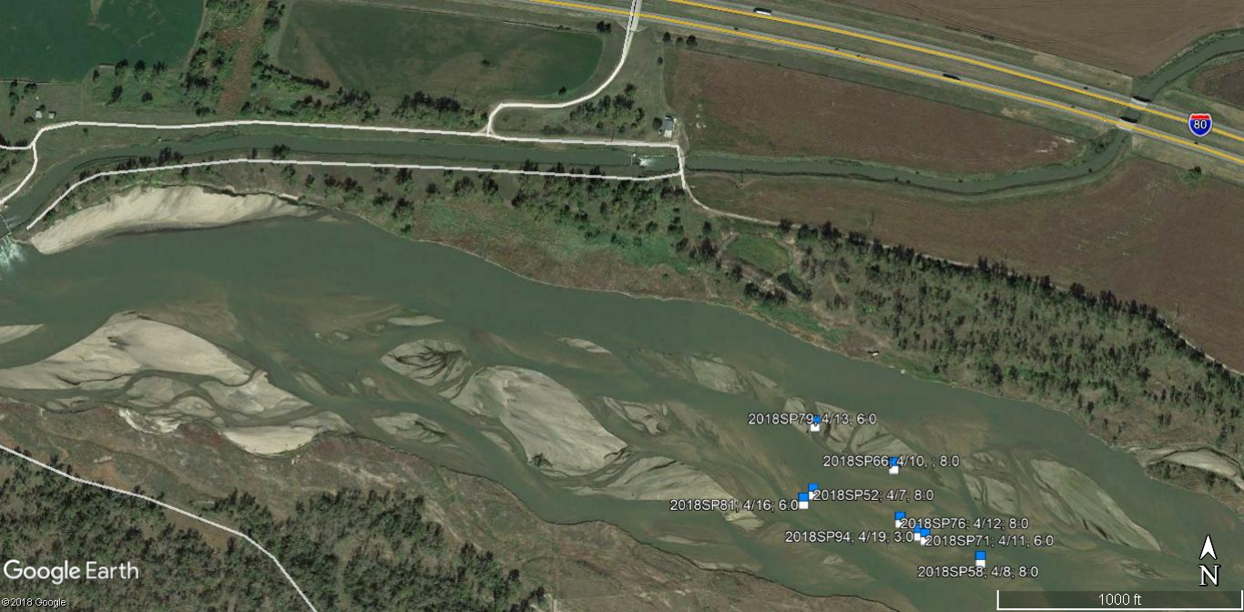

FIGURE 17. Observed whooping crane locations. 11 of 11 collective crane group maps. See Table 1 for icon color coding and details.
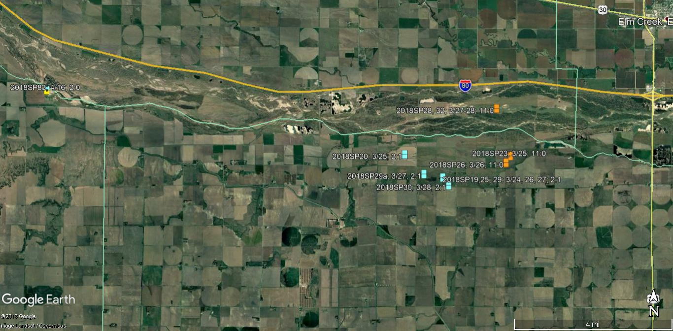

FIGURE 18. Observed locations of the 1:0 crane group designated with ID #’s: 2018SP01-13, 16, 17, 22, 24, 27, 31, 34, & 37. This group was observed in the survey area 2/28-3/30.

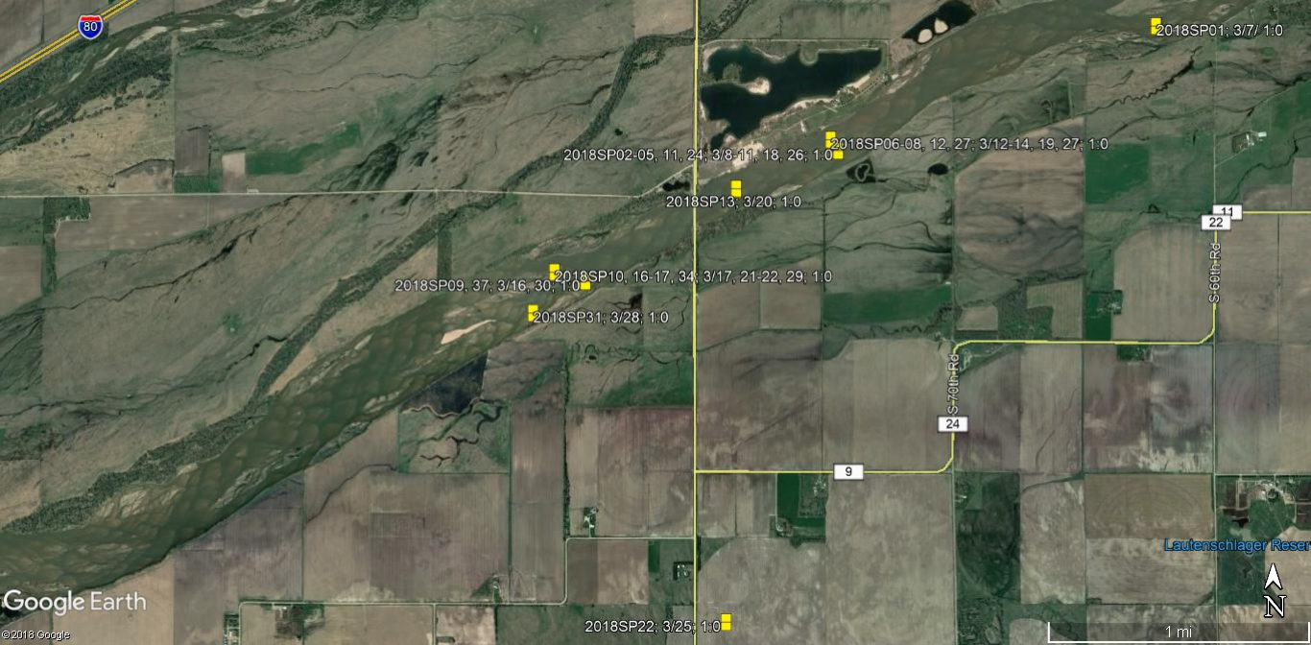
FIGURE 19. This photo was taken during a systematic observation of the 1:0 crane group 2018SP02 at Use Site 2 on 3/8 in the main channel of the Platte River.
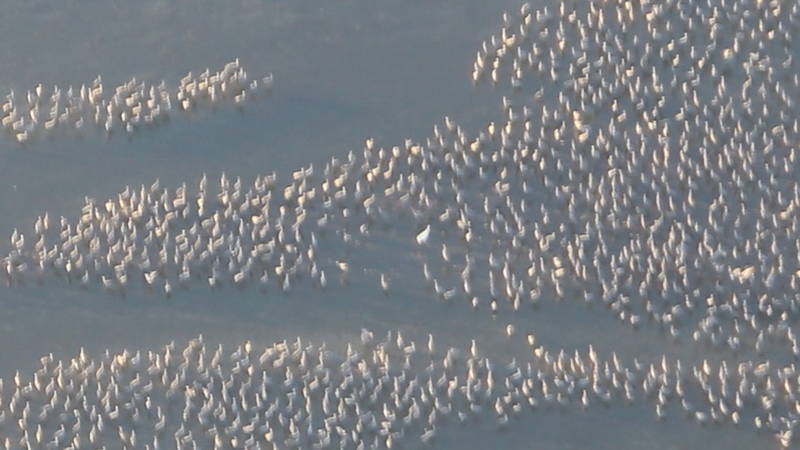
FIGURE 20. Map 1 of 4 of observed locations of the 1:0 crane group designated with ID #’s: 2018SP14, 15, 18, 21, 33, 35, 38, 39, 41, 45, 56, 62, 69, 75, 77, 80, 85, 88, 93, 97, & 100. This group was observed in the survey area 3/20-4/20.
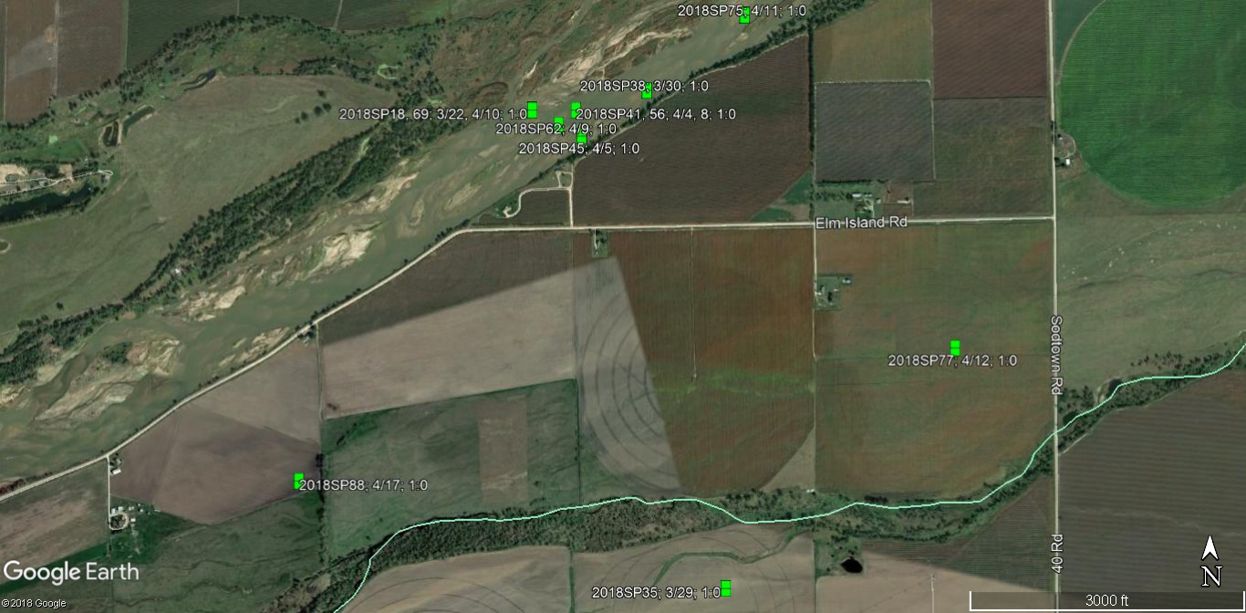
FIGURE 21. Map 2 of 4 of observed locations of the 1:0 crane group designated with ID #’s: 2018SP14, 15, 18, 21, 33, 35, 38, 39, 41, 45, 56, 62, 69, 75, 77, 80, 85, 88, 93, 97, & 100. This group was observed in the survey area 3/20-4/20.
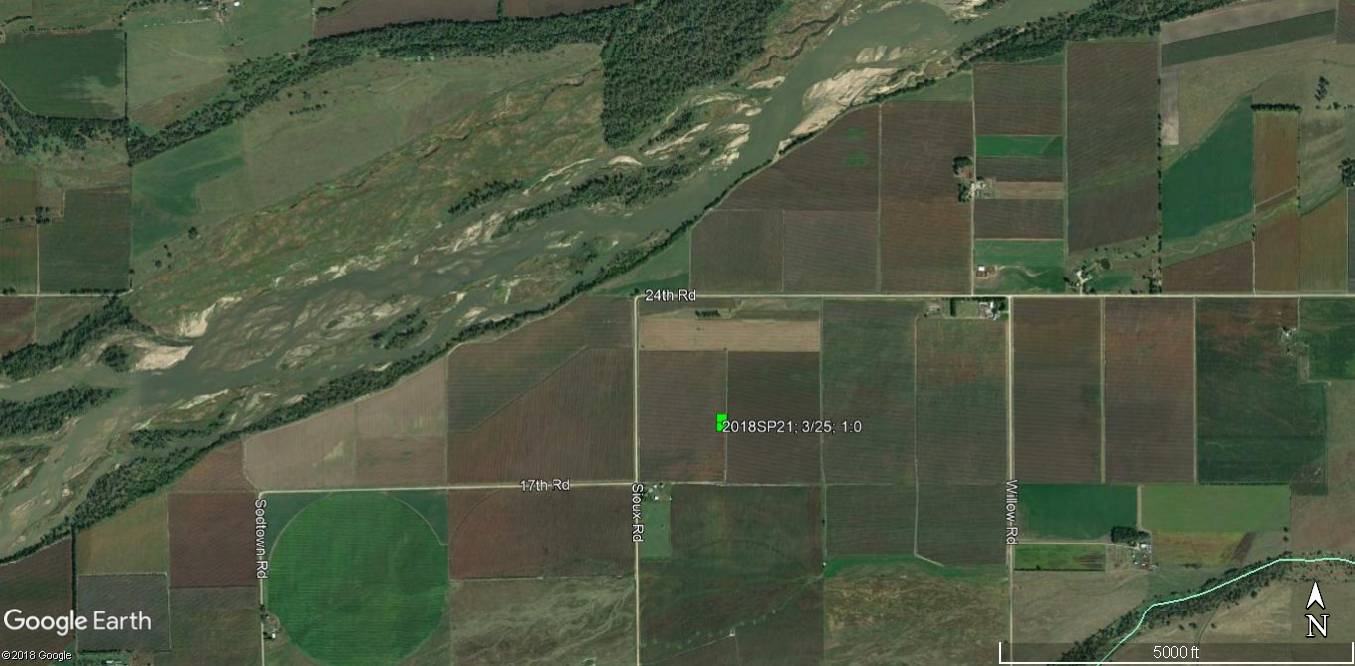
FIGURE 22. Map 3 of 4 of observed locations of the 1:0 crane group designated with ID #’s: 2018SP14, 15, 18, 21, 33, 35, 38, 39, 41, 45, 56, 62, 69, 75, 77, 80, 85, 88, 93, 97, & 100. This group was observed in the survey area 3/20-4/20.
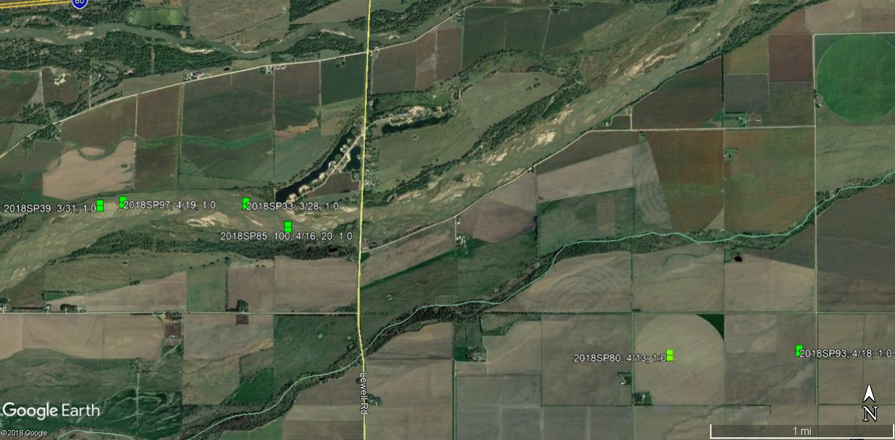
FIGURE 23. Map 4 of 4 of observed locations of the 1:0 crane group designated with ID #’s: 2018SP14, 15, 18, 21, 33, 35, 38, 39, 41, 45, 56, 62, 69, 75, 77, 80, 85, 88, 93, 97, & 100. This group was observed in the survey area 3/20-4/20.
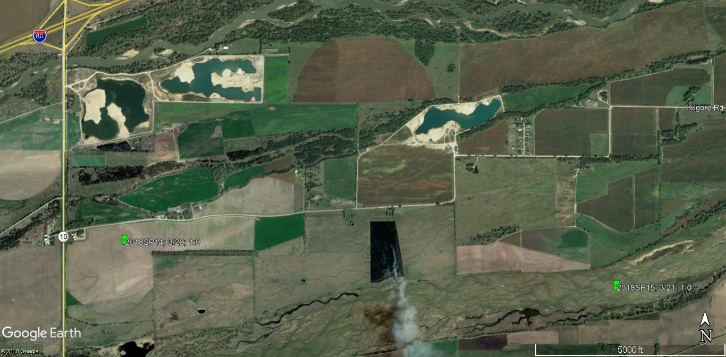
FIGURE 24. This photo was taken during a systematic observation of the 1:0 crane group 2018SP18 on 3/22 at use site 8 in the main channel of the Platte River.
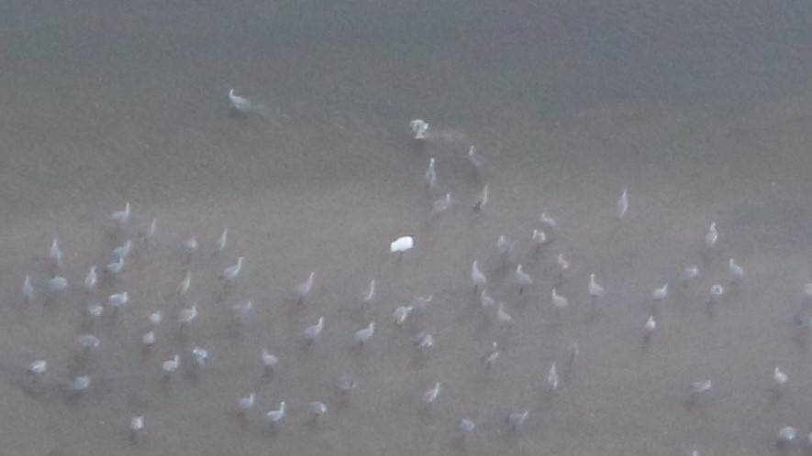

FIGURE 25. Observed locations of the 2:1 crane group designated with ID #’s: 2018SP19, 20, 25, 29, 29a, & 30. This group was observed in the survey area 3/24-3/28.
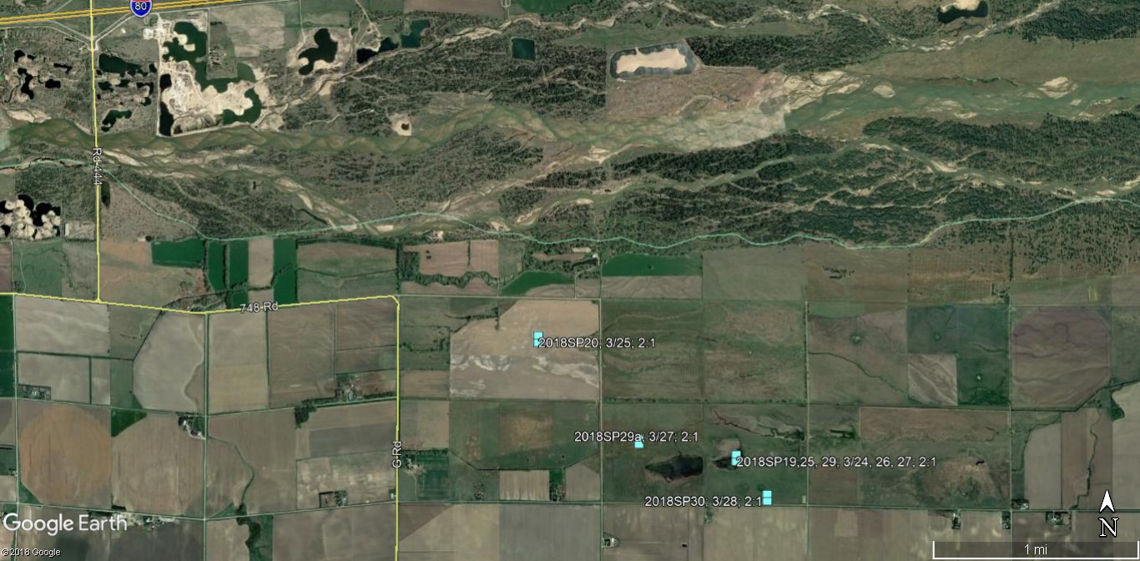
FIGURE 26. This photo was taken during a systematic observation of the 2:1 crane group 2018SP29a at use site 11 on 3/27 in a small wetland on the east end of the Morse property.
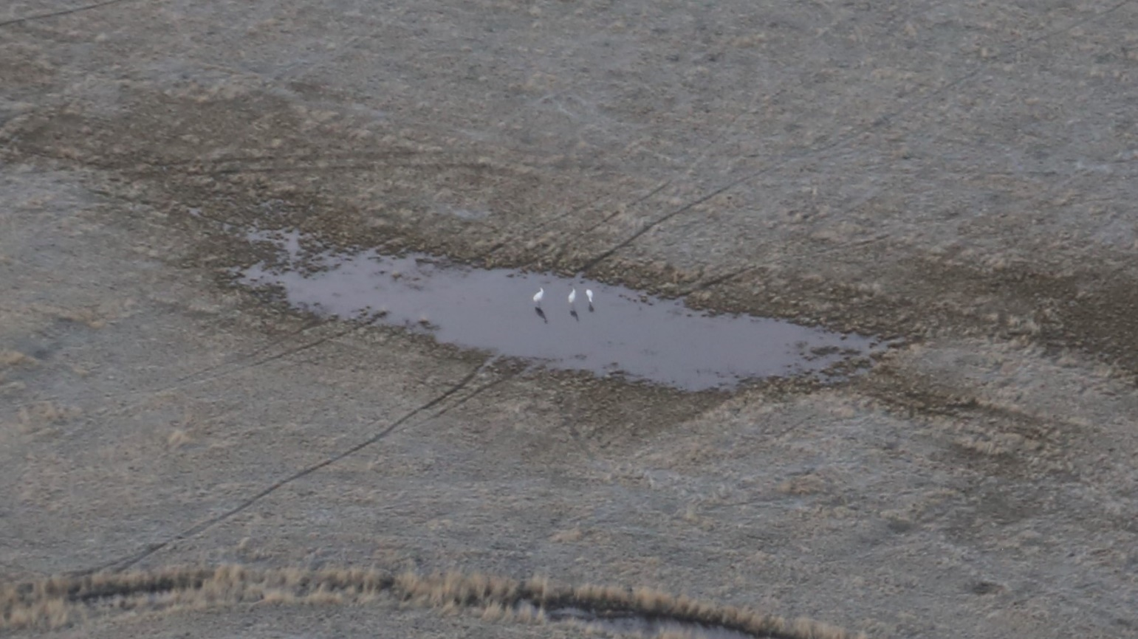
FIGURE 27. Observed locations of the 11:0 crane group designated with ID #’s: 2018SP23, 26, 28, & 32. This group was observed in the survey area 3/20-3/28.
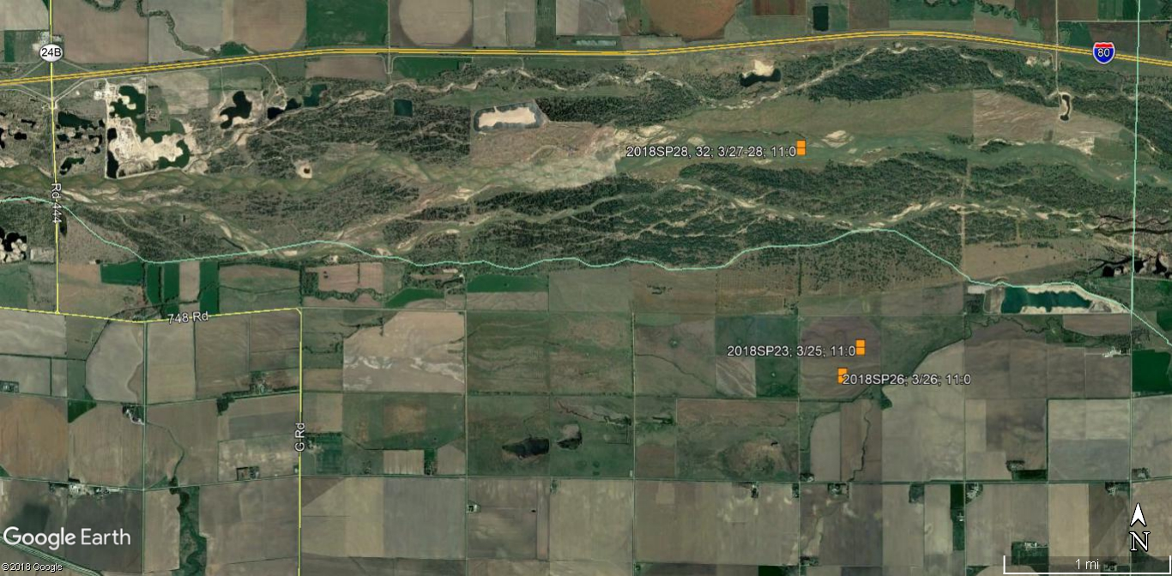
FIGURE 28. This photo was taken during the systematic observation of the 11:0 crane group 2018SP28 at use site 10 on 3/27 in the main channel of the Platte River.
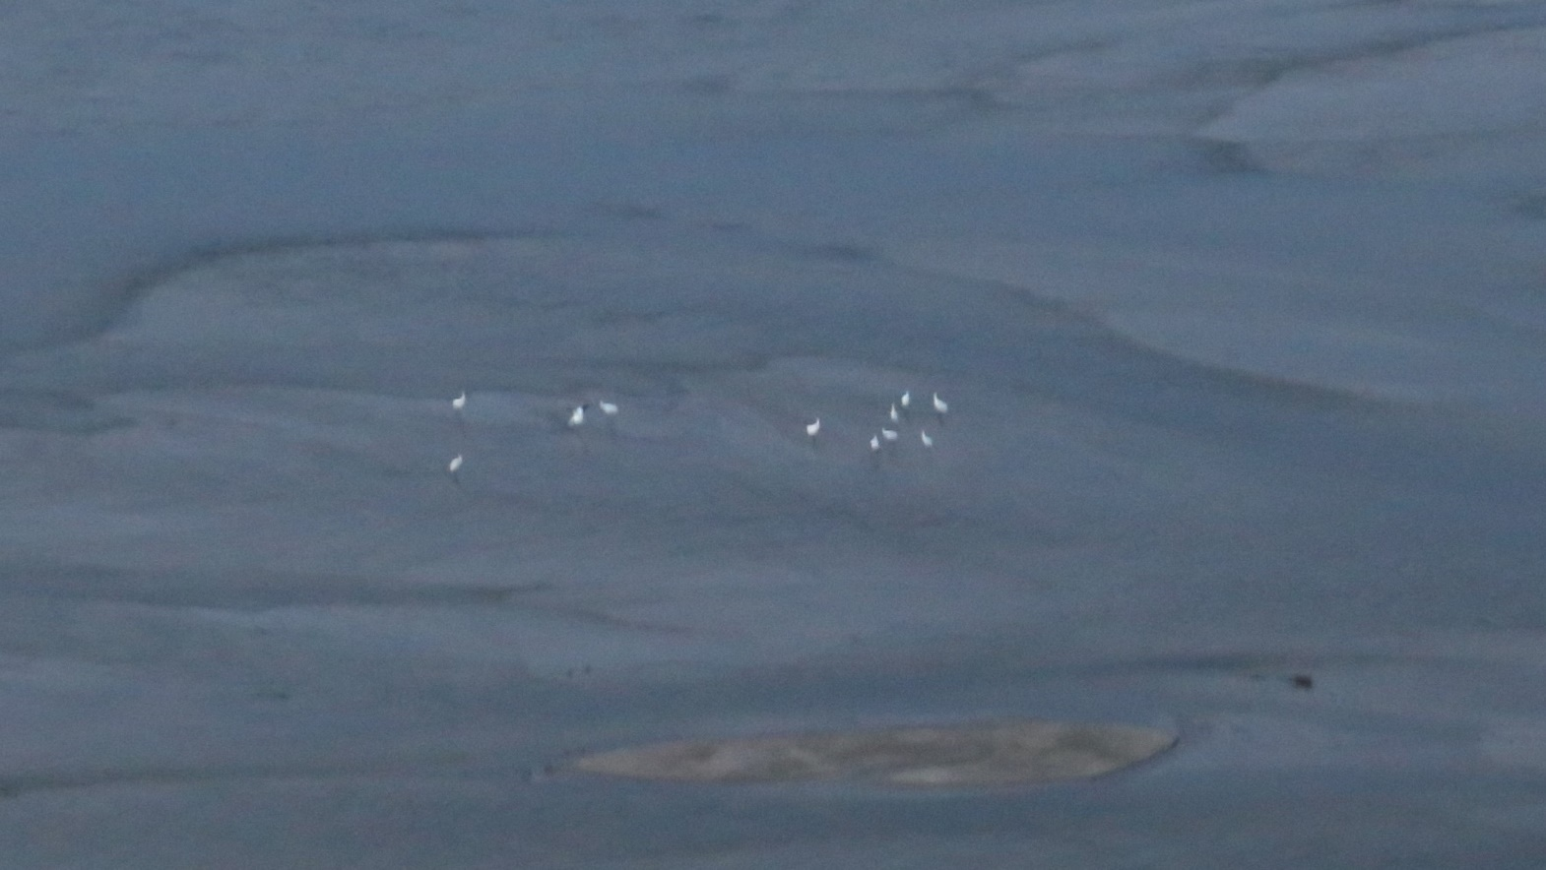
FIGURE 29. Observed location of the 5:0 crane group designated with ID # 2018SP36. This group was observed in the survey area 3/29-30.
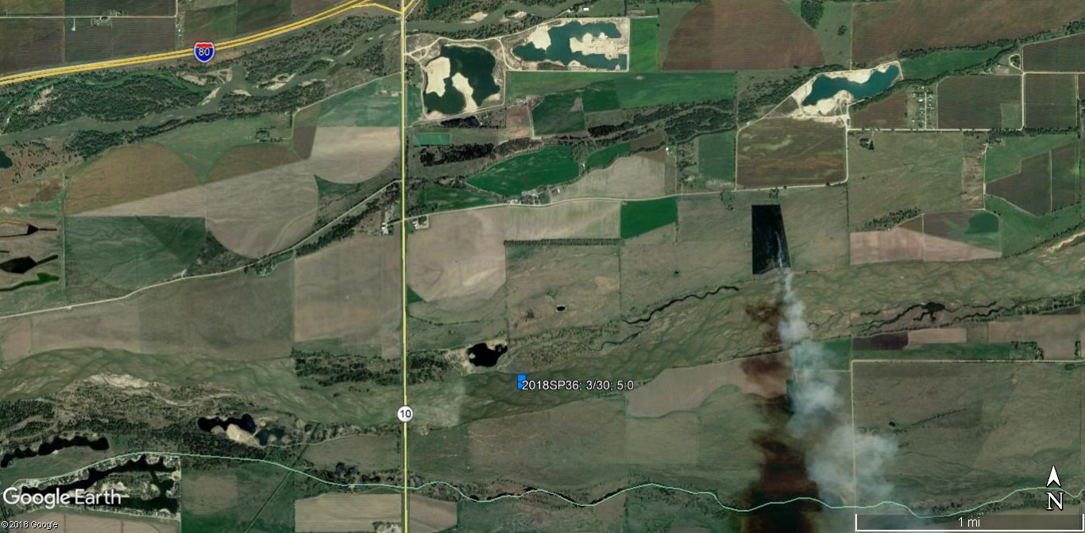
FIGURE 30. This photo was taken during a systematic observation of the 5:0 crane group 2018SP36 use site 14 on 3/30 in the main channel of the Platte River.
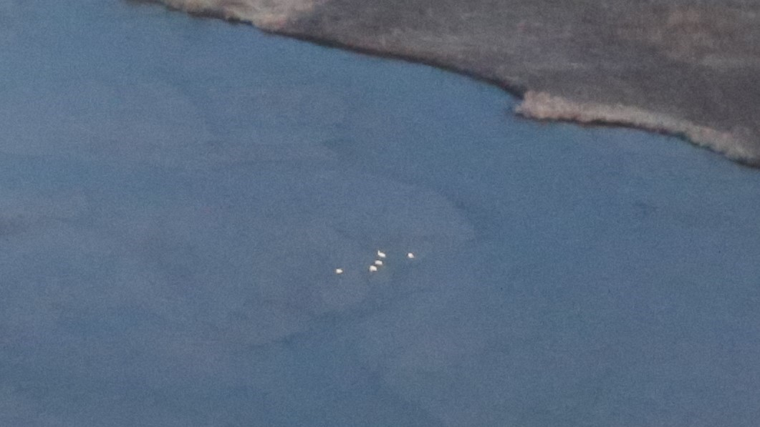
FIGURE 31. Observed locations of the 2:0 crane group designated with ID #’s: 2018SP40 & 42. This group was observed in the survey area 4/02-4/04.
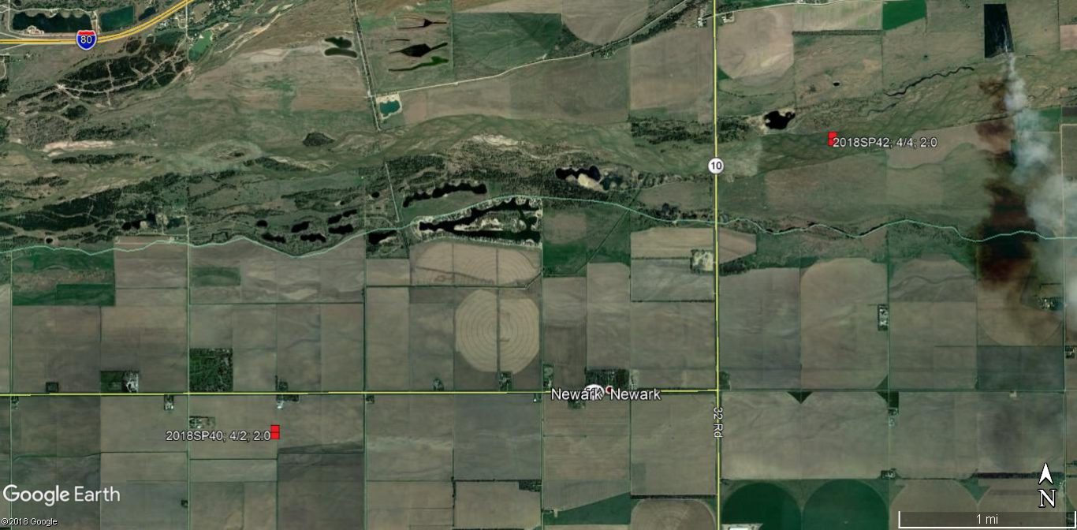
FIGURE 32. This photo was taken during a systematic observation of the 2:0 crane group 2018SP42 use site 18 on 4/04 in the main channel of the Platte River.
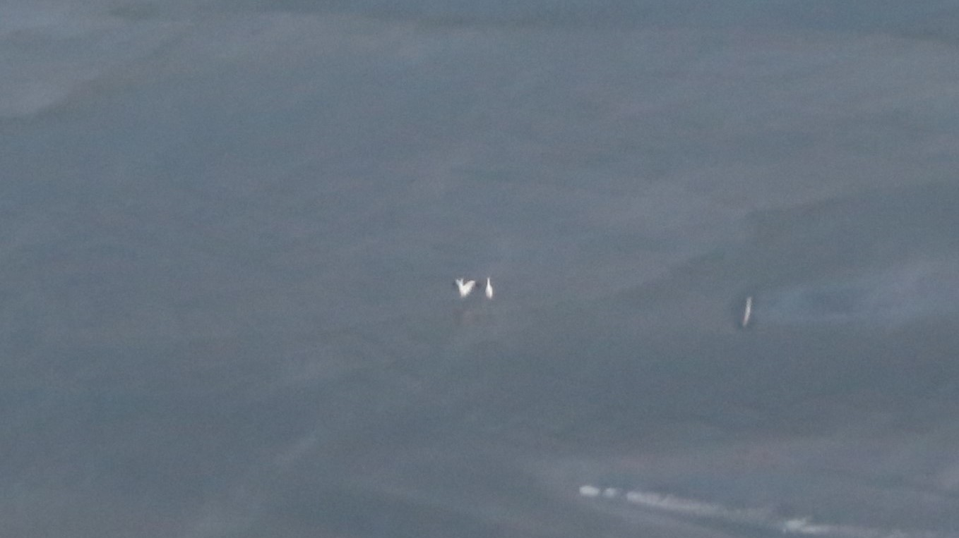
FIGURE 33. Observed location of the 4:0 crane group designated with ID # 2018SP43. This group was observed in the survey area on 4/05.
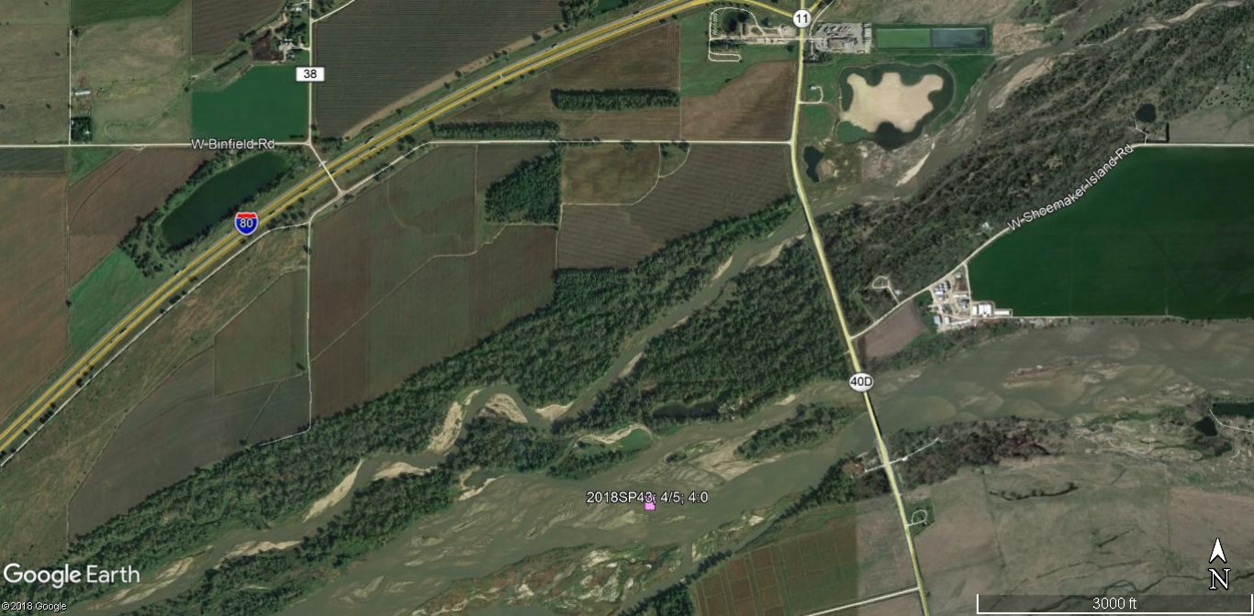
FIGURE 34. This photo was taken during a systematic observation of the 4:0 crane group 2018SP43 use site 19 on 4/05 in the main channel of the Platte River.
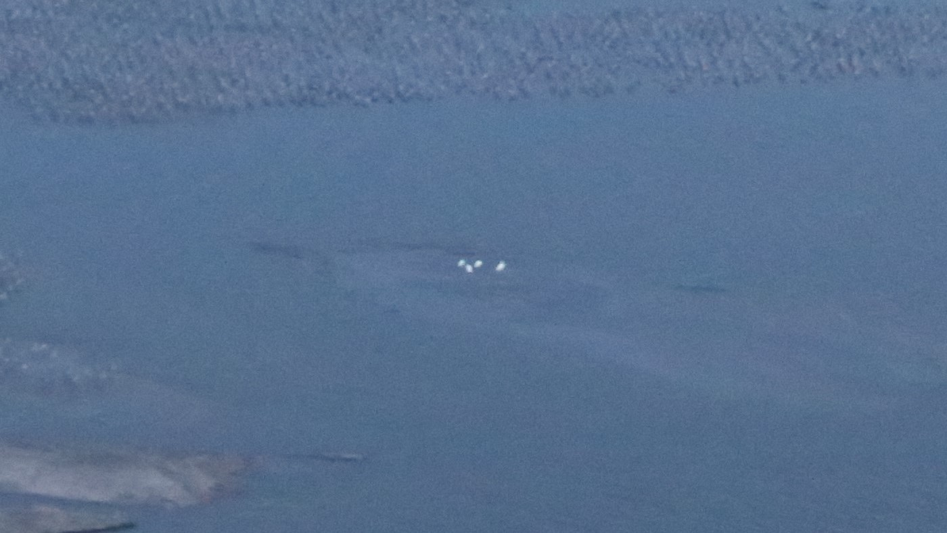
FIGURE 35. Observed location of the 7:0 crane group designated with ID # 2018SP44. This group was observed in the survey area on 4/05.
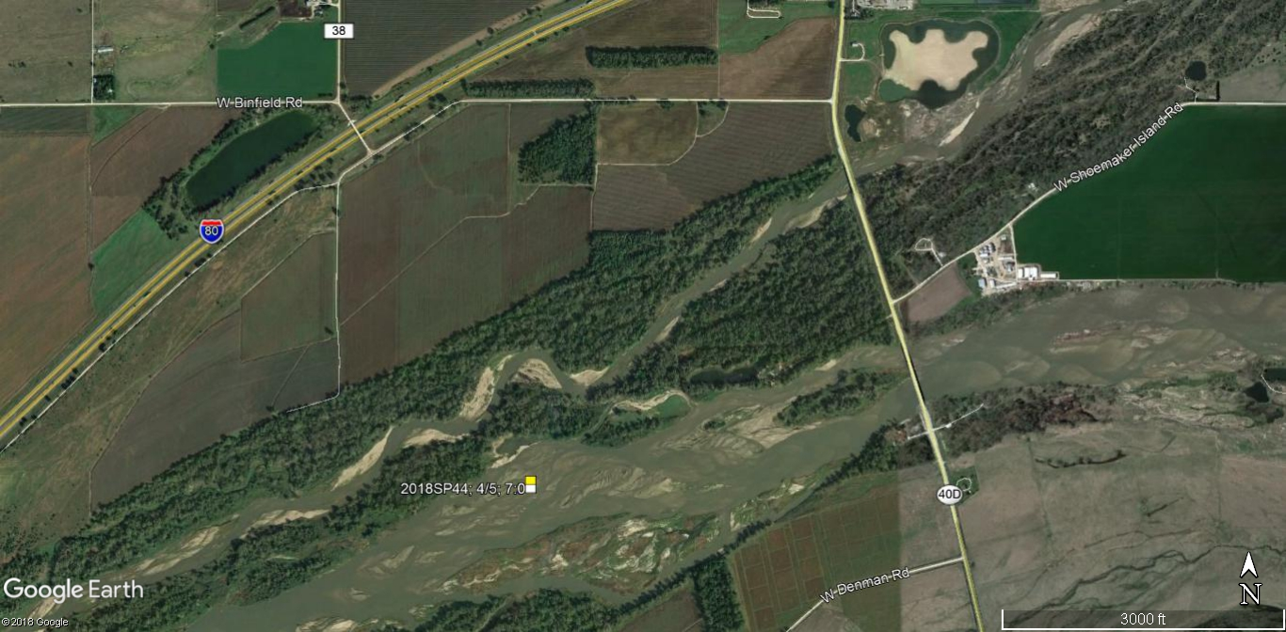
FIGURE 36. This photo was taken during a systematic observation of the 7:0 crane group 2018SP44 use site 20 on 4/05 in the main channel of the Platte River.
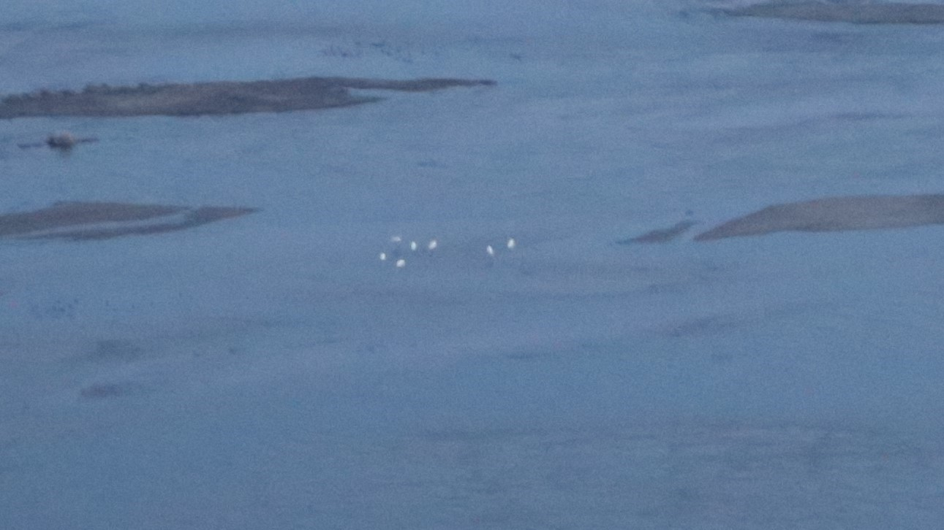
FIGURE 37. Observed location of the 16:0 crane group designated with ID # 2018SP46. This group was observed in the survey area on 4/05.
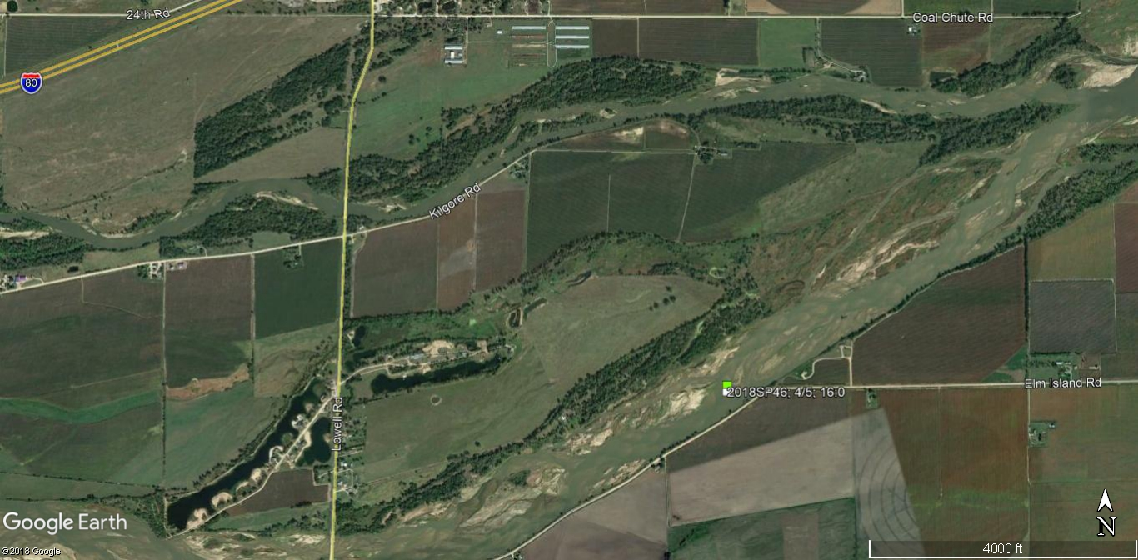
FIGURE 38. This photo was taken during a systematic observation of the 16:0 crane group 2018SP46 use site 22 on 4/05 in the main channel of the Platte River.
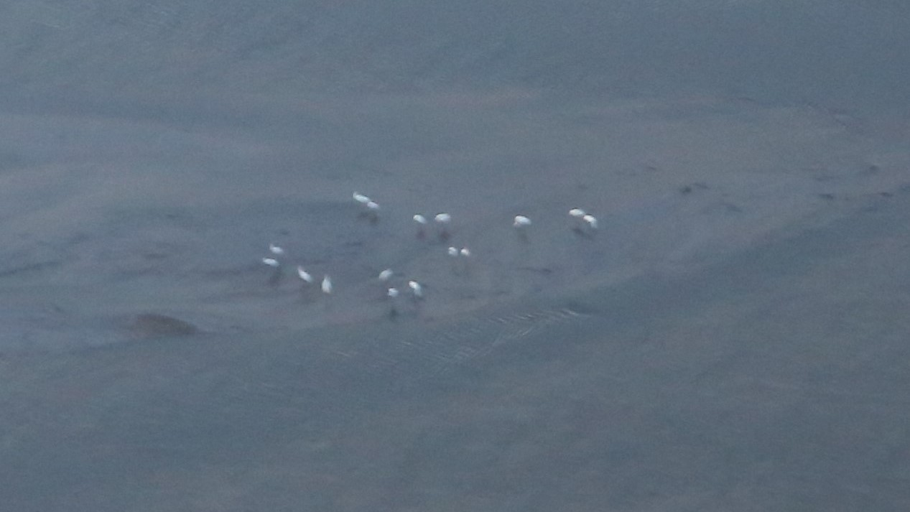
FIGURE 39. Observed location of the 4:0 crane group designated with ID # 2018SP47. This group was observed in the survey area on 4/05.
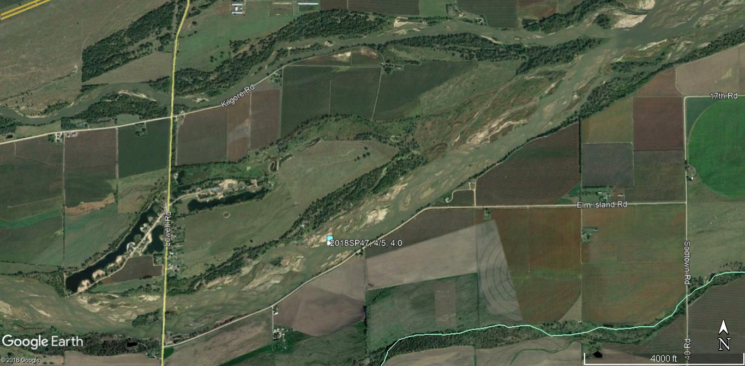
FIGURE 40. This photo was taken during a systematic observation of the 4:0 crane group 2018SP47 use site 23 on 4/05 in the main channel of the Platte River.
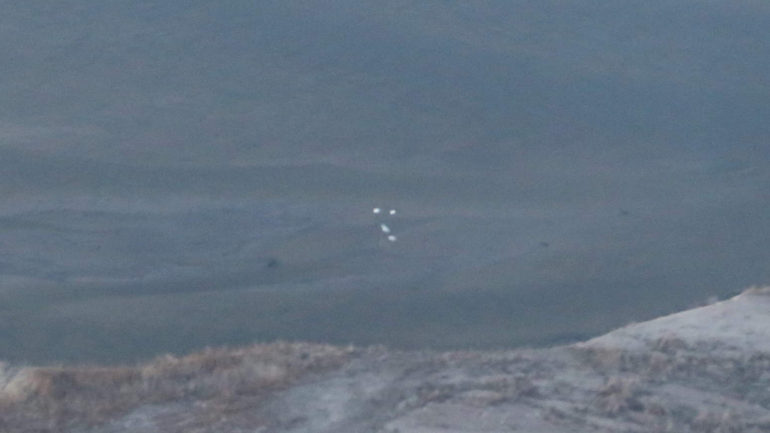
FIGURE 41 Observed location of the 3:0 crane group designated with ID # 2018SP48. This group was observed in the survey area on 4/05.
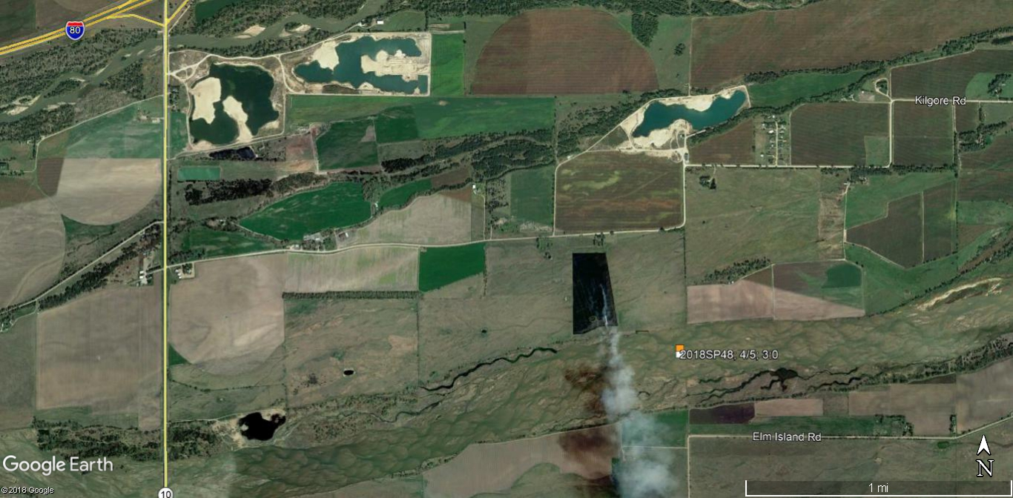
FIGURE 42. This photo was taken during a systematic observation of the 3:0 crane group 2018SP48 use site 24 on 4/05 in the main channel of the Platte River.
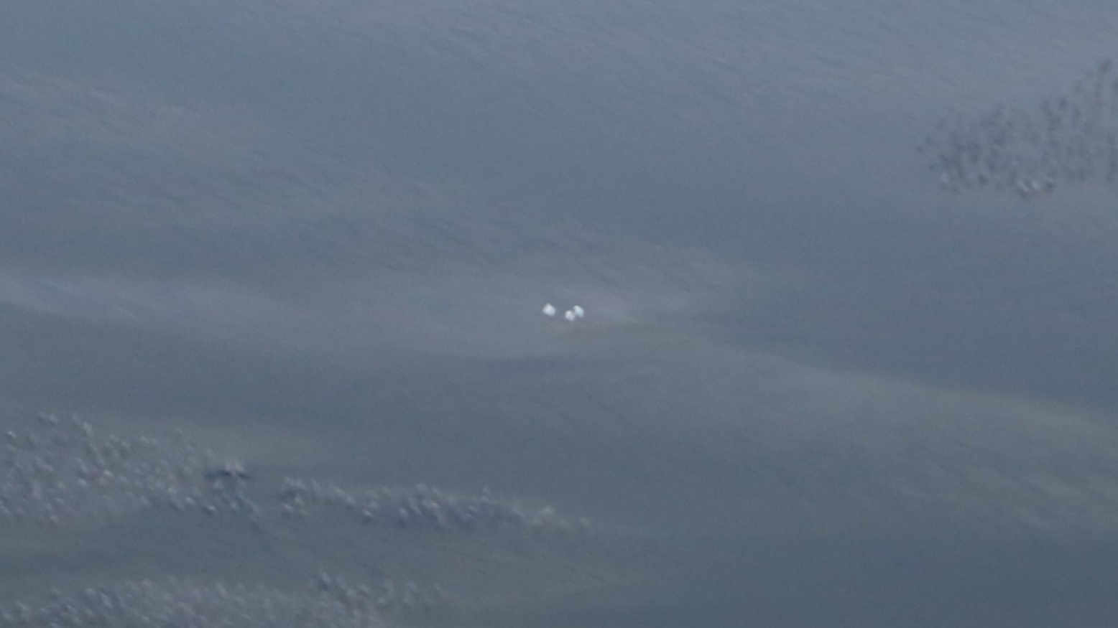
FIGURE 43. Observed locations of the 8:0 crane group designated with ID #’s: 2018SP49, 52, 58, 64-66, 71, 76, 79, 81, 81a, 86, 89 & 94. This group also separated into smaller groups (See Table 1) and was observed in the survey area 4/06-4/19.
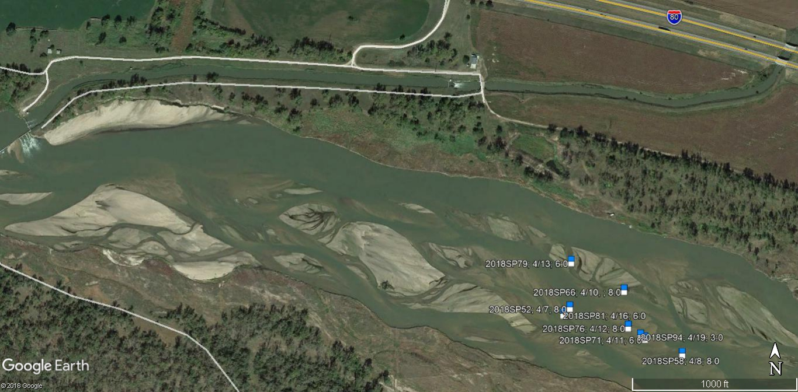
FIGURE 44. Observed locations of the 8:0 crane group designated with ID #’s: 2018SP49, 52, 58, 64-66, 71, 76, 79, 81, 81a, 86, 89 & 94. This group also separated into smaller groups (See Table 1) and was observed in the survey area 4/06-4/19.
FIGURE 45. This photo was taken during a systematic observation of the 8:0 crane group 2018SP52 use site 27 on 4/07 in the main channel of the Platte River.
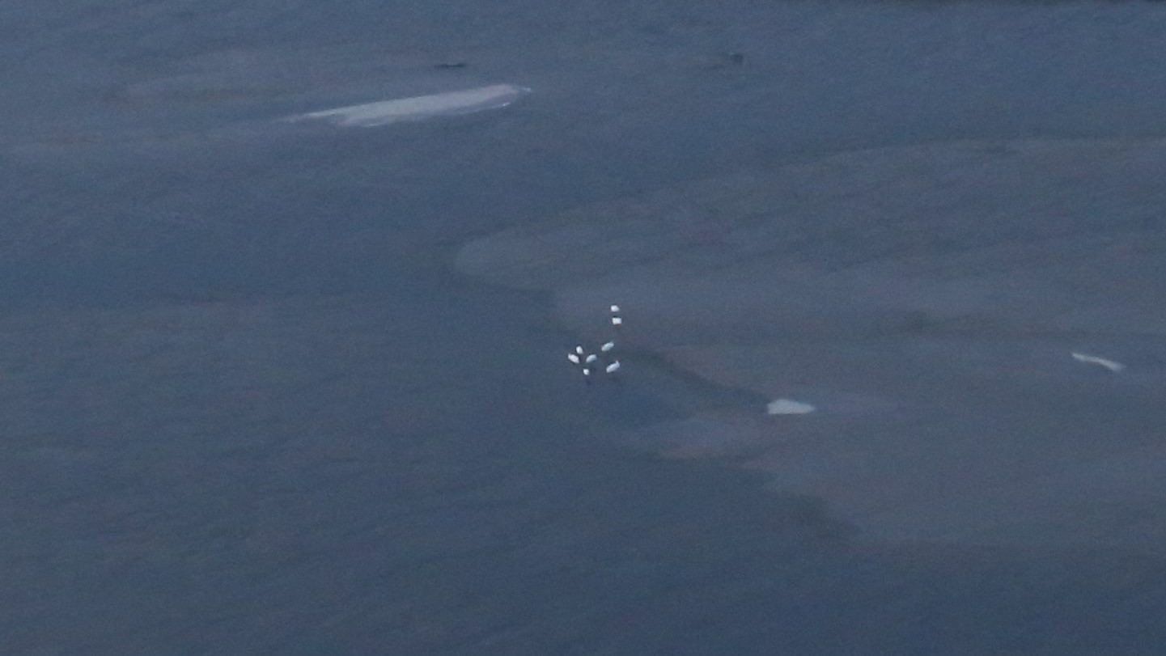

FIGURE 46. Observed location of the 2:0 crane group designated with ID # 2018SP50. This group was observed in the survey area on 4/07.
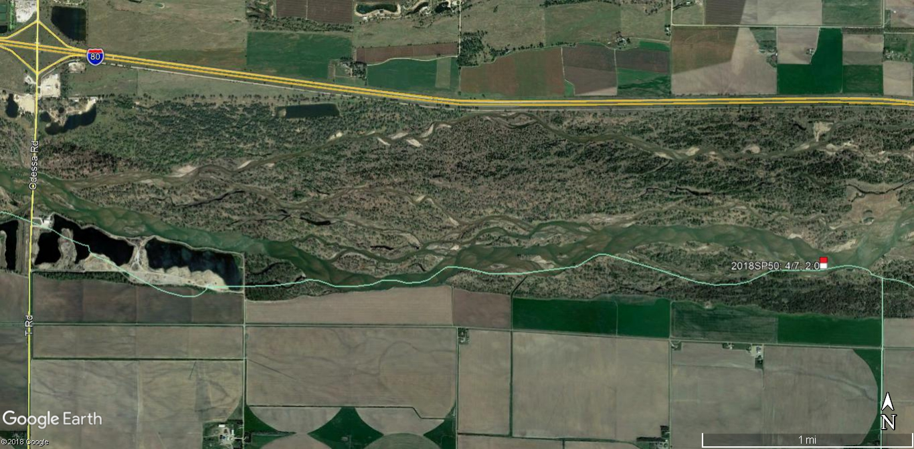
FIGURE 47 This photo was taken during a systematic observation of the 2:0 crane group 2018SP50 use site 25 on 4/07 in the main channel of the Platte River.
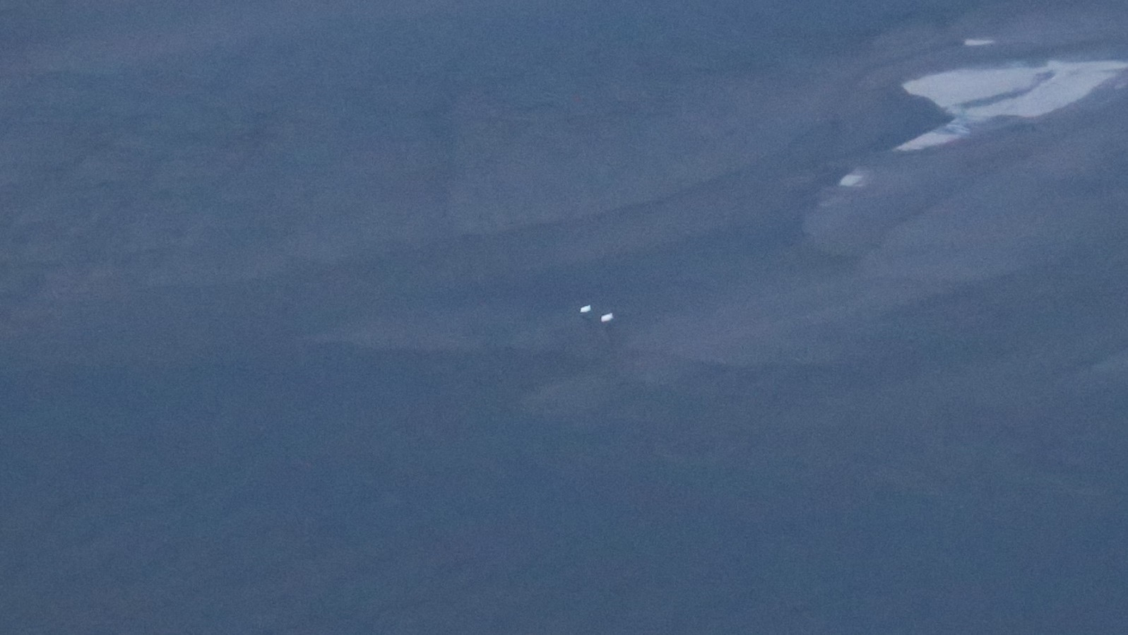
FIGURE 48. Observed location of the 2:0 crane group designated with ID # 2018SP53. This group was observed in the survey area on 4/07.
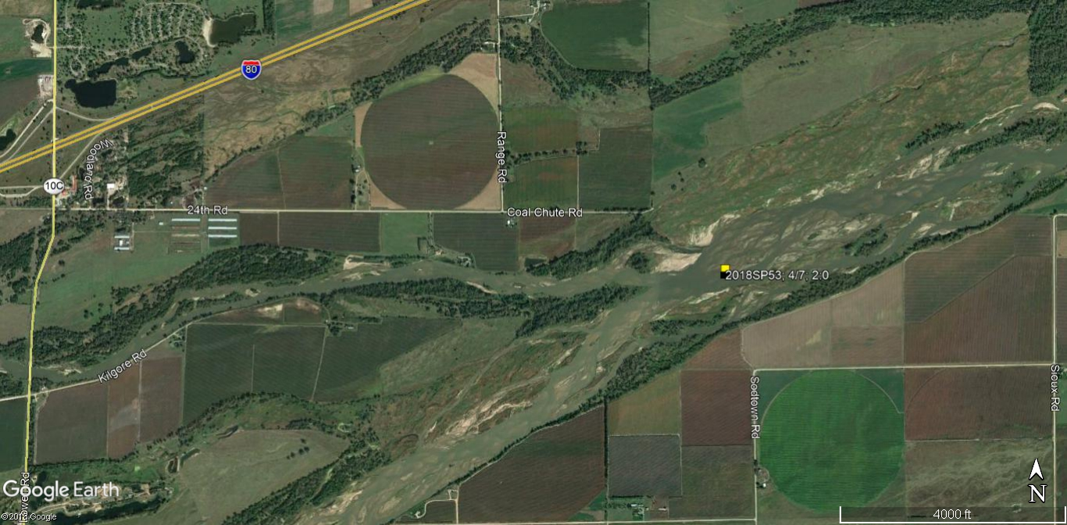
FIGURE 49. This photo was taken during a systematic observation of the 2:0 crane group 2018SP53 use site 28 on 4/07 in the main channel of the Platte River.
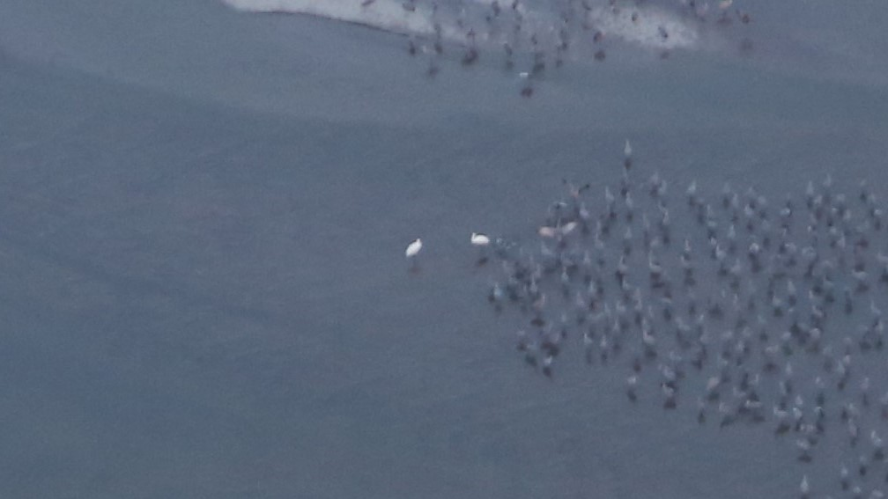
FIGURE 50. Observed location of the 9:0 crane group designated with ID # 2018SP54. This group was observed in the survey area on 4/07.
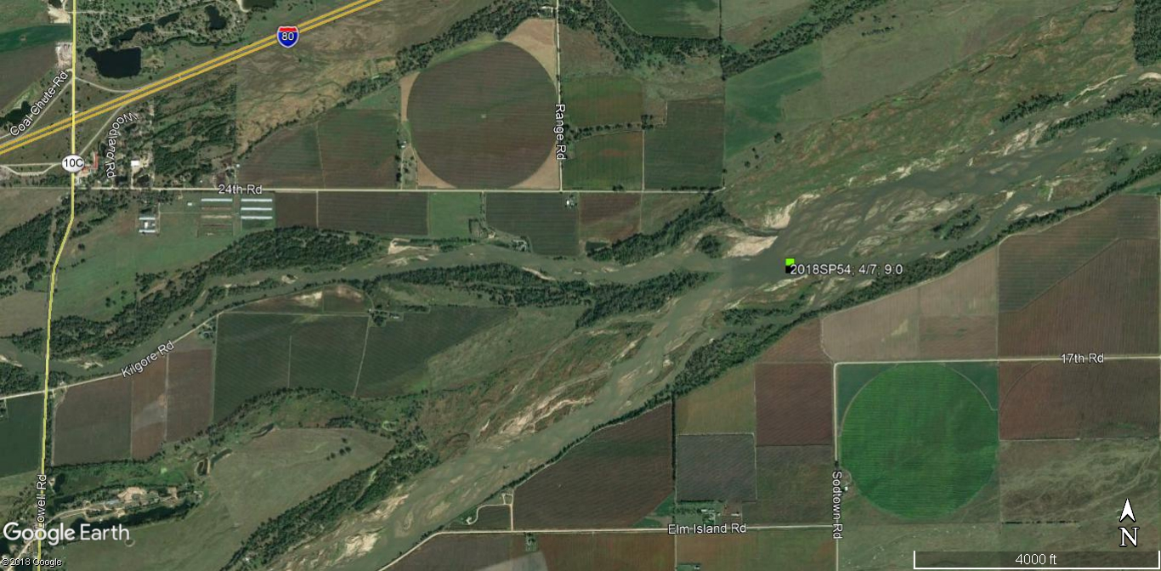
FIGURE 51. This photo was taken during a systematic observation of the 9:0 crane group 2018SP54 use site 29 on 4/07 in the main channel of the Platte River.
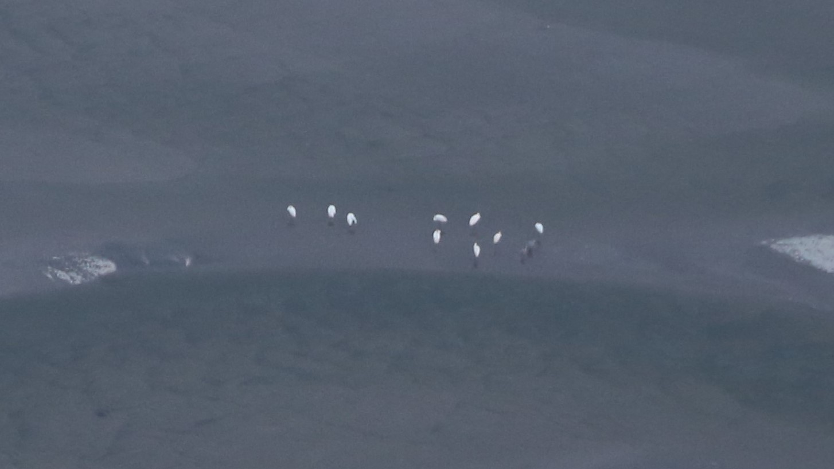
FIGURE 52. Observed locations of the 2:0 crane group designated with ID #’s: 2018SP55 & 63. This group was observed in the survey area 4/06-4/09.
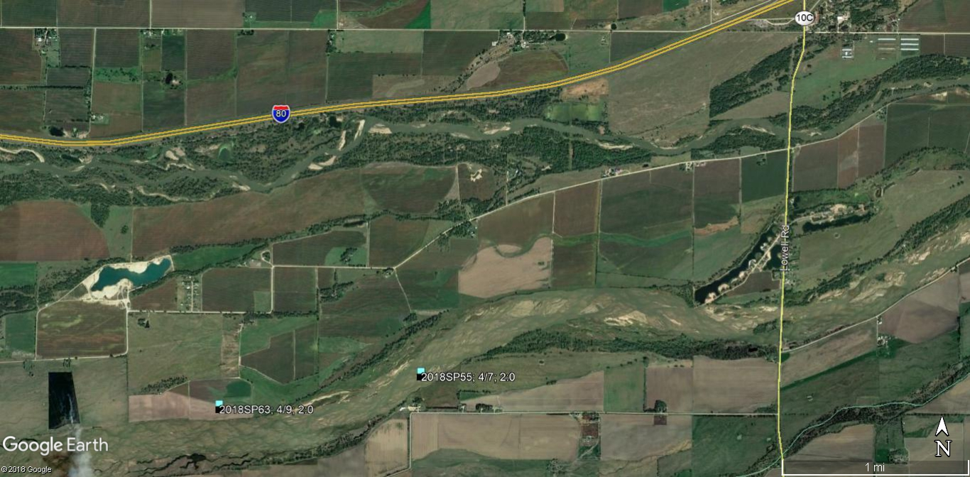
FIGURE 53. This photo was taken during a systematic observation of the 2:0 crane group 2018SP55 use site 30 on 4/07 in the main channel of the Platte River.
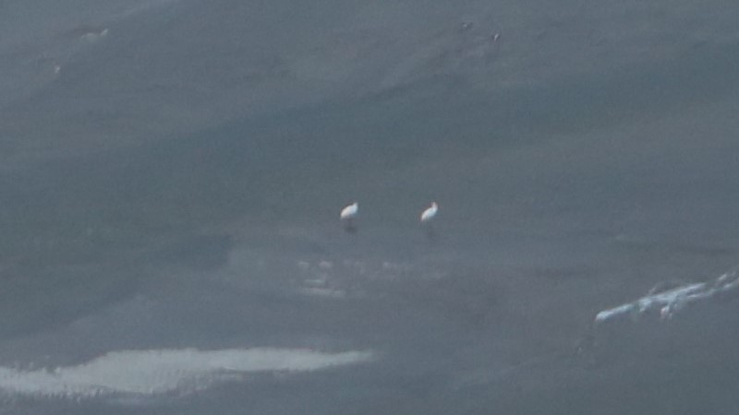
FIGURE 54. Observed locations of the 2:0 crane group designated with ID #’s: 2018SP51, 57, 61 & 68. This group was observed in the survey area 4/07-4/10.
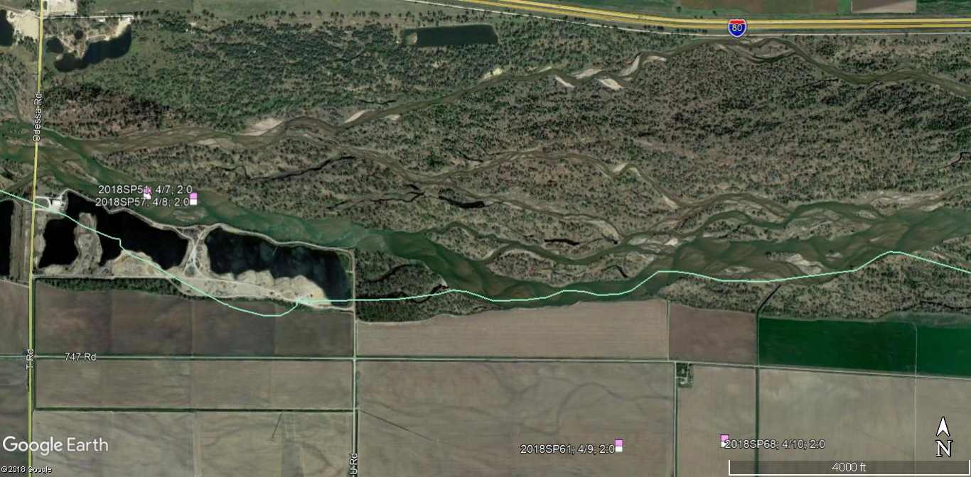
FIGURE 55. This photo was taken during a systematic observation of the 2:0 crane group 2018SP51 use site 26 on 4/07 in the main channel of the Platte River.
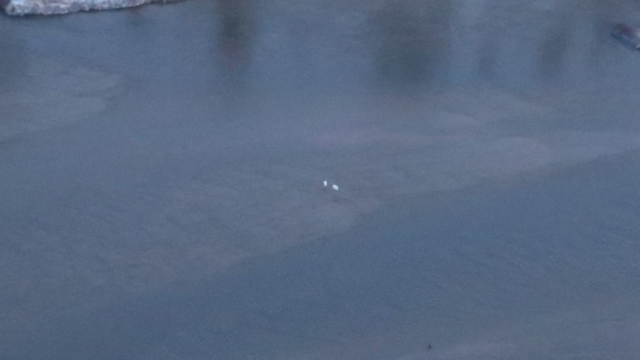
FIGURE 56. Observed locations of the 9:0 (also observed as a 7:0 & 2:0 group) crane group designated with ID #’s: 2018SP59, 60, 67 & 70. This group was observed in the survey area 4/07-4/10.
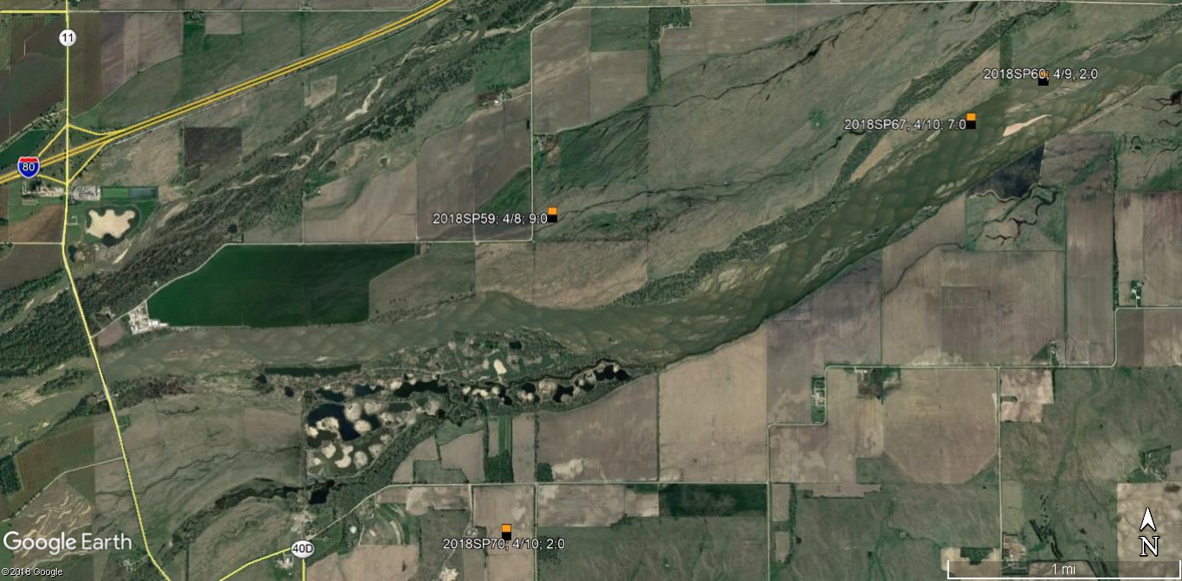
FIGURE 57. This photo was taken during a ground observation of the 9:0 crane group 2018SP59 on 4/07 in a cornfield.
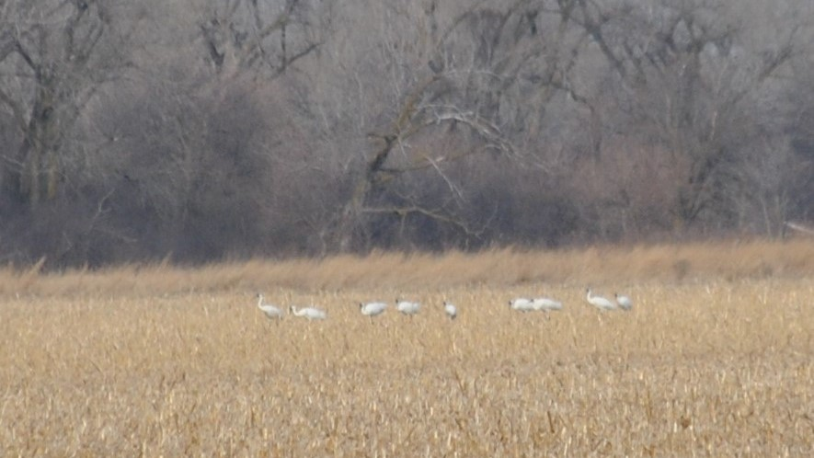
FIGURE 58. Observed locations of the 4:0 crane group designated with ID #’s: 2018SP72 & 78. This group was observed in the survey area 4/11-4/12.
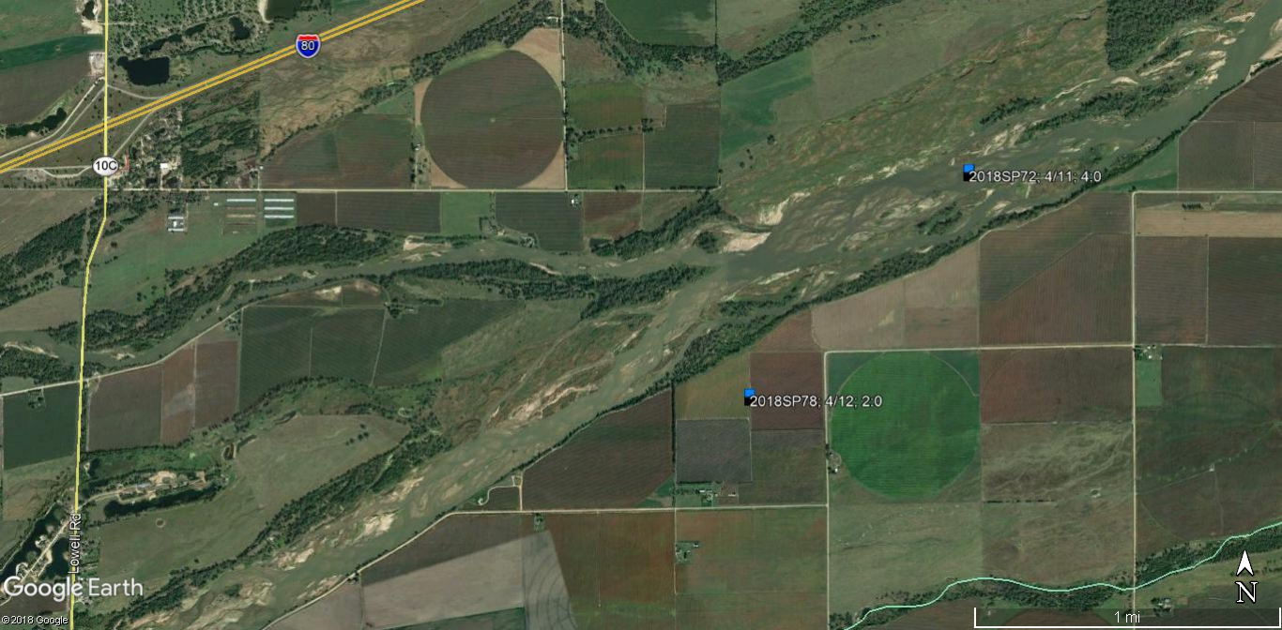
FIGURE 59. This photo was taken during a systematic observation of the 4:0 crane group 2018SP72 use site 38 on 4/11 in the main channel of the Platte River.
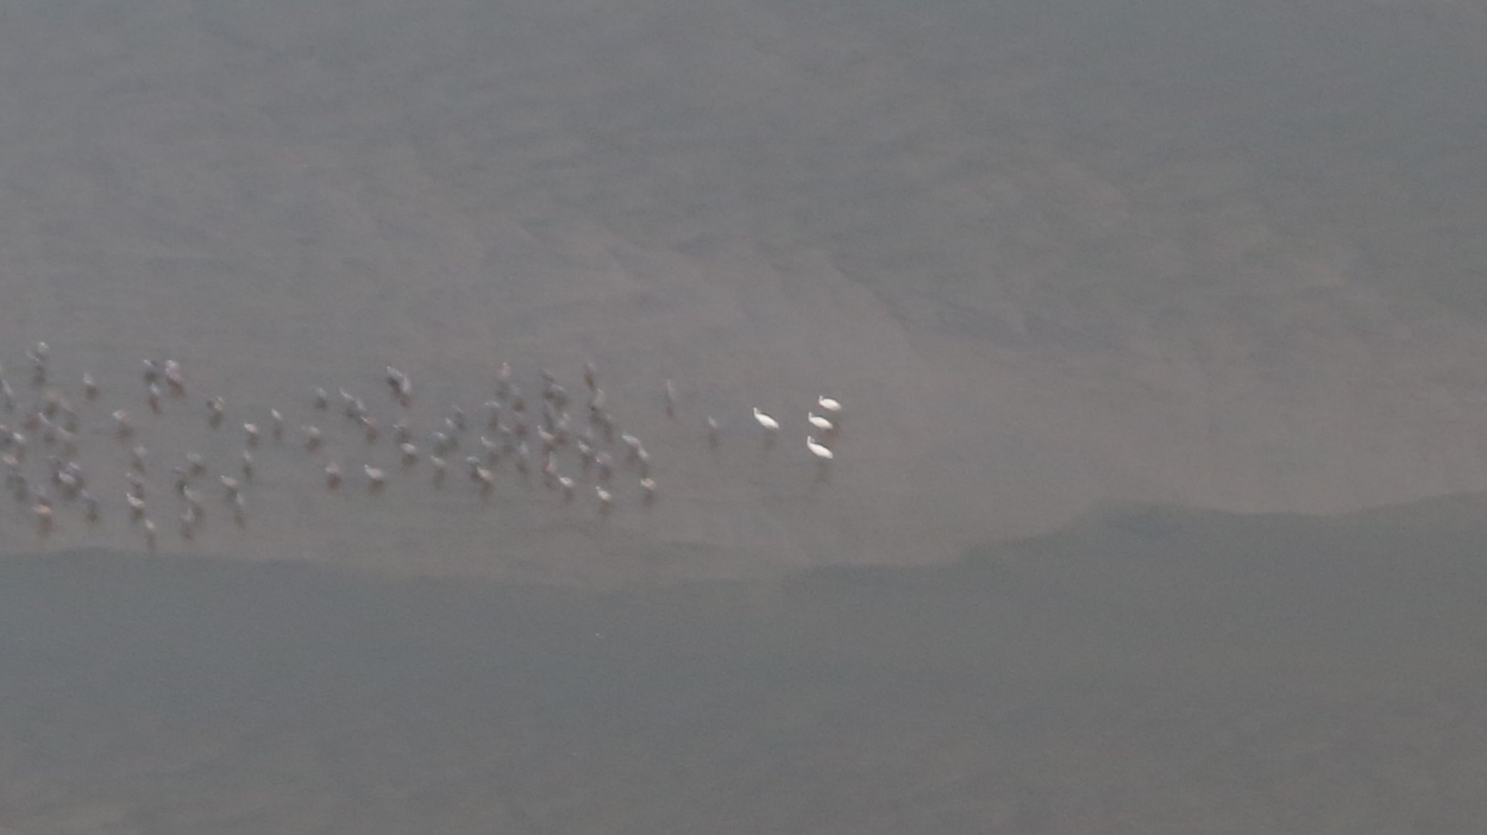
FIGURE 60. Observed location of the 3:0 crane group designated with ID # 2018SP73. This group was observed in the survey area on 4/11.
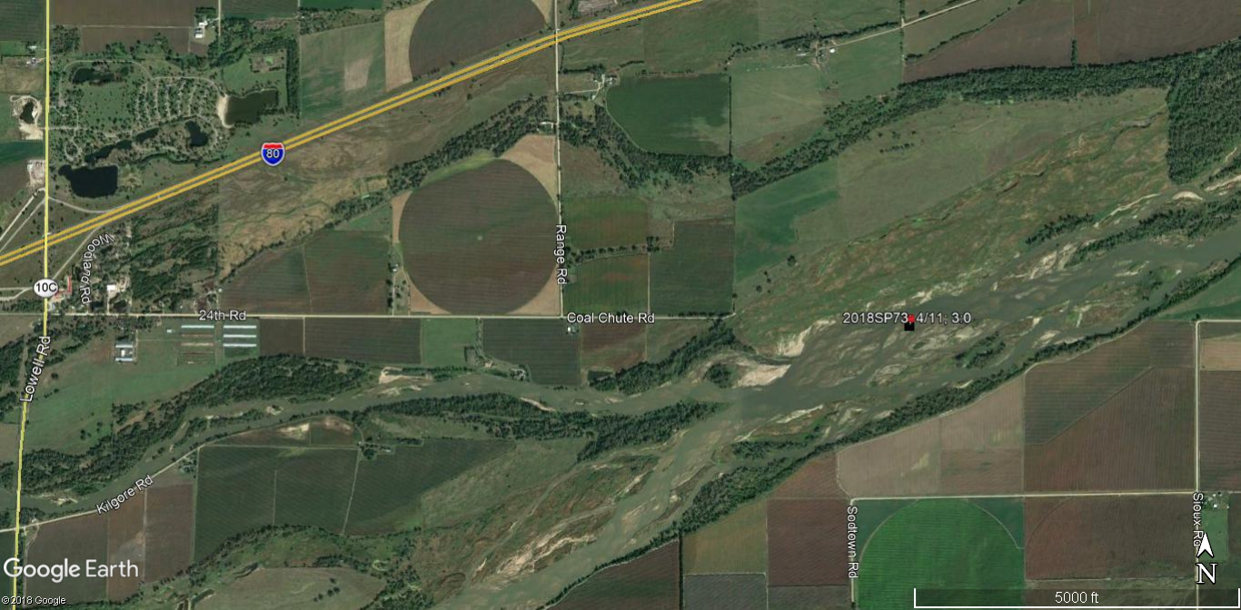
FIGURE 61. This photo was taken during a systematic observation of the 3:0 crane group 2018SP73 use site 39 on 4/11 in the main channel of the Platte River.
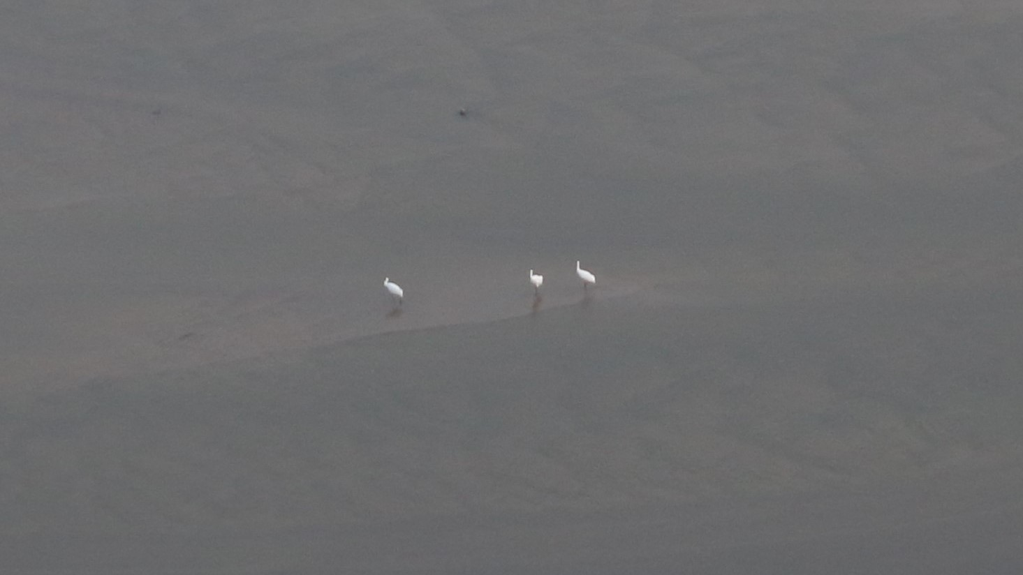
FIGURE 62. Observed location of the 4:0 crane group designated with ID # 2018SP74. This group was observed in the survey area on 4/11.
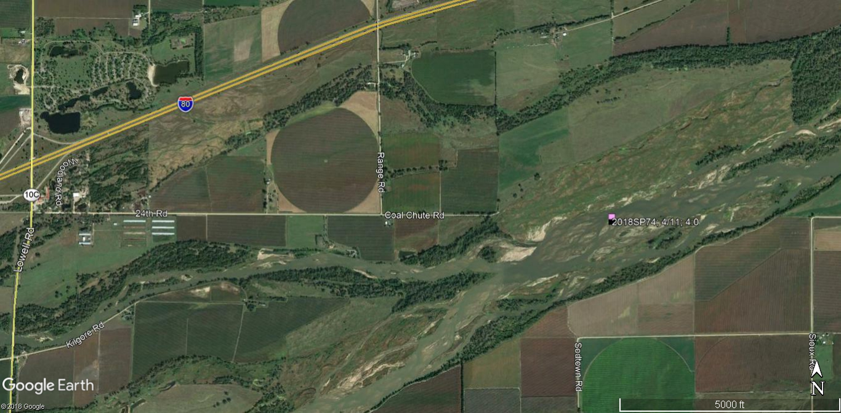
FIGURE 63. This photo was taken during a systematic observation of the 4:0 crane group 2018SP74 use site 40 on 4/11 in the main channel of the Platte River.
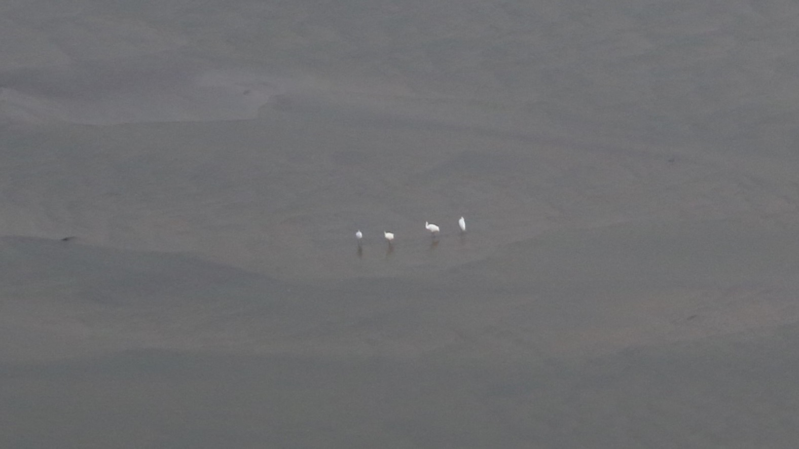
FIGURE 64. Observed location of the 1:0 crane group designated with ID # 2018SP82. This group was observed in the survey area on 4/16.
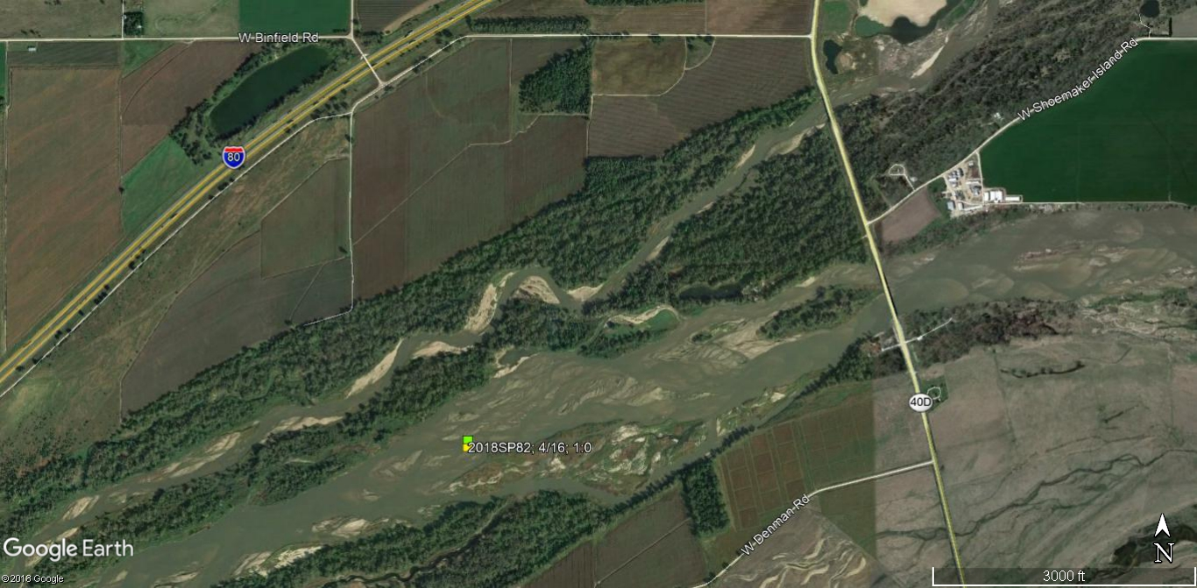
FIGURE 65. This photo was taken during a systematic observation of the 1:0 crane group 2018SP82 use site 46 on 4/16 in the main channel of the Platte River.
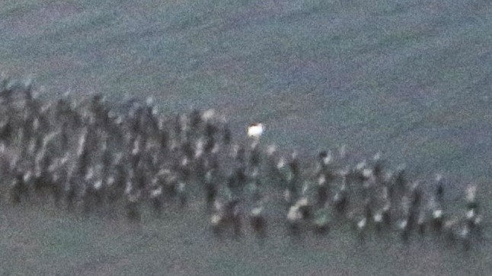
FIGURE 66. Observed location of the 2:0 crane group designated with ID # 2018SP83. This group was observed in the survey area on 4/16.
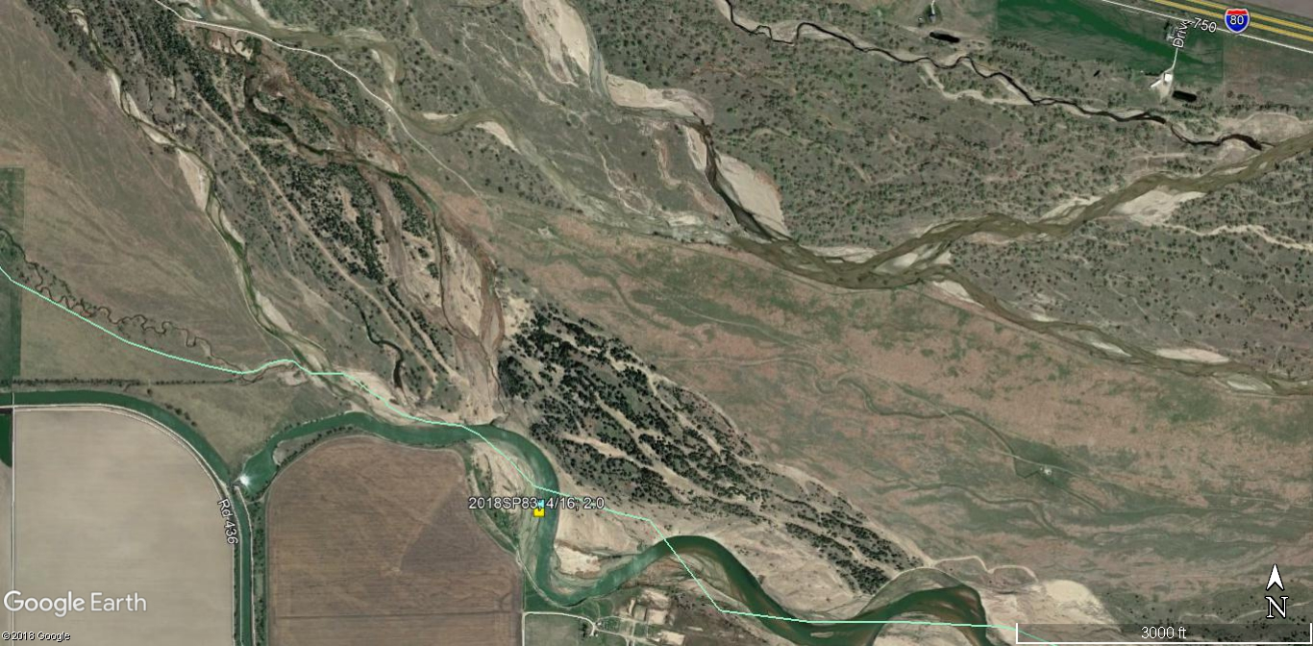
FIGURE 67. This photo was taken during a systematic observation of the 2:0 crane group 2018SP83 use site 47 on 4/16 in the main channel of the Platte River.
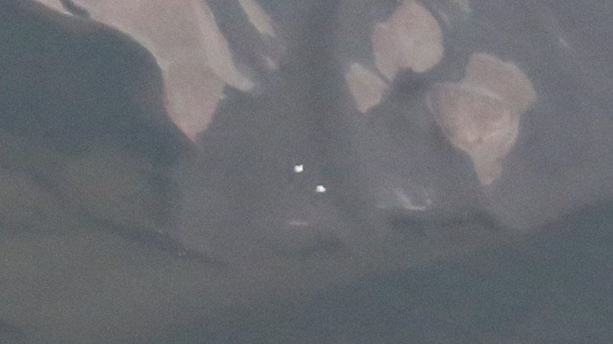
FIGURE 68. Observed locations of the 10:1 crane group designated with ID # 2018SP83. This group also separated into smaller groups (See Table 1) and was observed in the survey area 4/16-4/22.
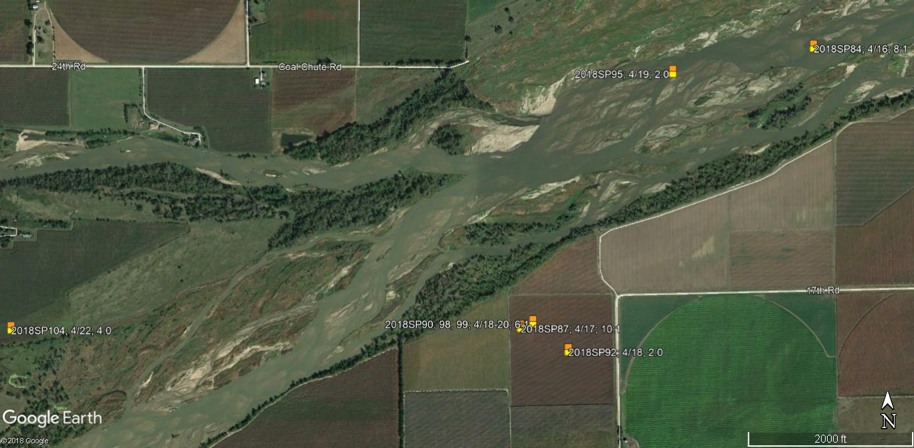
FIGURE 69. This photo was taken during a ground observation of the 10:1 crane group 2018SP87 on 4/16 in a cornfield. Just a portion of one crane can be seen on the far right of the photo.
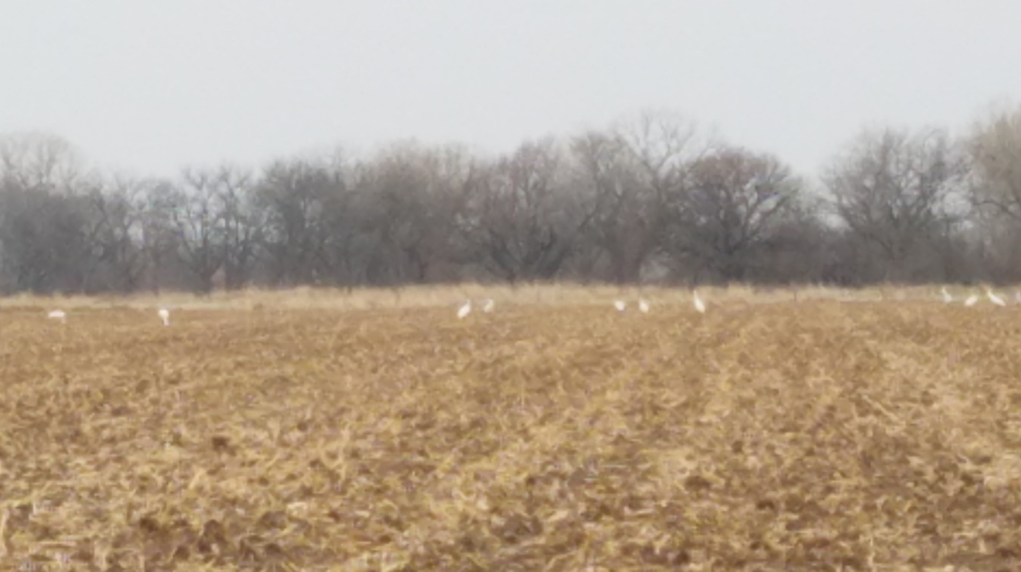
FIGURE 70. Observed locations of the 2:0 crane group designated with ID #’s: 2018SP91, 96 & 101-103. This group was observed in the survey area on 4/18-4/22.
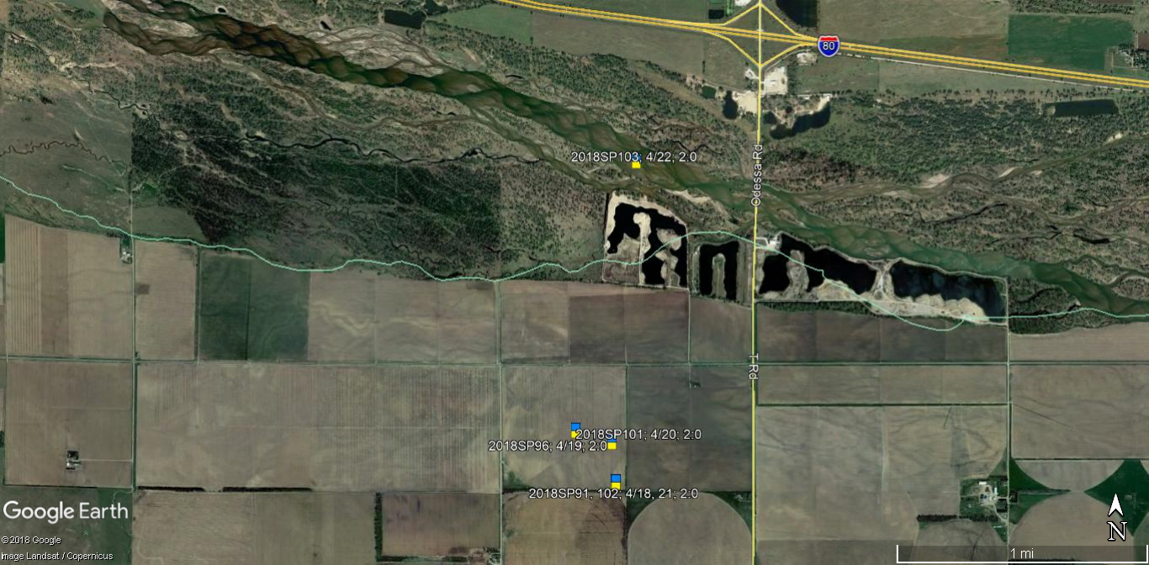
FIGURE 71. This photo was taken during a ground observation of the 2:0 crane group 2018SP103 use site 53 on 4/22 in the main channel of the Platte River. The cranes can be seen behind the right side of the flock of pelicans.
