Platte River Recreation Access Usage Statistics 2011-2018
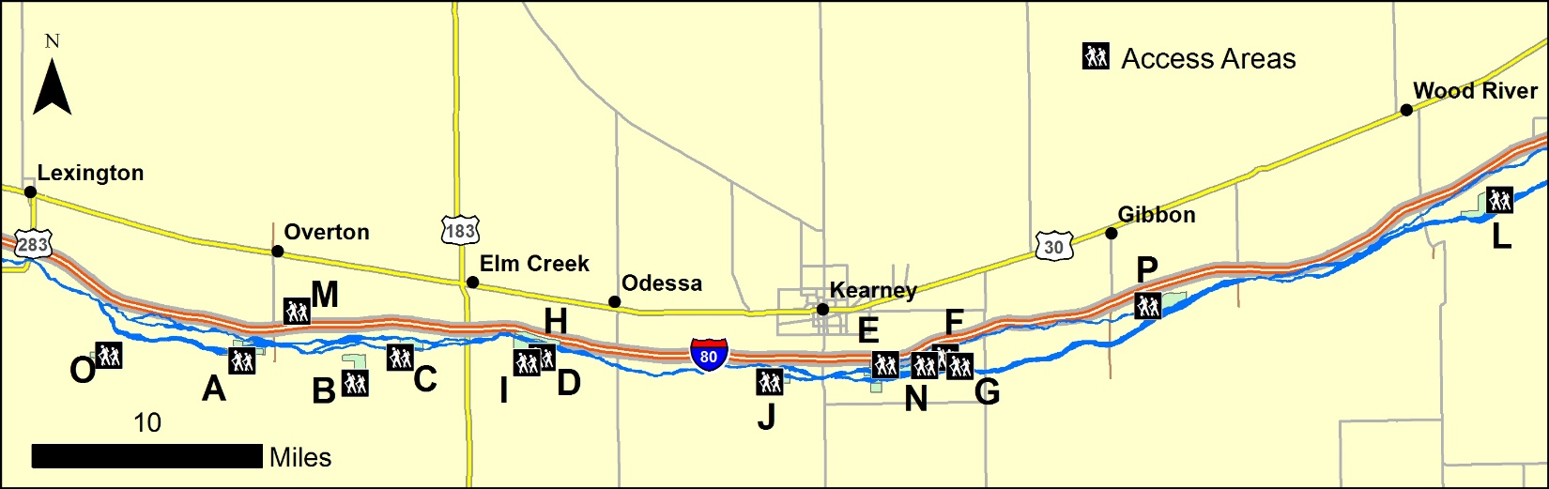
 | 2011-2012 | 2012-2013 | 2013-2014 | 2014-2015 | 2015-2016 | 2016-2017 | 2017-2018 | 2018-2019
Number of PRRA Properties | 8 | 9 | 10 | 11 | 11 | 14 | 15 | 15
Total Acres | 2783 | 3503 | 3745 | 4732 | 4643 | 5824 | 5924 | 5876
Permission Slips Available/Day | 34 | 42 | 42 | 51 | 49 | 63 | 65 | 64
Permission Slips Available During Season | 1666 | 2562 | 4494 | 5457 | 5341 | 6993 | 7735 | 7328
Permission Slips Issued During Season | 384 | 762 | 1407 | 1762 | 1864 | 2122 | 1991 | 1734
Rifle Season Users | 32 | 38 | 38 | 46 | 43 | 56 | 56 | 47
General Access Surveys Sent Out | 83 | 210 | 263 | 252 | 287 | 330 | 281 | 374
Longest Distance Travelled- Rifle Season | 210 miles | 175 miles | 202 miles | 220 miles | 620 miles | 700 miles | 180 miles | 430 miles
Average Distance Travelled- Rifle Season | 73 miles | 56 miles | 50 miles | 69 miles | 53 miles | 91 miles | 58 miles | 87 miles
Longest Distance Travelled- General Access | 400 miles | 691 miles | 937 miles | 325 miles | 1300 miles | 950 miles | 915 miles | 1250 miles
Average Distance Travelled- General Access | 41 miles | 62 miles | 68 miles | 70 miles | 103 miles | 85 miles | 90 miles | 69 miles
Allowed Uses | Deer, turkey, mushroom, fishing,  hiking,  birdwatching | Add site-specific waterfowl and small game |  | Open to waterfowl and small game unless excepted

